**DAY 1 (29-5-25)**

Intro:

What is the Industrial Revolution?

1. The **Industrial Revolutions** are distinct phases in history that radically changed how humans **produce goods**, **work**, and **live** — each driven by **technological innovation**.
2. In Short it is Known as Revolution which happen based upon the latest tech in that period.

INDUSTRY 1.0 (Late 1700s to Mid-1800s):

* **Steam Engine**
* **Water Wheels**
* **Mechanical Looms**
* **Textile Machines**
* **Iron Production (Blast Furnace)**
* **Canals and Railways**
* **Hand Tools to Machines**

**INDUSTRY 2.0** (Late 1800s to Early 1900s):

* Electricity
* Assembly Line (e.g., Ford Model T)
* Telegraph & Telephone
* Steel Manufacturing
* Internal Combustion Engine
* Light Bulb
* Railroads and Shipping Expansion
* Oil and Chemical Industries

INDUSTRY 3.0 (1970s–2000s):

* Computers & Microprocessors
* Programmable Logic Controllers (PLCs)
* Robotics
* Information Technology (IT)
* Enterprise Resource Planning (ERP) systems
* Internet (early stages)
* Digital Communication (e.g., email)
* Basic Data Storage & Retrieval Systems

INDUSTRY 4.0 (2010s–Now):

* GEN AI
* Metaverse
* Cyber security and Cyber Physical Systems
* Block Chain
* IOT
* BIG DATA
* Quantum Computing
* Cloud Computing
* Prompt Engineering

What is Data Engineering?

Data Engineering focuses on the design, building, and maintenance of systems that collect, store, and process data at scale.

Processes in Data Engineering:

Data Engineering involves the following core processes:

1. **Data Collection** – Getting data from different sources.
2. **Data Ingestion** – Moving raw data into a system (cloud, lake, warehouse).
3. **Data Cleaning & Transformation (ETL/ELT)** – Ensuring data quality, consistency.
4. **Data Storage** – Storing data efficiently using databases or data lakes/warehouses.
5. **Data Pipeline Orchestration** – Automating workflows using tools like Apache Airflow.
6. **Serving Data** – Making it accessible for analysts and data scientists (Power BI).

What is Data Science?

Data Science focuses on analysing and interpreting complex data to extract insights, build models, and drive decision-making.

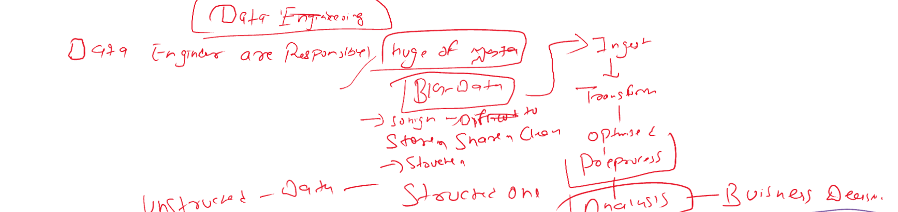

DATA PIPELINE WORKFLOW:

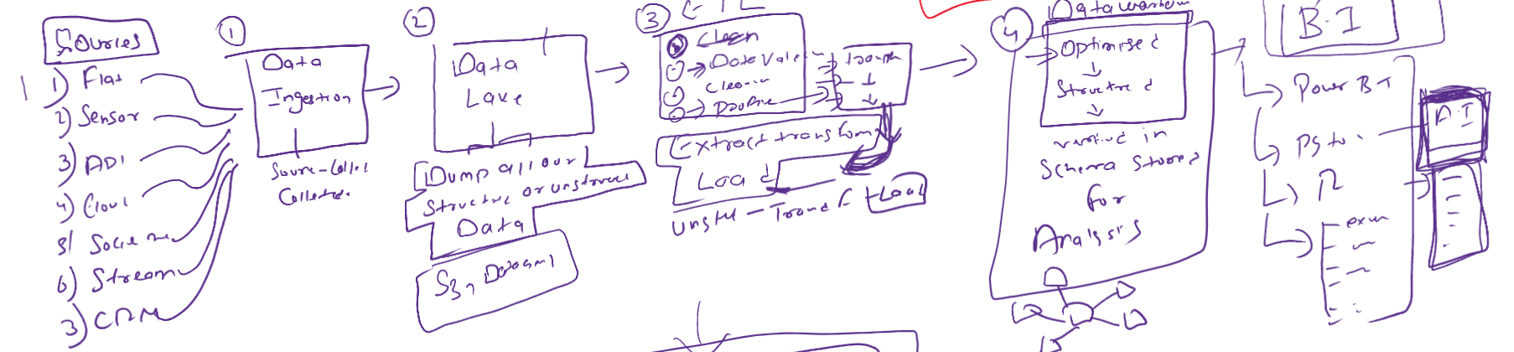

Step 1:

Collect Data from multiple sources like,

* Flat Files (CSV, Excel, etc.)
* Sensors (IoT devices)
* APIs
* Cloud-based data
* Social Media
* Streaming data (real-time sources)
* CRM systems (like Salesforce)

Step 2:

Store the collected Raw Data,

* All Structured and Un-structured Data are stored.
* Stored in Amazon or Azure clouds.

Step 3:

Convert the data into usable Format and need to structure according to it and this process is known as ETL.

* Extract - Pull data from the storage space.
* Transform – clean the data, validate data and prepare for Loading.
* Load - Send the transformed data to the next stage

Step 4:

Storing the cleaned data,

* Transformed data is loaded here.
* Uses schema-based storage for High-speed queries retrieval and Analytical workloads.

Step 5:

Provide insights, dashboards, and reports from the stored data.

Tools which can be used for this process are,

* Power BI
* Tableau
* Excel

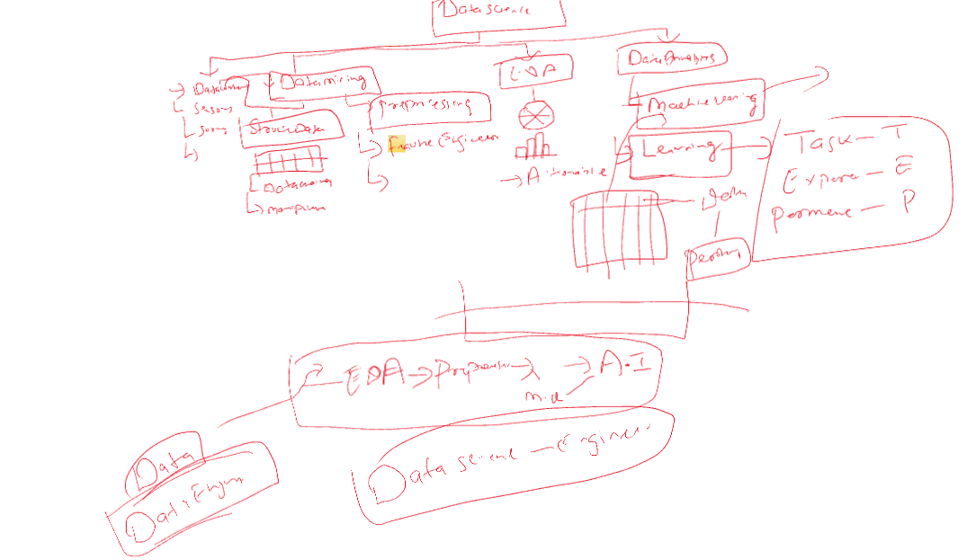

**Data Ingestion**: Importing raw data from multiple sources into a system.

* + *Example*: Bringing data from sensors or websites into a cloud platform.

**Data Lake**: A large storage repository for raw, unstructured, semi-structured, and structured data.

* + *Tools*: AWS S3, Azure Data Lake

**Machine Learning:**

**Machine Learning (ML)** is a subfield of **Artificial Intelligence (AI)** that enables computers to **learn from data** and **make decisions or predictions** without being explicitly programmed for every task.

Day 2 (2-6-25)

Advanced SQL Concepts

What are Window Functions?

Window functions perform **calculations across a set of rows** that are related to the current row — without grouping or losing individual row data.

**Common examples:**

* ROW_NUMBER()
* RANK()
* DENSE_RANK()
* LAG(), LEAD()
* SUM(), AVG() OVER a window

**Use cases:**

* Ranking employees by salary
* Getting running totals or moving averages
* Comparing values from previous or next rows (e.g., sales growth)
* Detecting duplicates (ROW_NUMBER() for de-duplication)

**When to use:**

Use window functions when you need **row-level calculations** that depend on other rows — but still want to **see every row**.

What is CTE?

Abbreviation – Common Table Expression

A CTE is a **temporary result set** defined with WITH, used to simplify complex queries by giving a name to a subquery.

**Use cases:**

* Breaking a big query into smaller parts
* Reusing the same subquery multiple times
* Making recursive queries (e.g., employee hierarchies)
* Improving readability

**When to use:**

Use CTEs when your SQL is getting messy with nested subqueries, or when you want to make your logic easier to follow step-by-step.

**SQL_Practice_Coding_challenge:**

create database dataset;

use dataset;

-- Create Departments Table

CREATE TABLE departments (

department_id INT PRIMARY KEY,

department_name VARCHAR(50)

);

-- Create Projects Table

CREATE TABLE projects (

project_id INT PRIMARY KEY,

project_name VARCHAR(50),

start_date DATE,

end_date DATE

);

-- Create Employees Table with Foreign Keys

CREATE TABLE employees (

emp_id INT PRIMARY KEY,

first_name VARCHAR(50),

last_name VARCHAR(50),

department VARCHAR(50),

salary INT,

join_date DATE,

manager_id INT,

project_id INT NULL,

CONSTRAINT fk_project FOREIGN KEY (project_id) REFERENCES projects(project_id)

);

-- Departments

INSERT INTO departments VALUES

(1, 'IT'), (2, 'HR'), (3, 'Finance'), (4, 'Sales'), (5, 'Marketing'), (6, 'strategy Analyzer');

-- Projects

INSERT INTO projects VALUES

(101, 'Apollo', '2023-01-01', '2023-12-31'),

(102, 'Zeus', '2022-06-01', '2023-05-31'),

(103, 'Hermes', '2024-01-15', '2024-12-15'),

(104, 'Hendry', '2025-02-10','2025-05-12'),

(105, 'Ronald', '2024-02-10','2025-04-12');

-- Employees

INSERT INTO employees VALUES

(1, 'Alice', 'Smith', 'IT', 90000, '2022-01-15', NULL, 101),

(2, 'Bob', 'Singh', 'strategy Analyzer', 88000, '2021-12-01', 1, 102),

(3, 'Carol', 'Suresh', 'Finance', 60000, '2023-03-12', 1, NULL),

(4, 'David', 'Jones', 'HR', 55000, '2024-04-10', 2, 104),

(5, 'Eva', 'Brown', 'Sales', 40000, '2023-06-20', 2, 103),

(6, 'Frank', 'Stone', NULL, 75000, '2020-08-01', NULL, NULL),

(7, 'Grace', 'Sharma', 'IT', 88000, '2021-01-10', 1, 105),

(8, 'Hank', 'Lee', 'HR', 39000, '2024-01-05', 4, NULL),

(9, 'Ivy', 'Sinha', 'Finance', 62000, '2023-09-15', 3, 101),

(10, 'John', 'Doe', 'Marketing', 90000, '2022-10-10', 1, 102);

**String Functions:**

--1. Find employees whose last name starts with 'S'.

SELECT first_name , last_name from employees where last_name LIKE 's%';

-- 2. Display first_name and last_name concatenated as full_name in uppercase.

SELECT UPPER(first_name + ' ' + last_name) AS full_name

FROM employees;

--3. Show employees with a 5-character first name.

SELECT first_name , last_name FROM employees WHERE LEN(first_name) = 5;

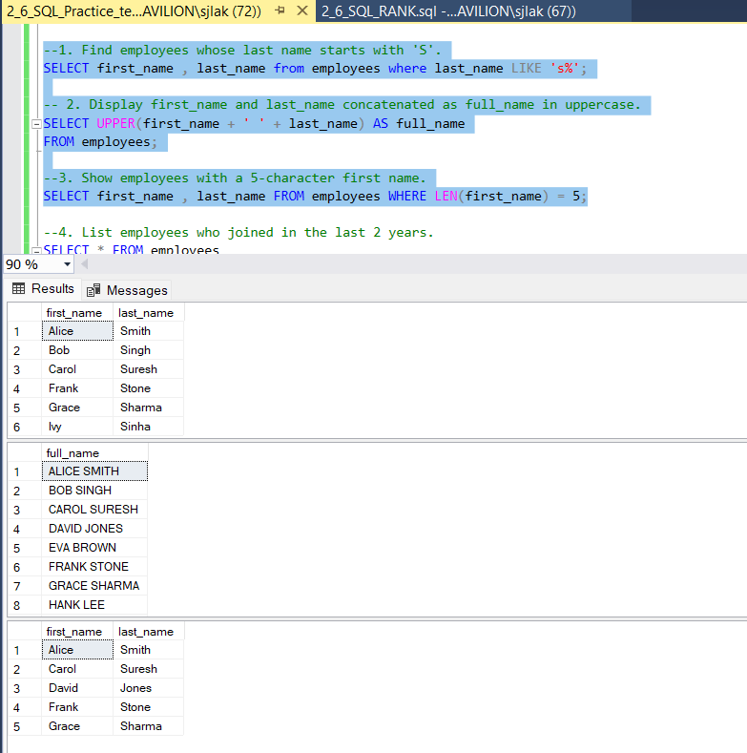

**Date Functions:**

--4. List employees who joined in the last 2 years.

SELECT * FROM employees

WHERE join_date >= DATEADD(YEAR, -2, GETDATE());

--5. Show number of days since each employee joined.

SELECT first_name, last_name, DATEDIFF(DAY, join_date, GETDATE()) AS days_worked

FROM employees;

-- 6. Find the month name and year from each employee's join_date.

SELECT DATENAME(MONTH, join_date) AS join_month, YEAR(join_date) AS join_year

FROM employees;

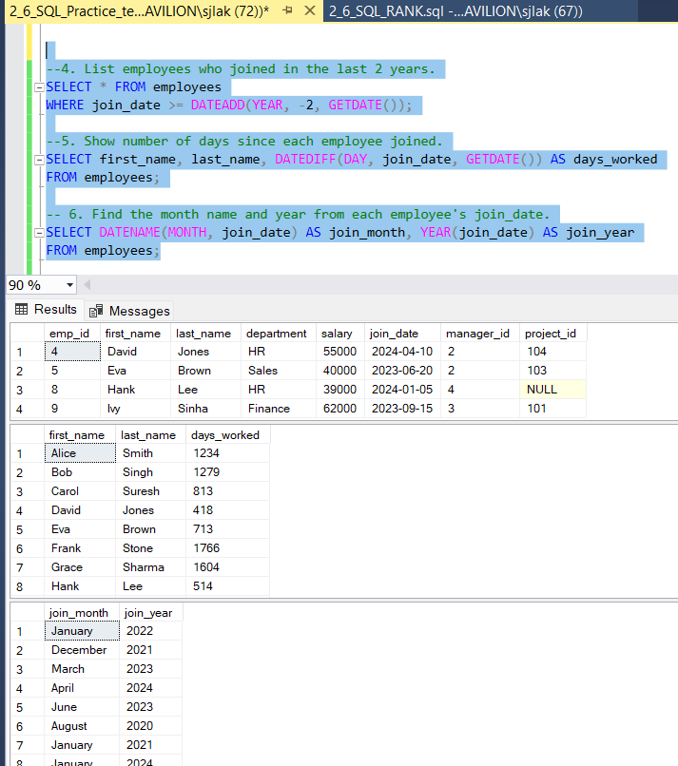

**Math Functions:**

-- 7. Round off each employee's salary to the nearest thousand.

SELECT first_name, last_name, FLOOR(salary / 1000.0) * 1000 AS round_off_salary

FROM employees;

-- 8. Find employees whose salary is above the average salary.

SELECT * FROM employees

WHERE salary > (SELECT AVG(salary) FROM employees);

-- 9. Show absolute difference from company average salary.

SELECT first_name, last_name, ABS(salary - (SELECT AVG(salary) FROM employees)) AS diff_from_avg

FROM employees;

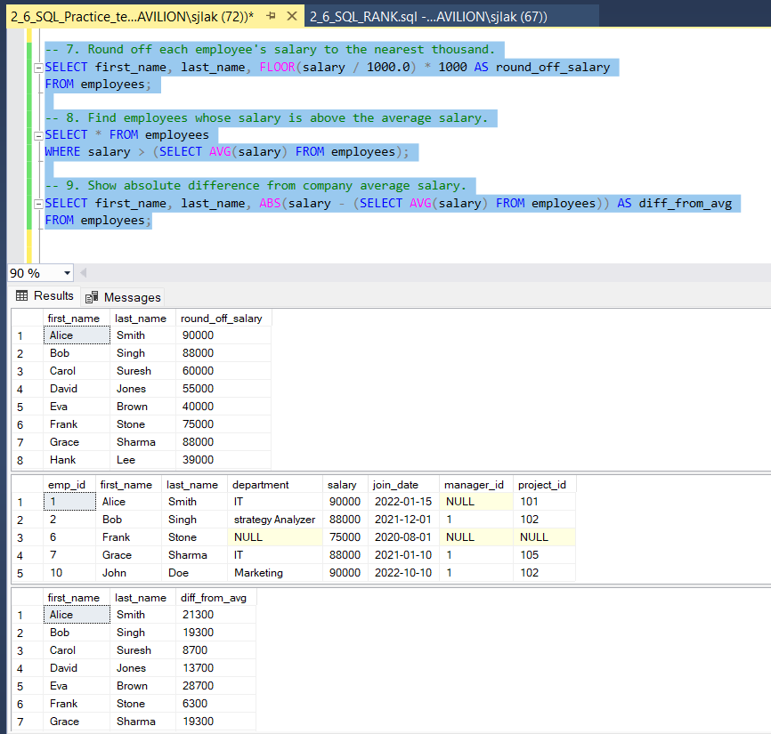

**Aggregate Functions with HAVING:**

-- 10. Find departments with more than 3 employees.

SELECT department, emp_count FROM (

SELECT department, COUNT(*) AS emp_count

FROM employees

GROUP BY department) AS temp

WHERE emp_count > 3;

--11. Show total and average salary per department with avg salary > 60000.

SELECT department, SUM(salary) AS total_salary, AVG(salary) AS avg_salary

FROM employees

GROUP BY department

HAVING AVG(salary) > 60000;

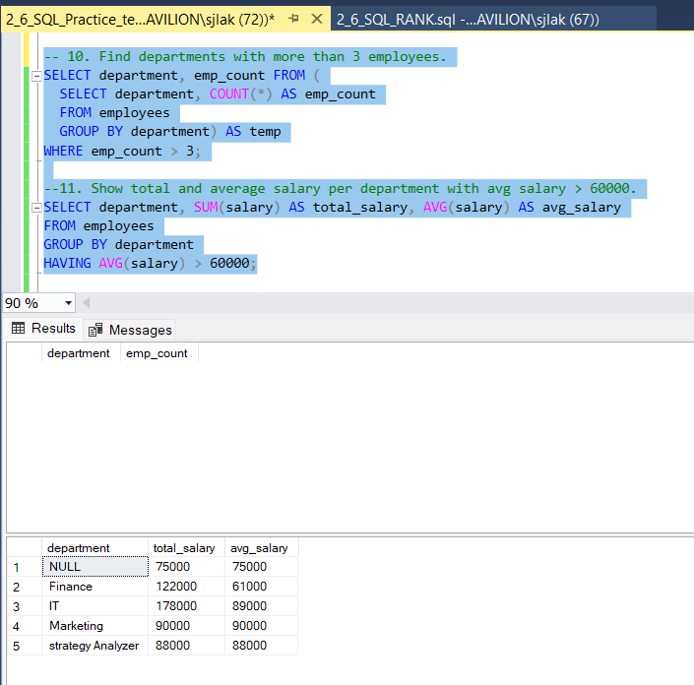

**Subqueries:**

-- 12. Find the employee(s) with the maximum salary.

SELECT * FROM employees

WHERE salary = (SELECT MAX(salary) FROM employees);

-- 13. List employees earning more than avg salary in their department.

SELECT * FROM employees e

WHERE salary > (

SELECT AVG(salary) FROM employees

WHERE department = e.department

);

--14. Show employees who joined before the earliest join date in IT.

SELECT * FROM employees

WHERE join_date < (

SELECT MIN(join_date) FROM employees WHERE department = 'IT'

);

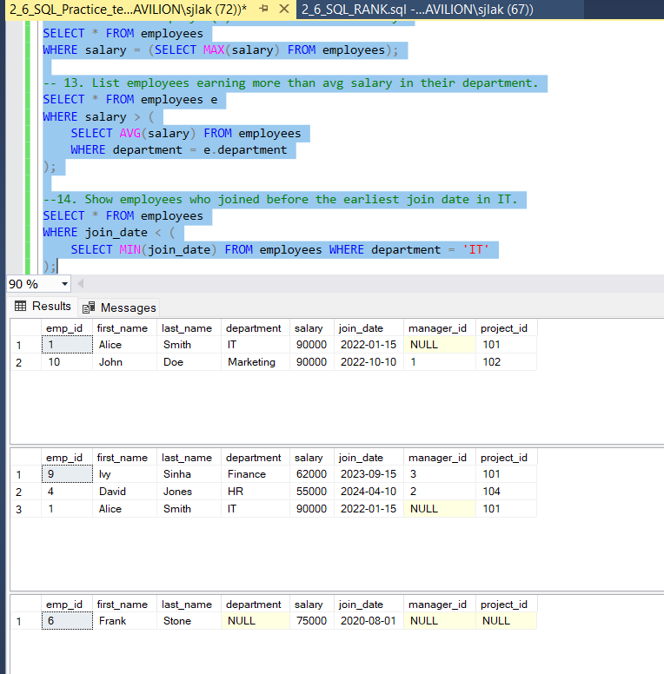

**JOINS:**

-- 15. Show each employee's name and manager's name.

SELECT e.first_name + ' ' + e.last_name AS employee,

m.first_name + ' ' + m.last_name AS manager

FROM employees e

LEFT JOIN employees m ON e.manager_id = m.emp_id;

-- 16. List employees with their department name.

SELECT e.first_name, e.last_name, d.department_name

FROM employees e

JOIN departments d ON e.department = d.department_name;

--17. List employees not assigned any project.

SELECT * FROM employees WHERE project_id IS NULL;

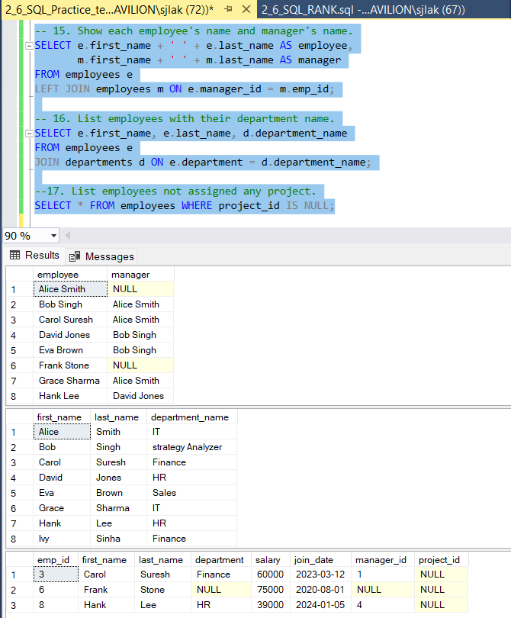

**Window Functions:**

-- 18. Assign a row number to employees in each department based on salary.

SELECT *, ROW_NUMBER() OVER (PARTITION BY department ORDER BY salary DESC) AS row_num

FROM employees;

-- 19. Show running total salary within each department.

SELECT *, SUM(salary) OVER (PARTITION BY department ORDER BY join_date) AS running_total

FROM employees;

--20. Show difference in salary between employee and previous by join date.

SELECT *, salary - LAG(salary) OVER (ORDER BY join_date) AS salary_diff_prev

FROM employees;

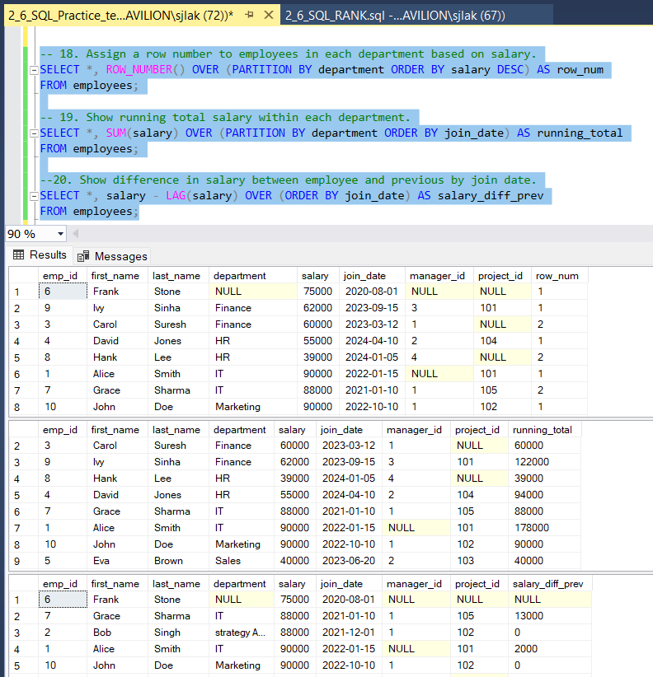

**CTE (Common Table Expressions):**

--21. Use CTE to calculate total salary per department, filter total > 200000.

WITH dept_salary AS (

SELECT department, SUM(salary) AS total_salary

FROM employees

GROUP BY department

)

SELECT * FROM dept_salary

WHERE total_salary > 200000;

--22. Create a recursive CTE to generate numbers 1 to 10.

WITH numbers(n) AS (

SELECT 1

UNION ALL

SELECT n + 1 FROM numbers WHERE n < 10

)

SELECT * FROM numbers;

--23. Use a CTE to find employees with duplicate first names.

WITH dup_names AS (

SELECT first_name, COUNT(*) AS cnt

FROM employees

GROUP BY first_name

HAVING COUNT(*) > 1

)

SELECT e.*

FROM employees e

JOIN dup_names d ON e.first_name = d.first_name;

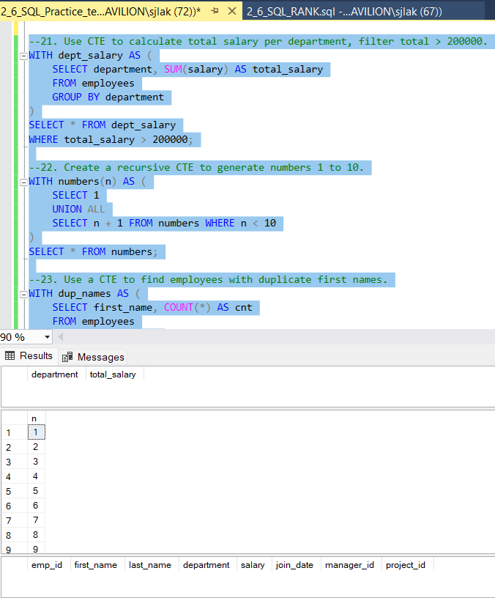

**Case Statements:**

--24. Label employees as 'Junior', 'Mid', or 'Senior' based on salary.

SELECT first_name, last_name, salary,

CASE

WHEN salary < 40000 THEN 'Junior'

WHEN salary BETWEEN 40000 AND 80000 THEN 'Mid'

ELSE 'Senior'

END AS level

FROM employees;

--25. Count employees in salary categories using CASE.

SELECT

COUNT(CASE WHEN salary < 40000 THEN 1 END) AS junior_count,

COUNT(CASE WHEN salary BETWEEN 40000 AND 80000 THEN 1 END) AS mid_count,

COUNT(CASE WHEN salary > 80000 THEN 1 END) AS senior_count

FROM employees;

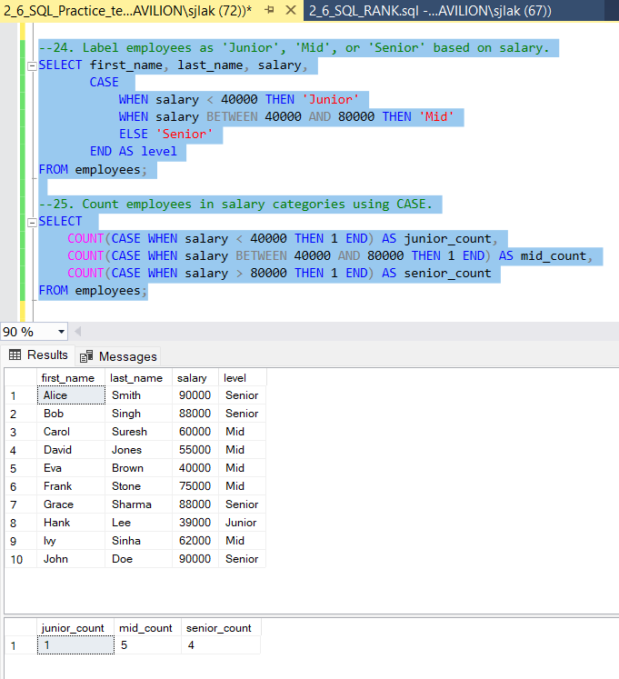

**NULL Functions:**

--26. Replace NULL department values with 'Unknown'.

SELECT ISNULL(department, 'Unknown') AS department

FROM employees;

--27. Show employees with no department.

SELECT * FROM employees WHERE department IS NULL;

--28. Use COALESCE to provide default for missing projects.

SELECT first_name, last_name, COALESCE(project_id, 0) AS project_assigned

FROM employees;

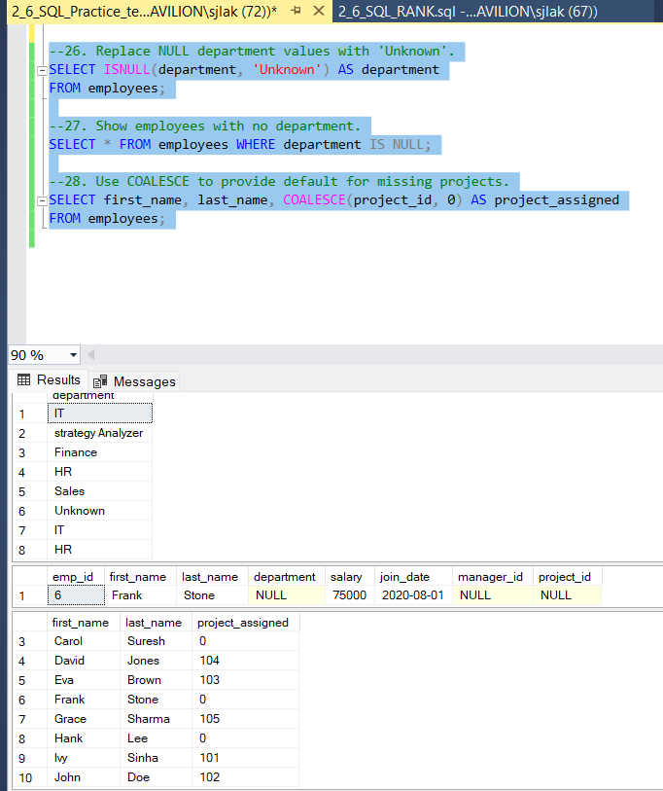

**PROJECT 1 (02-06-2025)**

**ShopFast**

**STEP 1: Creating a new Database,**

create database ShopFast;

**STEP 2: using the new database,**

use ShopFast;

**STEP 3: Inserting the values through given csv files,**

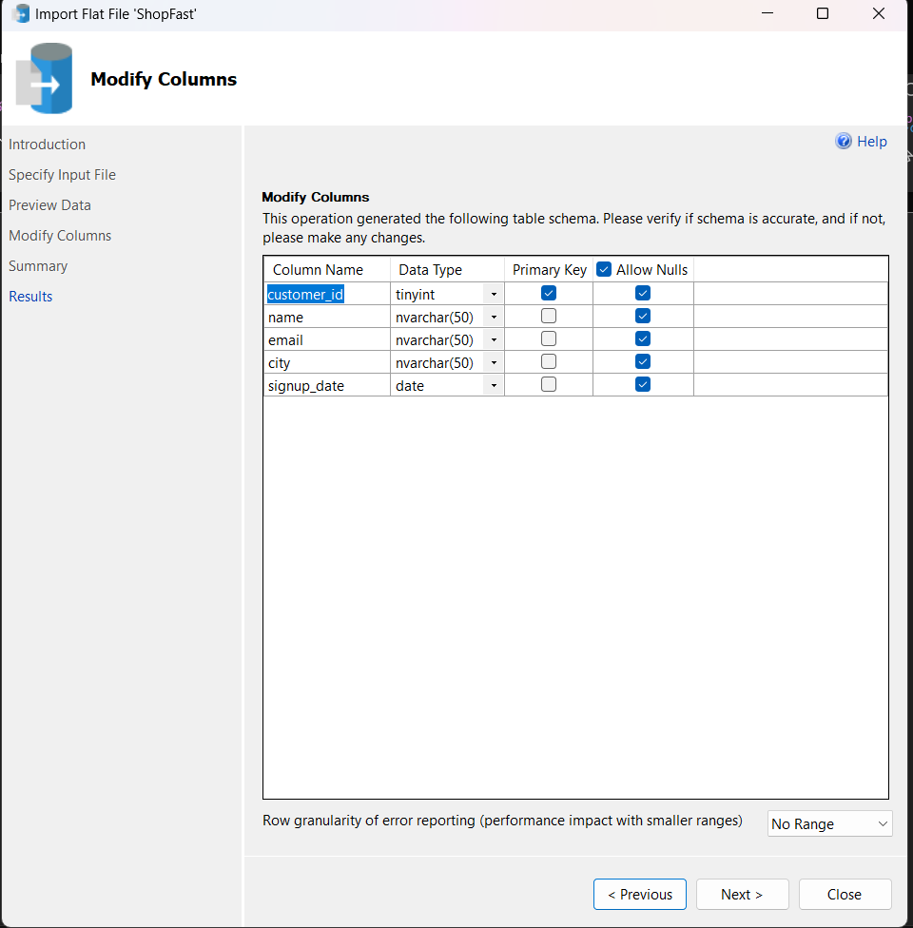

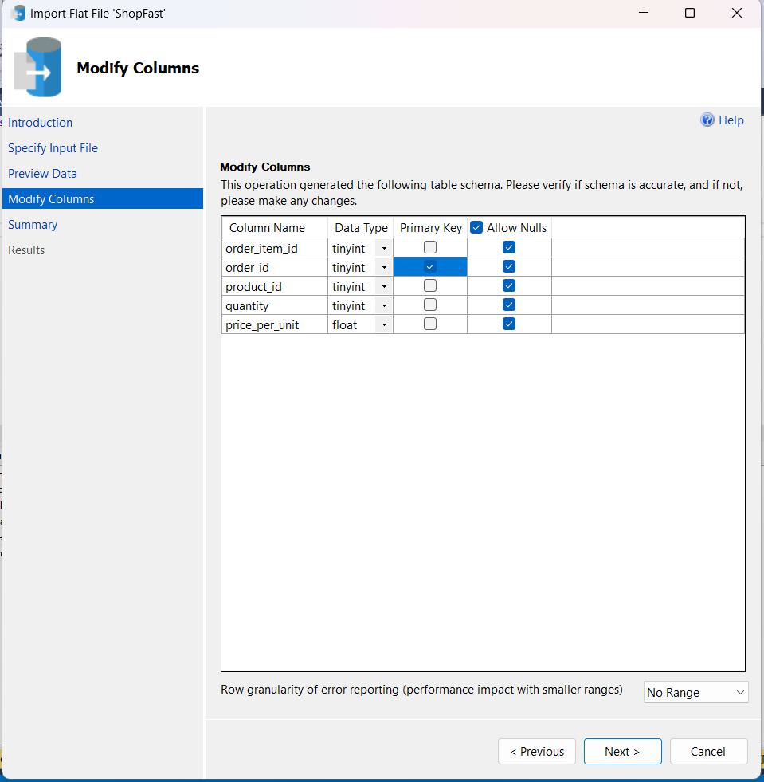

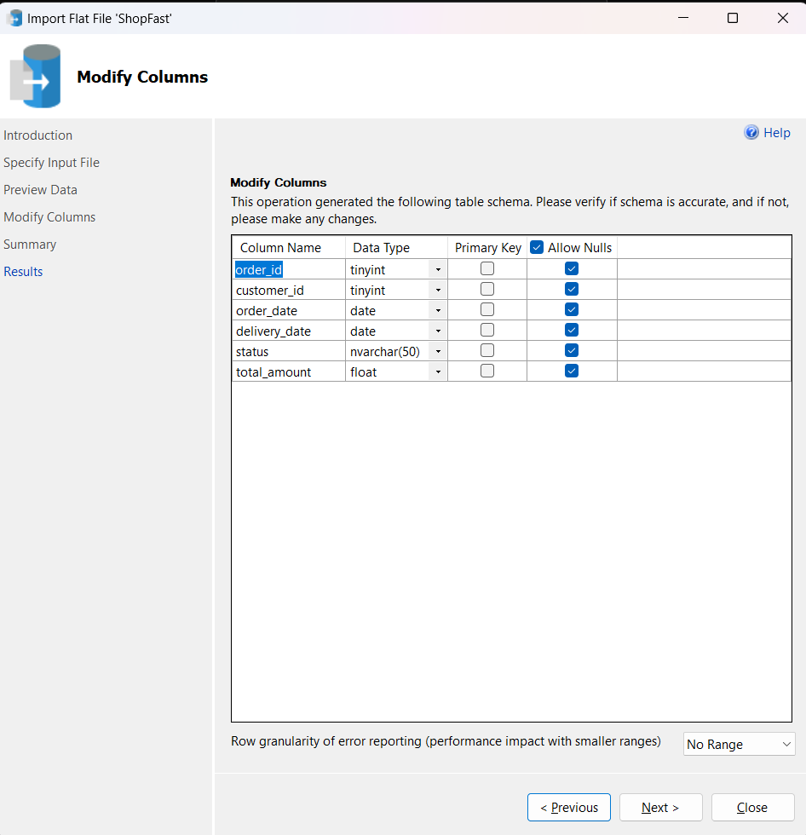

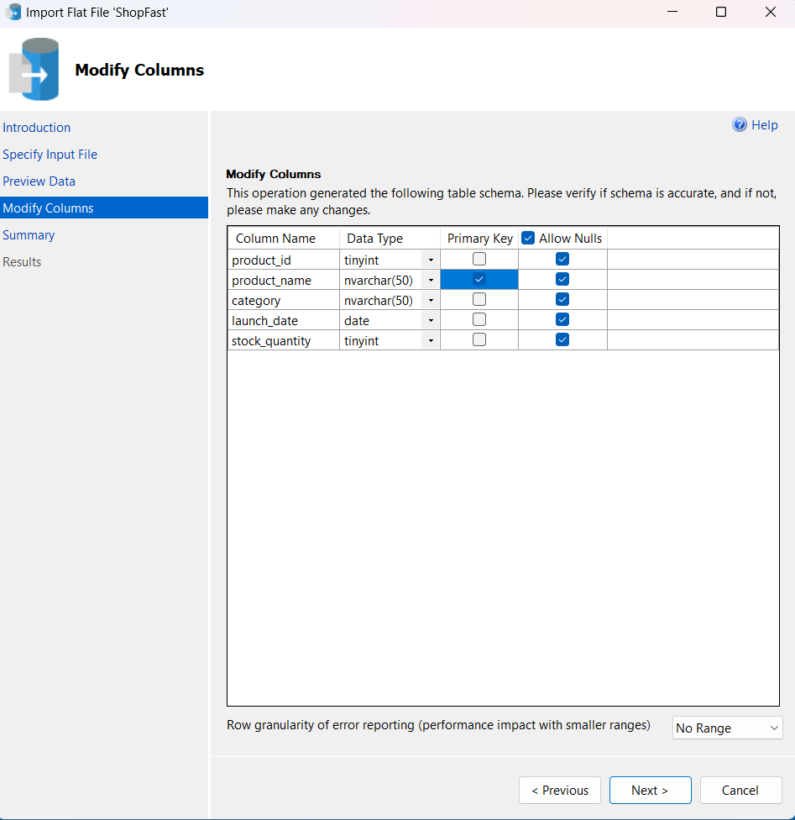

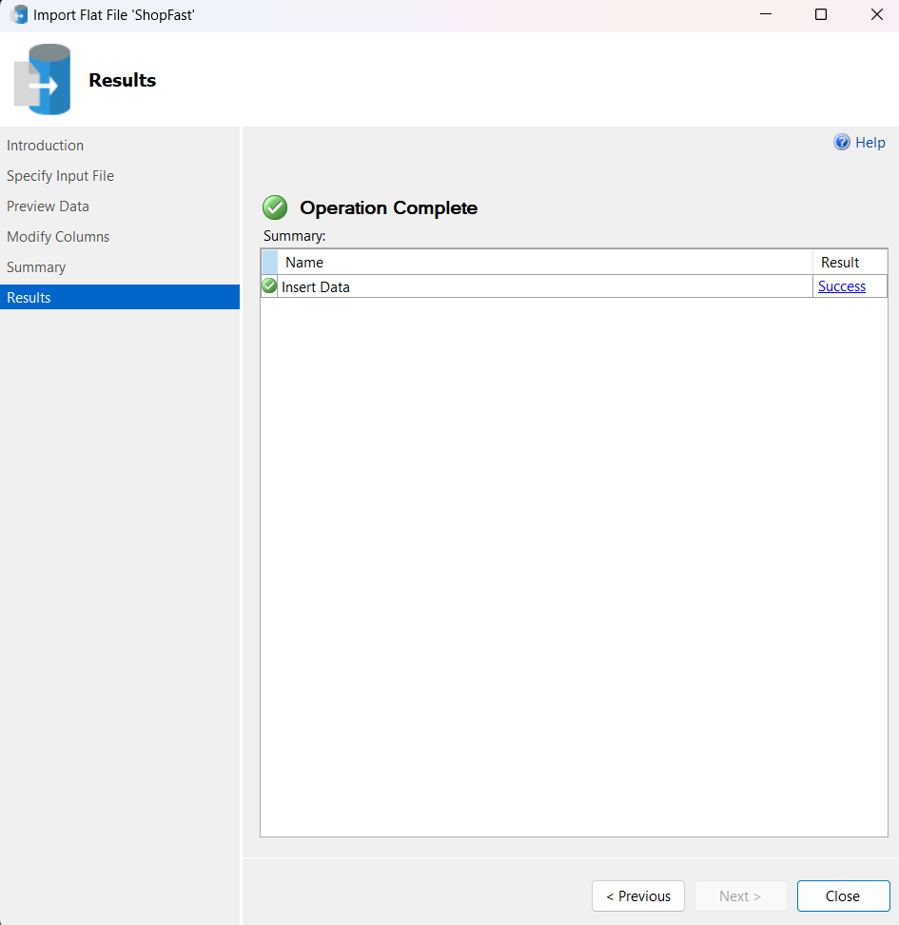

**STEP 4: Check weather all the data’s are inserted properly,**

select * from CUSTOMERS;

select * from ORDER_ITEMS;

select * from ORDERS;

select * from PRODUCTS;

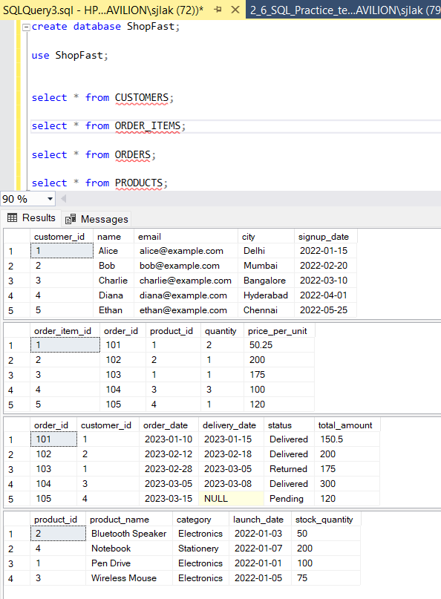

**STEP 5: Answers for all Problem Set**

--1. Customer Sign-up Trend: New customers per month (last 12 months)

SELECT customer_id, name, signup_date FROM CUSTOMERS

WHERE signup_date >= DATEADD(MONTH, -12, GETDATE());

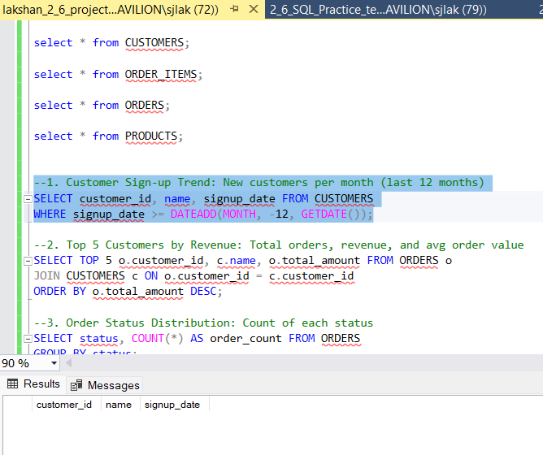

--2. Top 5 Customers by Revenue: Total orders, revenue, and avg order value

SELECT TOP 5 o.customer_id, c.name, o.total_amount FROM ORDERS o

JOIN CUSTOMERS c ON o.customer_id = c.customer_id

ORDER BY o.total_amount DESC;

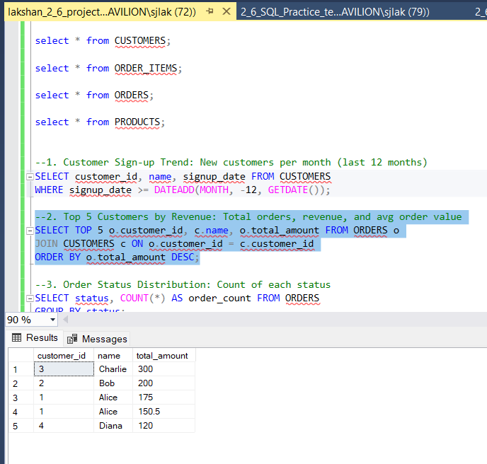

--3. Order Status Distribution: Count of each status

SELECT status, COUNT(*) AS order_count FROM ORDERS

GROUP BY status;

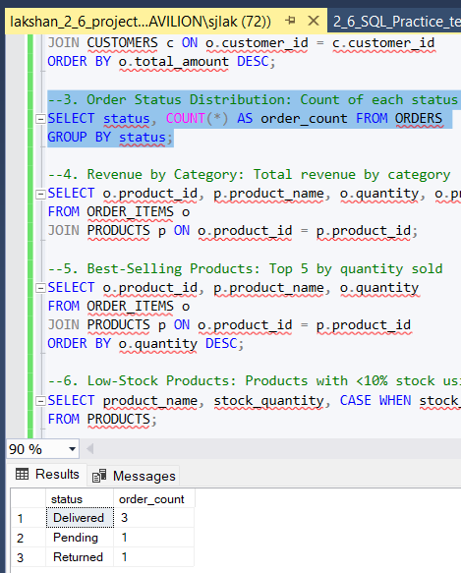

--4. Revenue by Category: Total revenue by category

SELECT o.product_id, p.product_name, o.quantity, o.price_per_unit

FROM ORDER_ITEMS o

JOIN PRODUCTS p ON o.product_id = p.product_id;

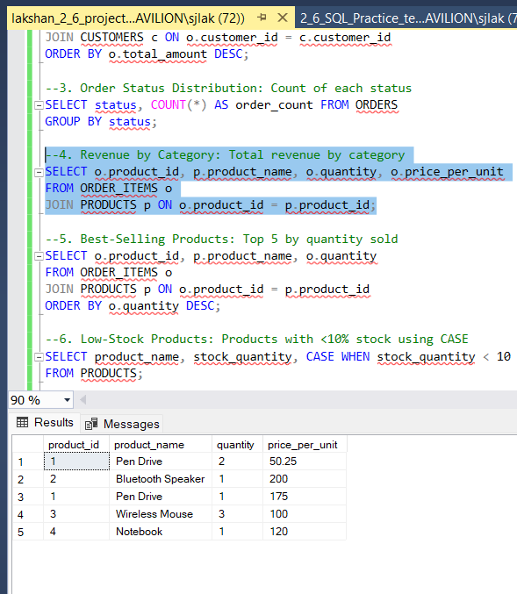

--5. Best-Selling Products: Top 5 by quantity sold

SELECT o.product_id, p.product_name, o.quantity

FROM ORDER_ITEMS o

JOIN PRODUCTS p ON o.product_id = p.product_id

ORDER BY o.quantity DESC;

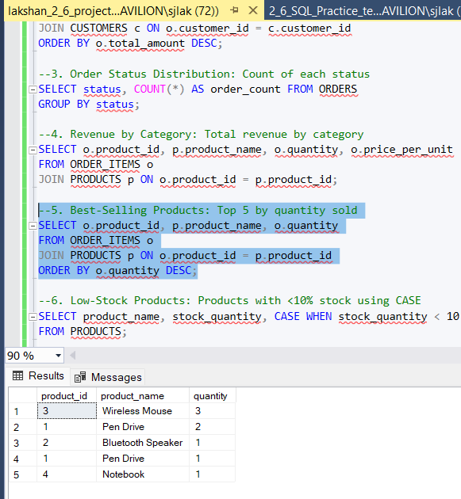

--6. Low-Stock Products: Products with <10% stock using CASE

SELECT product_name, stock_quantity, CASE WHEN stock_quantity < 10 THEN 'Low Stock' ELSE 'OK' END AS stock_status

FROM PRODUCTS;

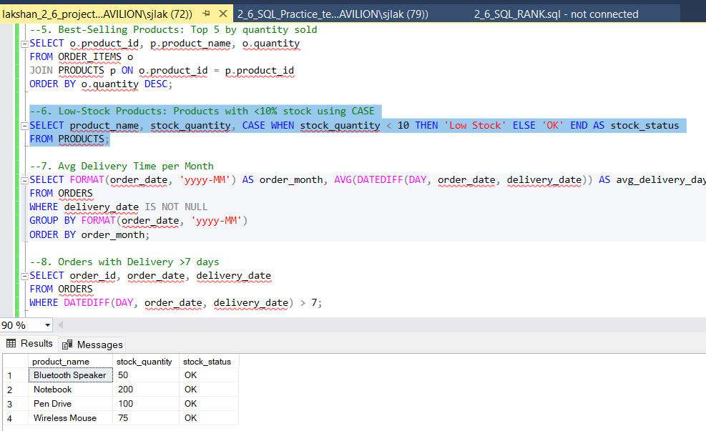

--7. Avg Delivery Time per Month

SELECT FORMAT(order_date, 'yyyy-MM') AS order_month, AVG(DATEDIFF(DAY, order_date, delivery_date)) AS avg_delivery_days

FROM ORDERS

WHERE delivery_date IS NOT NULL

GROUP BY FORMAT(order_date, 'yyyy-MM')

ORDER BY order_month;

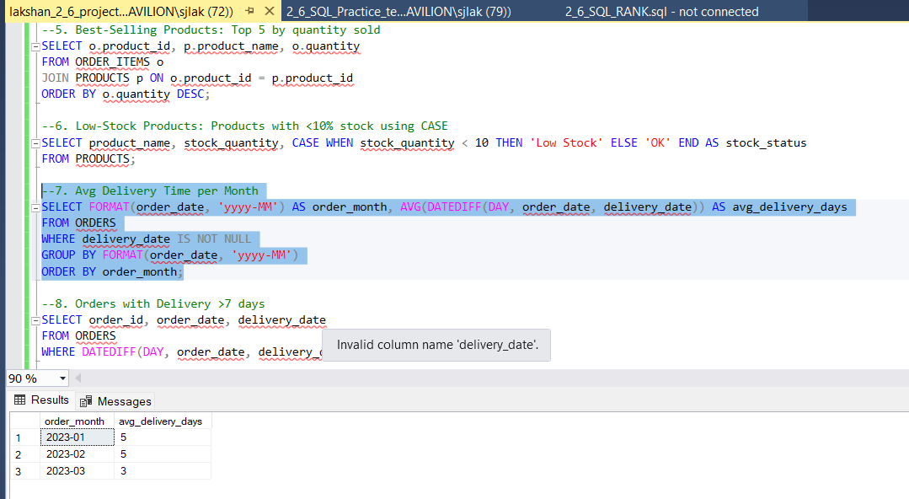

--8. Orders with Delivery >7 days

SELECT order_id, order_date, delivery_date

FROM ORDERS

WHERE DATEDIFF(DAY, order_date, delivery_date) > 7;

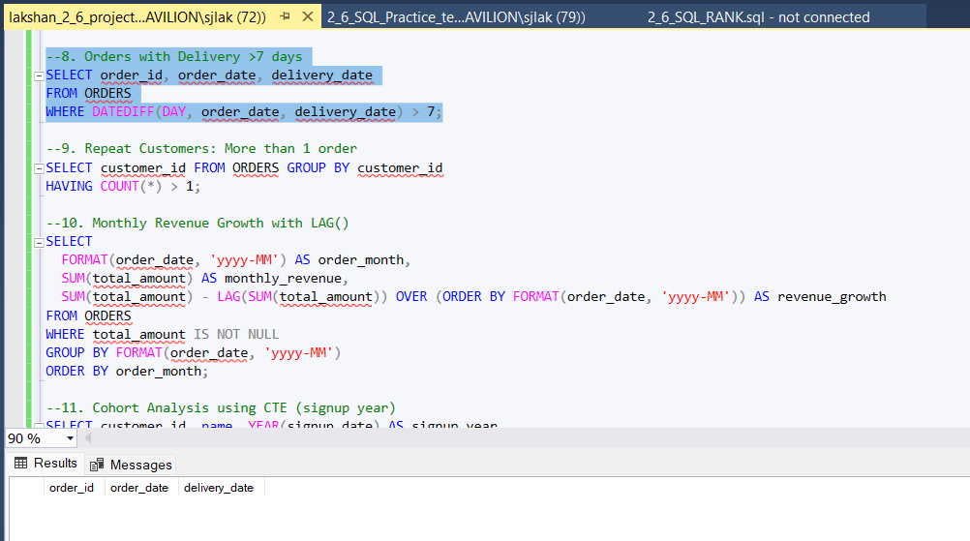

--9. Repeat Customers: More than 1 order

SELECT customer_id FROM ORDERS GROUP BY customer_id

HAVING COUNT(*) > 1;

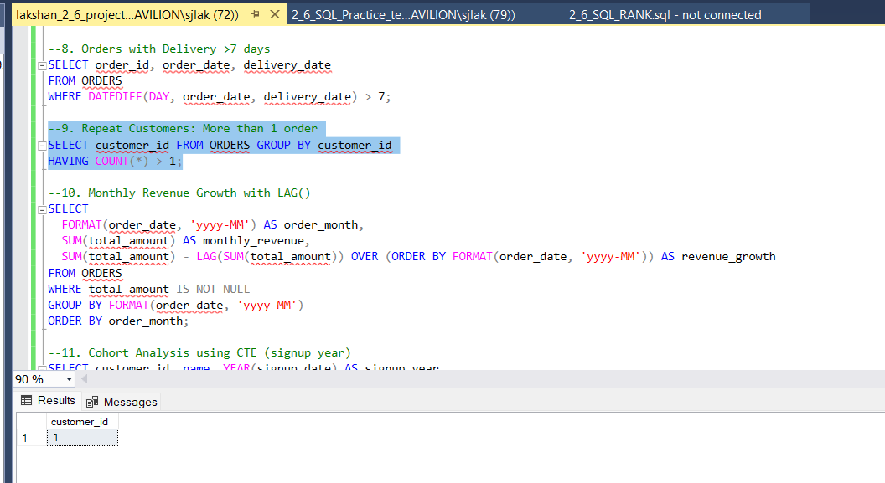

--10. Monthly Revenue Growth with LAG()

SELECT

FORMAT(order_date, 'yyyy-MM') AS order_month,

SUM(total_amount) AS monthly_revenue,

SUM(total_amount) - LAG(SUM(total_amount)) OVER (ORDER BY FORMAT(order_date, 'yyyy-MM')) AS revenue_growth

FROM ORDERS

WHERE total_amount IS NOT NULL

GROUP BY FORMAT(order_date, 'yyyy-MM')

ORDER BY order_month;

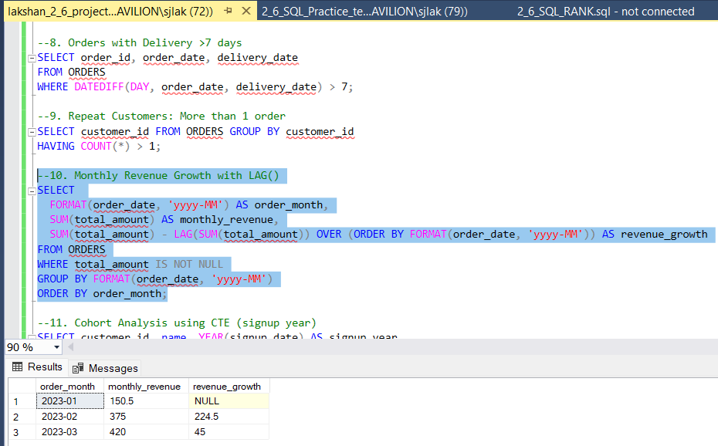

--11. Cohort Analysis using CTE (signup year)

SELECT customer_id, name, YEAR(signup_date) AS signup_year

FROM CUSTOMERS;

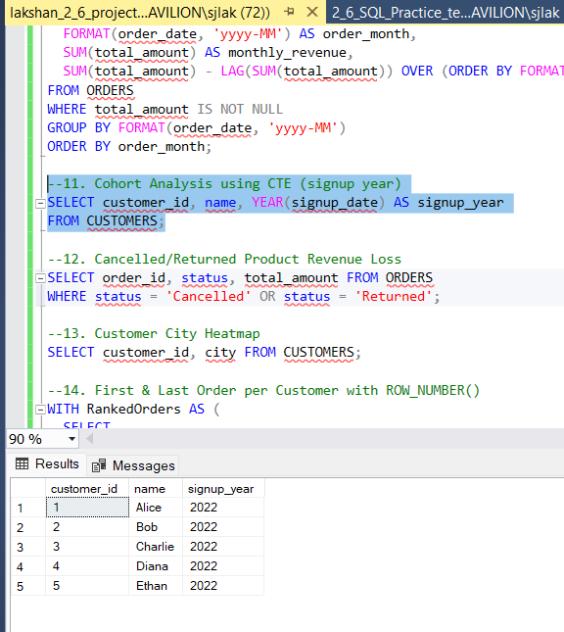

--12. Cancelled/Returned Product Revenue Loss

SELECT order_id, status, total_amount FROM ORDERS

WHERE status = 'Cancelled' OR status = 'Returned';

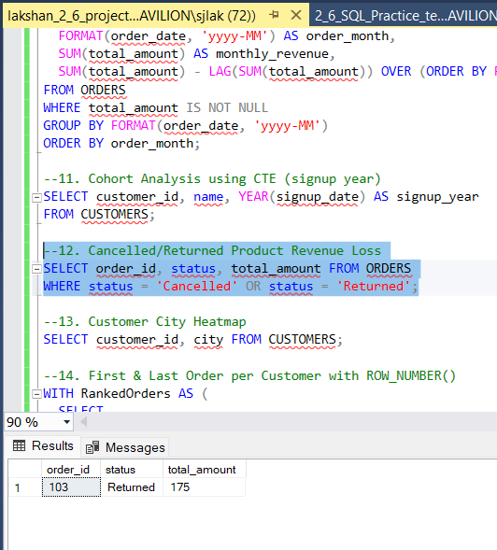

--13. Customer City Heatmap

SELECT customer_id, city FROM CUSTOMERS;

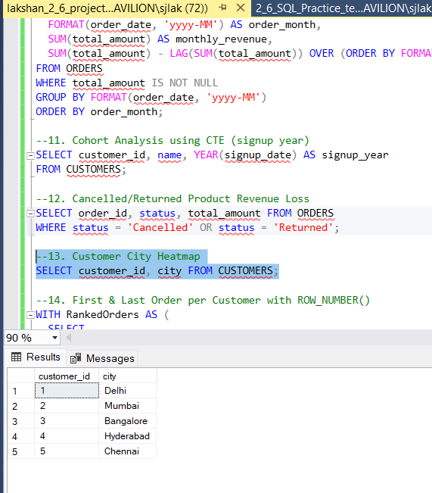

--14. First & Last Order per Customer with ROW_NUMBER()

WITH RankedOrders AS (

SELECT

customer_id,

order_id,

order_date,

ROW_NUMBER() OVER (PARTITION BY customer_id ORDER BY order_date ASC) AS rn_asc,

ROW_NUMBER() OVER (PARTITION BY customer_id ORDER BY order_date DESC) AS rn_desc

FROM ORDERS

)

SELECT customer_id, order_id, order_date, 'First Order' AS order_type

FROM RankedOrders WHERE rn_asc = 1

UNION

SELECT customer_id, order_id, order_date, 'Last Order'

FROM RankedOrders WHERE rn_desc = 1;

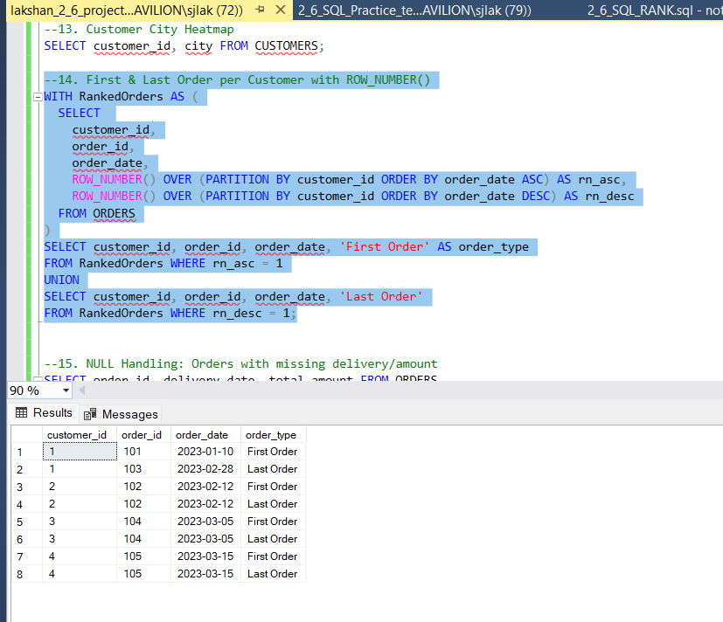

--15. NULL Handling: Orders with missing delivery/amount

SELECT order_id, delivery_date, total_amount FROM ORDERS

WHERE delivery_date IS NULL OR total_amount IS NULL;

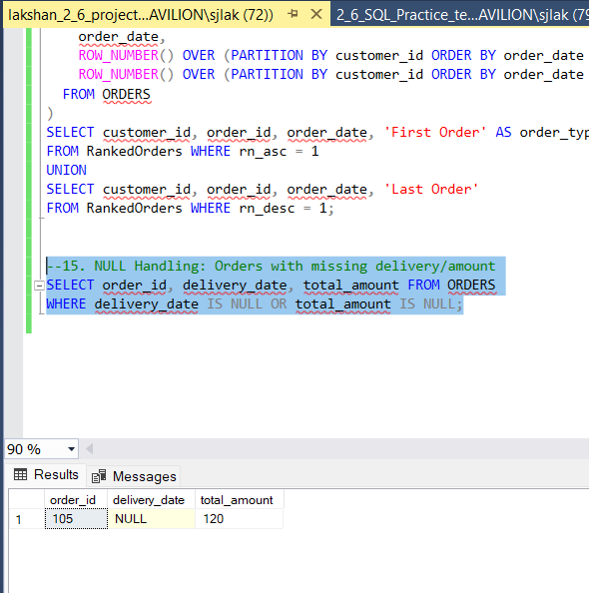

Day 3 (03-06-2025)

[Data Warehousing](https://www.analyticsvidhya.com/blog/2022/06/what-are-schemas-in-data-warehouse-modeling/)

What is Business Intelligence?

**Business Intelligence (BI)** is a **technology-driven process** that collects, integrates, analyzes, and presents **business data** to help organizations **make informed decisions**.

It turns **raw data** into **meaningful insights** using tools like dashboards, reports, visualizations, and analytics.

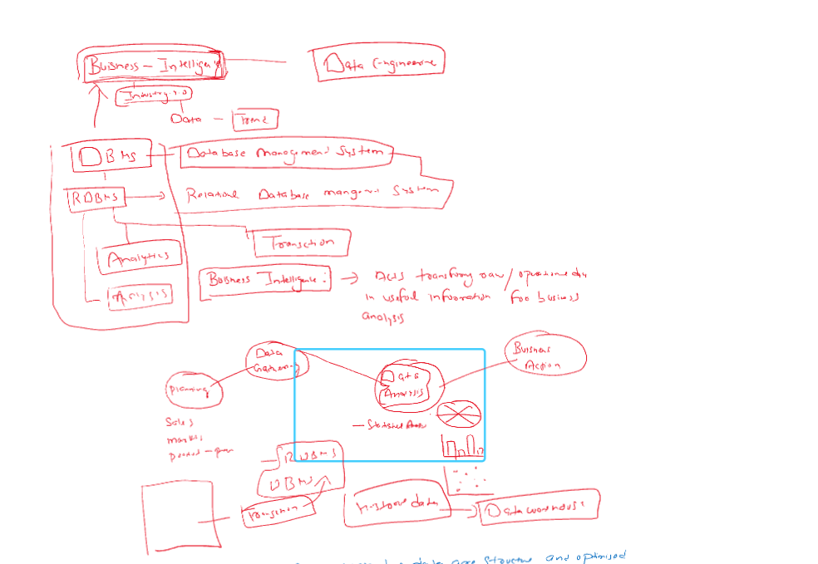

What is Database?

A **database** is an organized collection of data that is stored and accessed electronically. It allows users to create, read, update, and delete (CRUD) data efficiently.

* **Examples**: MySQL, Oracle, PostgreSQL, MongoDB

What is RDBMS?

Abbreviation - Relational Database Management System

An **RDBMS** is a DBMS based on the **relational model**, where data is stored in **tables** with relationships between them.

* **Examples**: MySQL, Oracle, SQL Server, PostgreSQL

What is Data Warehousing?

A **data warehouse** is a centralized system used for storing large volumes of historical data from multiple sources, primarily for **analytics and reporting**.

* **Purpose**: Optimized for reading, analysis, and business intelligence (not frequent updates).
* **Examples**: Amazon Redshift, Snowflake, Google BigQuery
* **Related Terms**:
  + **ETL (Extract, Transform, Load)**: Process of moving and preparing data for warehousing.
  + **OLAP (Online Analytical Processing)**: Multidimensional analysis of business data.
  + **Star Schema / Snowflake Schema**: Common designs for organizing data in warehouses.

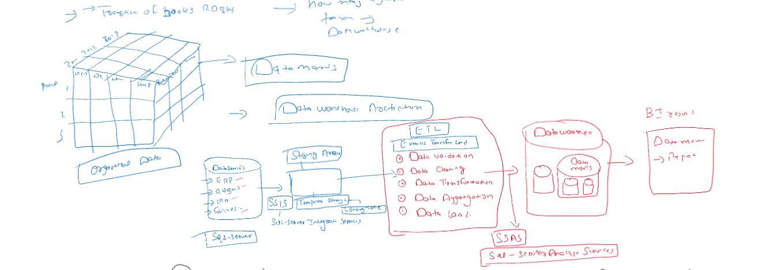

What is Datamart?

A **data mart** is a **subset** of a data warehouse, focused on a specific business area (like sales, finance, or HR).

* **Purpose**: Speeds up access for specific users or departments.
* **Example**: A sales data mart within a larger company-wide data warehouse.
* **Types**:
  + **Dependent Data Mart**: Extracted from an existing data warehouse.
  + **Independent Data Mart**: Created directly from operational systems.

What is Data Lake?

A **data lake** is a centralized repository that stores **raw, unstructured, semi-structured, and structured data** at any scale.

* **Examples**: AWS S3, Azure Data Lake, Hadoop HDFS
* **Purpose**: Allows storage of data without defining structure first (schema-on-read).
* **Related Terms**:
  + **Big Data**: Large and complex datasets that traditional databases can't handle efficiently.
  + **Schema-on-Read**: The data structure is applied when data is read, not when stored.
  + **Unstructured Data**: Data like images, logs, video, and text.

Difference between RDBMS and Data Warehousing:

| **Aspect** | **RDBMS (Relational Database Management System)** | **Data Warehouse** |
| --- | --- | --- |
| **Primary Purpose** | Handles **day-to-day operations (OLTP)** | Handles **analytical queries & reporting (OLAP)** |
| **Data Type** | **Current, transactional data** | **Historical, aggregated data** |
| **Data Format** | **Normalized** tables for efficiency and integrity | **Denormalized** for faster querying and reporting |
| **Use Case** | CRUD operations for applications (insert, update, delete) | Complex queries for business insights |
| **Query Type** | **Simple, fast transactions** | **Complex queries and aggregations** |
| **Users** | Application developers, operational staff | Business analysts, data scientists, management |
| **Read/Write Ratio** | **Balanced read/write** operations | **High read**, low write (write-once, read-many) |
| **Latency** | Low latency, real-time access | Higher latency, not designed for real-time |
| **Data Volume** | Handles **smaller datasets** (GB to TB) | Handles **very large datasets** (TB to PB) |
| **Storage Type** | Row-based storage | Columnar or hybrid storage models |
| **Schema Type** | **Schema-on-write** (predefined schema) | **Schema-on-write** (but supports star/snowflake schemas) |
| **Data Sources** | Typically one application | Multiple heterogeneous sources (ERP, CRM, logs, etc.) |
| **Examples** | MySQL, PostgreSQL, Oracle, SQL Server | Amazon Redshift, Google BigQuery, Snowflake, Teradata |
| **Performance Optimization** | Optimized for fast **transactional processing** | Optimized for fast **read-intensive analytical queries** |
| **Backup/Restore** | Frequent, due to data changes | Periodic backups (data is mostly read-only) |
| **Indexing** | Highly indexed for quick transaction lookups | Indexed selectively for analytical efficiency |
| **Data Integrity** | Strong integrity constraints (PK, FK, ACID) | Integrity maintained during ETL, but less rigid |
| **Scalability** | Vertical scaling (limited horizontal) | Designed for **horizontal scaling** (distributed systems) |
| **Data History** | Usually does **not** maintain history | Maintains **historical snapshots** and audit trails |
| **ETL (Extract, Transform, Load)** | Rarely used inside an RDBMS itself | Central to data warehouse architecture |
| **Real-Time Use** | Yes, supports real-time transactions | Not ideal for real-time (used for periodic loads) |
| **Examples of Queries** | “Update customer address”, “Insert order” | “What were the monthly sales trends in 2023?” |
| **Data Redundancy** | Avoided using normalization | Allowed/used intentionally for query speed |
| **Data Modeling** | ER Modeling (Entity-Relationship) | Dimensional modeling (Star, Snowflake schema) |

**Types of Data Warehouses**

The different [types of Data Warehouses](https://www.geeksforgeeks.org/types-of-data-warehouses/)are:

1. **Enterprise Data Warehouse (EDW)**: A centralized warehouse that stores data from across the organization for analysis and reporting.
2. **Operational Data Store (ODS)**: Stores real-time operational data used for day-to-day operations, not for deep analytics.
3. **Data Mart**: A [subset](https://www.geeksforgeeks.org/data-marts-storage-component-of-hdfs/) of a data warehouse, focusing on a specific business area or department.
4. **Cloud Data Warehouse**: A data warehouse hosted in the cloud, offering scalability and flexibility.
5. **Big Data Warehouse**: Designed to store vast amounts of unstructured and structured data for big data analysis.
6. **Virtual Data Warehouse**: Provides access to data from multiple sources without physically storing it.
7. **Hybrid Data Warehouse**: Combines on-premises and cloud-based storage to offer flexibility.
8. **Real-time Data Warehouse**: Designed to handle real-time data streaming and analysis for immediate insights.

Date warehouse Architecture:

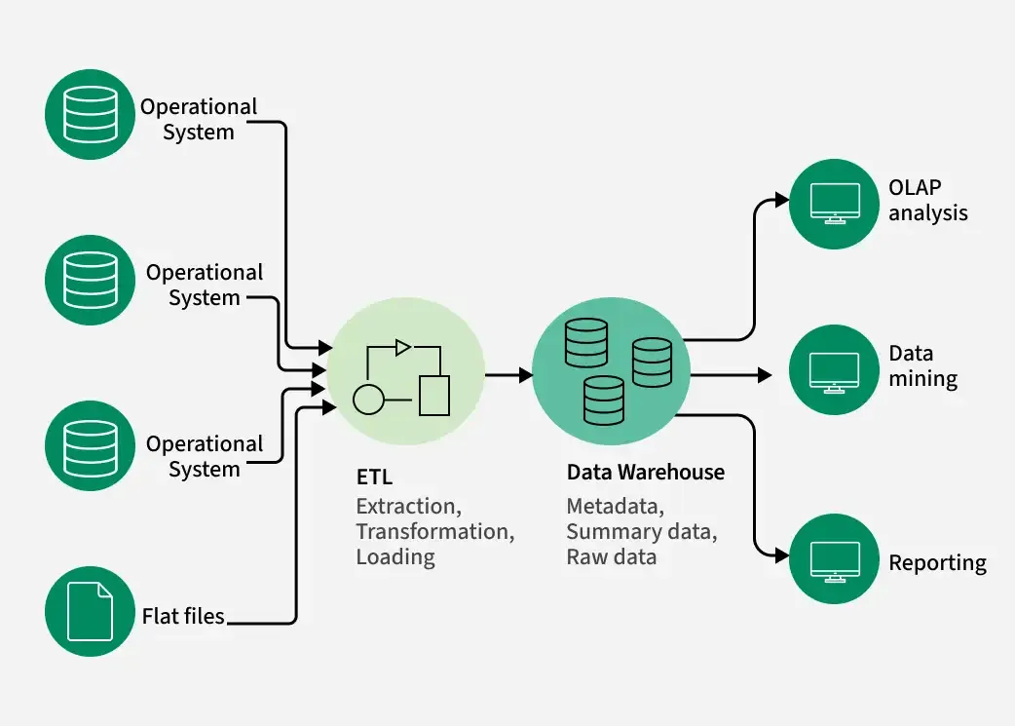

RDBMS architecture:

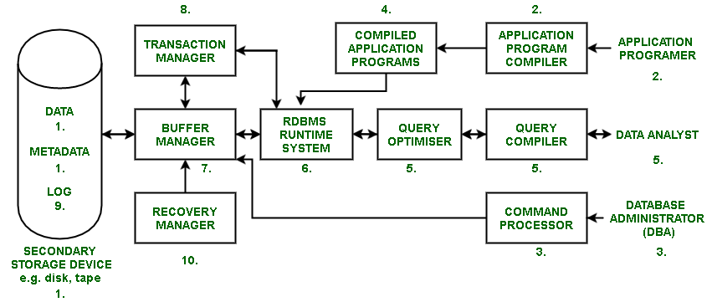

What is Data Mart?

A **data mart** is a subject-oriented database that contains a **focused portion of the data warehouse**, designed to meet the specific requirements of a **particular department or business unit**.

Difference between Datamart and data warehouse:

| **Feature** | **Data Mart** | **Data Warehouse** |
| --- | --- | --- |
| **Scope** | Department-specific | Enterprise-wide |
| **Data Volume** | Smaller | Large |
| **Complexity** | Less complex | More complex |
| **Implementation** | Faster and cheaper | Requires more resources and planning |
| **Users** | Business users of a specific department | Company-wide data consumers |
| **Maintenance** | Easier to manage | More complex and centralized |

Types of Datamart:

| **Type** | **Description** |
| --- | --- |
| **Dependent** | Created by extracting data from a central **data warehouse**. Fully consistent with enterprise data. |
| **Independent** | Built **directly from operational systems**, without a data warehouse. Used in small organizations. |
| **Hybrid** | Combines features of both dependent and independent data marts. |

**Dependent Data Mart -**

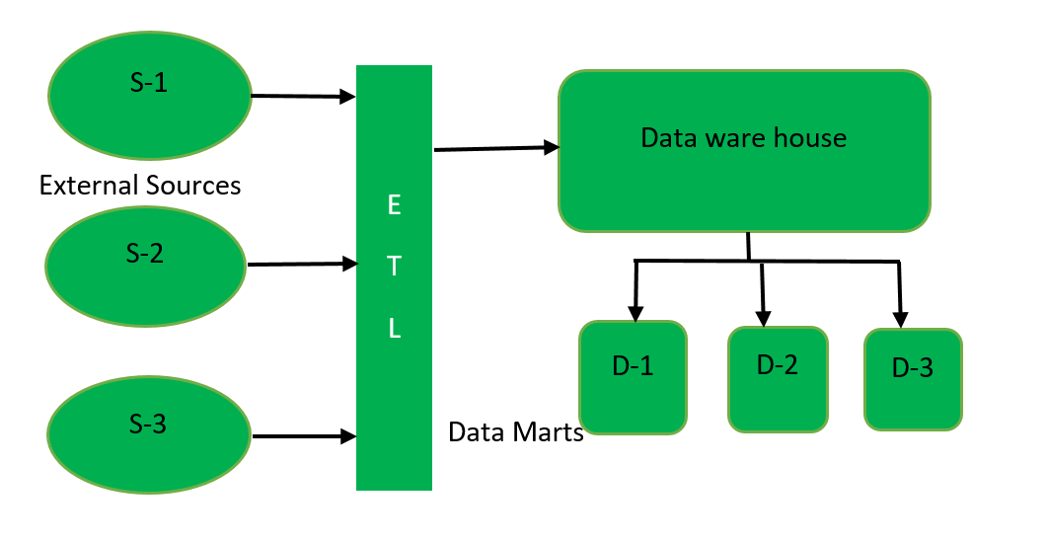

**2. Independent Data Mart -**

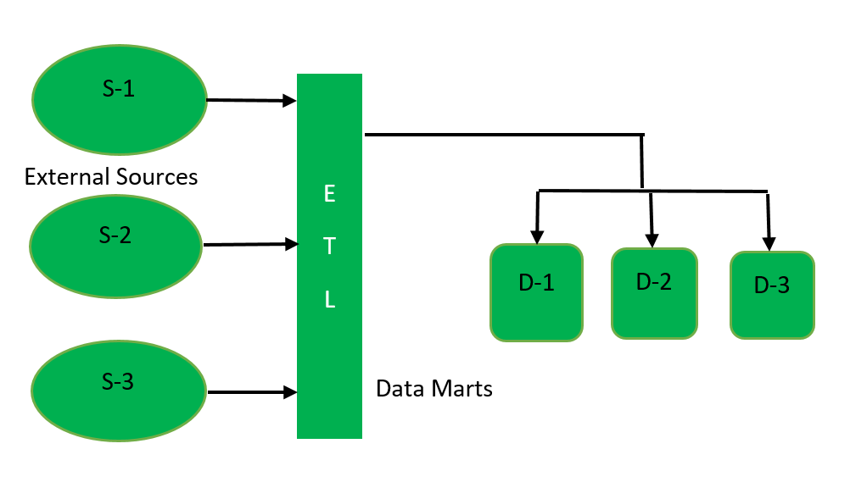

**3. Hybrid Data Mart -**

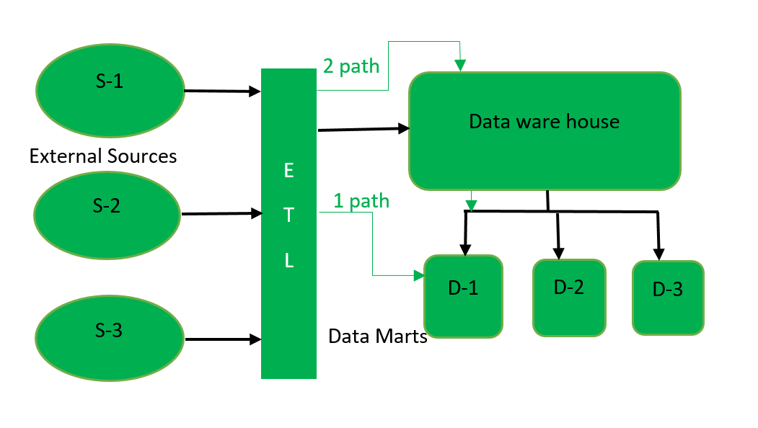

What is OLAP?

Abbreviation - Online Analytical Processing

It is a category of technologies that enables users to **interactively analyze multidimensional data** from multiple perspectives, typically for **business intelligence (BI)**, **reporting**, and **decision-making**.

Key Features:

| **Feature** | **Description** |
| --- | --- |
| **Multidimensional View** | Data is structured into **dimensions** and **measures** (e.g., sales by region, time, product) |
| **High-Speed Querying** | Optimized for **fast read-only access** on large volumes of data |
| **Complex Calculations** | Supports aggregations (SUM, AVG), trend analysis, rankings, etc. |
| **Drill-Down/Up** | Navigate data hierarchies (e.g., year → quarter → month) |
| **Slice & Dice** | Select and filter data along any dimension |
| **Pivoting** | Rearranging dimensions for different views |

Important Terms in OLAP:

| **Term** | **Explanation** |
| --- | --- |
| **Cube** | A multidimensional data structure used in OLAP |
| **Measure** | Numeric data values (e.g., sales amount, profit) |
| **Dimension** | Categories by which data is grouped (e.g., time, product, location) |
| **Hierarchy** | Levels within dimensions (e.g., Year → Quarter → Month → Day) |
| **Drill-down** | Going from summary to detailed data |
| **Roll-up** | Aggregating data up to a higher level |
| **Slice** | Filtering a cube by a single dimension value (e.g., all sales in 2023) |
| **Dice** | Filtering the cube on multiple dimension values (e.g., sales in Q1 2023 for Product A in Europe) |

Types of OLAP:

| **Type** | **Description** | **Storage** | **Performance** |
| --- | --- | --- | --- |
| **MOLAP** (Multidimensional OLAP) | Uses **precomputed cubes** stored in multidimensional databases | Fastest for fixed queries | Very high |
| **ROLAP** (Relational OLAP) | Uses **relational databases** with SQL for analysis | No pre-aggregation | Slower |
| **HOLAP** (Hybrid OLAP) | Combines both MOLAP and ROLAP approaches | Mixed | Balanced |

**Benefits of OLAP:**

* Fast performance for large datasets
* Multidimensional analysis
* Better support for business decision-making
* Easy to explore and visualize data

How does OLAP work?

An online analytical processing (OLAP) system works by collecting, organizing, aggregating, and analyzing data using the following steps:

1. The OLAP server collects data from multiple data sources, including relational databases and data warehouses.
2. Then, the extract, transform, and load (ETL) tools clean, aggregate, precalculate, and store data in an OLAP cube according to the number of dimensions specified.
3. Business analysts use OLAP tools to query and generate reports from the multidimensional data in the OLAP cube.

OLAP uses Multidimensional Expressions (MDX) to query the OLAP cube. MDX is a query, like SQL, that provides a set of instructions for manipulating databases.

OLAP Storage Approaches:

| **Type** | **Data Storage** | **Speed** | **Flexibility** | **Example Use Case** |
| --- | --- | --- | --- | --- |
| **MOLAP** | Multidimensional cubes | Very Fast | Less flexible | Financial dashboards |
| **ROLAP** | Relational DB | Slower | Highly flexible | Dynamic ad-hoc analysis |
| **HOLAP** | Mixed | Balanced | Balanced | Scalable enterprise reporting |

OLAP Architecture:

┌──────────────────────────────┐

│ 1. Front-End Tools │ ← User Interface Layer

│ (BI Tools: Tableau, Power BI)│

└─────────────▲────────────────┘

│

┌─────────────┴──────────────┐

│ 2. OLAP Server (Engine) │ ← Analytical Processing Layer

│(MOLAP / ROLAP / HOLAP engine)│

└─────────────▲──────────────┘

│

┌─────────────┴──────────────┐

│ 3. Data Warehouse / DBMS │ ← Data Storage Layer

│(Star/Snowflake Schema) │

└────────────────────────────┘

**Relational OLAP (ROLAP):**

Relational On-Line Analytical Processing (ROLAP) is primarily used for data stored in a relational database, where both the base data and dimension tables are stored as relational tables. ROLAP servers are used to bridge the gap between the relational back-end server and the client's front-end tools. ROLAP servers store and manage warehouse data using RDBMS, and OLAP middleware fills in the gaps.

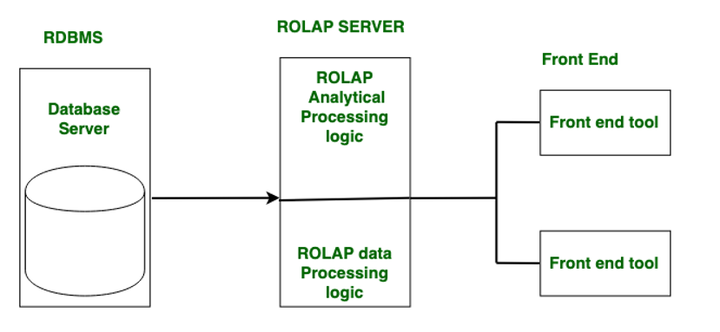

**Multidimensional OLAP (MOLAP):**

**MOLAP (Multidimensional OLAP)** stores data in **pre-aggregated multidimensional cubes**, allowing for **very fast querying**, especially for **fixed, structured analysis**. It offers **high performance** but less flexibility and scalability compared to other OLAP types.

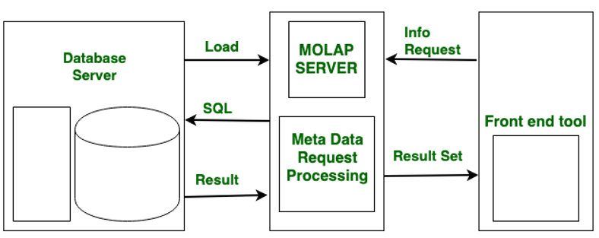

**Hybrid OLAP (HOLAP):**

ROLAP and MOLAP are combined in Hybrid On-Line Analytical Processing (HOLAP). HOLAP offers greater scalability than ROLAP and faster computation than MOLAP.HOLAP is a hybrid of ROLAP and MOLAP. HOLAP servers are capable of storing large amounts of detailed data. On the one hand, HOLAP benefits from ROLAP's greater scalability. HOLAP, on the other hand, makes use of cube technology for faster performance and summary-type information. Because detailed data is stored in a relational database, cubes are smaller than MOLAP.

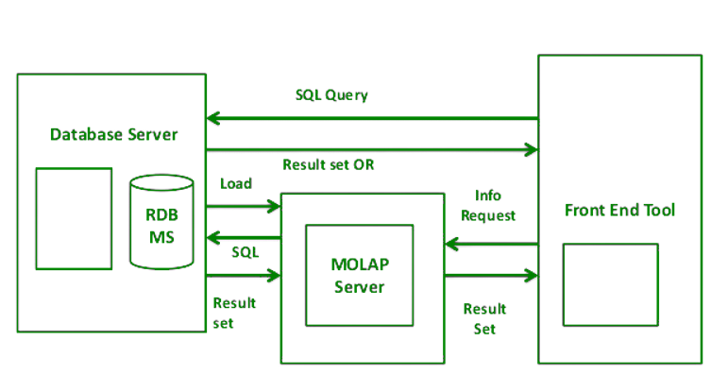

**Facts and Dimensions in Data Warehousing**

In a data warehouse, **facts and dimensions** are the core components used to organize data into a **multidimensional model** (like OLAP cubes). This structure supports efficient analysis and reporting.

Fact Table

A **Fact Table** stores **quantitative, measurable data** (facts) related to business processes — such as **sales amount, revenue, units sold**, etc.

**Characteristics:**

* Contains **numeric values** (measures)
* **Foreign keys** referencing dimension tables
* Typically **large in size**
* **Additive or semi-additive**

Dimension Table

A **Dimension Table** contains **descriptive attributes** (context) related to the facts — such as **product name, category, region, customer name**, etc.

**Characteristics:**

* Used to **filter, group, label** facts
* Typically **textual or categorical**
* **Smaller** in size than fact tables
* Contains **hierarchies** (e.g., Year → Quarter → Month)

Difference Between Facts and Dimensions:

| **Component** | **Fact Table** | **Dimension Table** |
| --- | --- | --- |
| Contains | Measures / Metrics | Descriptive Attributes |
| Type of Data | Quantitative | Qualitative / Categorical |
| Size | Large | Smaller |
| Keys | Foreign keys to dimensions | Primary keys used in fact table |
| Examples | Sales amount, Profit, Quantity sold | Product name, Date, Region, Customer name |
| Usage | Aggregation, Calculations | Filtering, Grouping, Labeling |

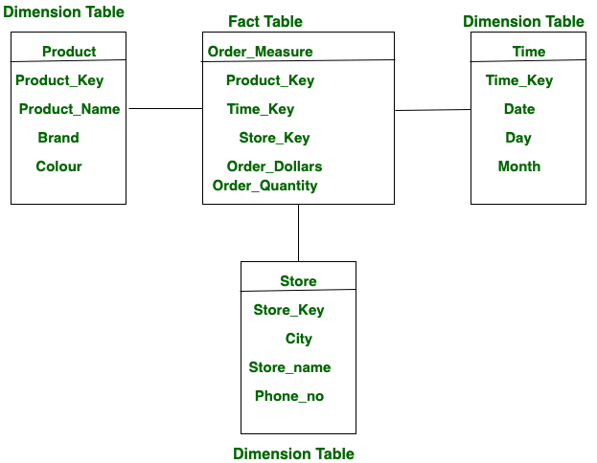

**Schema in Data Warehousing:**

In data warehousing, a **schema** defines the **structure and organization** of data — how fact and dimension tables are arranged and how they relate to each other. It’s essentially the **blueprint** for designing a data warehouse.

Three Types of Schemas are there in Data warehousing:

* Star Schema
* Snowflakes Schema
* Fact Constellation Schema (Galaxy Schema)

Star Schema:

* Each dimension in a star schema is represented with only one-dimension table.
* This dimension table contains the set of attributes.
* The following diagram shows the sales data of a company with respect to the four dimensions, namely time, item, branch, and location.

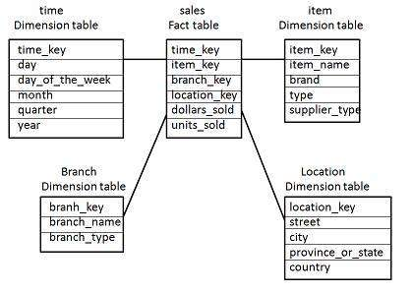

* There is a fact table at the center. It contains the keys to each of four dimensions.
* The fact table also contains the attributes, namely dollars sold and units sold.

Snowflake Schema

* Some dimension tables in the Snowflake schema are normalized.
* The normalization splits up the data into additional tables.
* Unlike Star schema, the dimensions table in a snowflake schema are normalized. For example, the item dimension table in star schema is normalized and split into two dimension tables, namely item and supplier table.

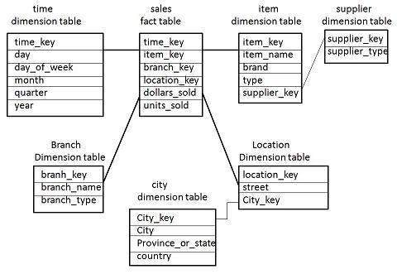

* Now the item dimension table contains the attributes item_key, item_name, type, brand, and supplier-key.
* The supplier key is linked to the supplier dimension table. The supplier dimension table contains the attributes supplier_key and supplier_type.

Fact Constellation Schema

* A fact constellation has multiple fact tables. It is also known as galaxy schema.
* The following diagram shows two fact tables, namely sales and shipping.

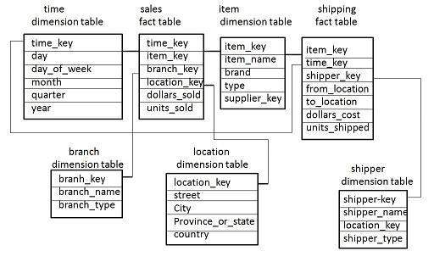

* The sales fact table is same as that in the star schema.
* The shipping fact table has the five dimensions, namely item_key, time_key, shipper_key, from_location, to_location.
* The shipping fact table also contains two measures, namely dollars sold and units sold.
* It is also possible to share dimension tables between fact tables. For example, time, item, and location dimension tables are shared between the sales and shipping fact table.

**MONGODB**

* Mongo db is nosql document database
* stores data in json like documents (internal uses BSON)
* Flexible schema, ideal for changing data

How to choose database?

Databases can be chosen according to the requirement,

| **Feature** | **SQL (Relational DB)** | **NoSQL (Non-Relational DB)** |
| --- | --- | --- |
| **Data Structure** | Tables (rows & columns) | Documents, Key-Value, Graph, or Column-based |
| **Schema** | Fixed schema (predefined structure) | Dynamic or flexible schema |
| **Scalability** | Vertical (scale-up: bigger machine) | Horizontal (scale-out: more machines) |
| **Transactions** | ACID-compliant (reliable, strong consistency) | Often BASE (eventual consistency) |
| **Query Language** | Structured Query Language (SQL) | Various: MongoDB uses JSON-like query syntax |
| **Best Use Cases** | Complex queries, transactions, joins | Big data, real-time apps, flexible data |
| **Examples** | MySQL, PostgreSQL, SQLite, SQL Server, Oracle | MongoDB, Cassandra, Redis, DynamoDB, CouchDB |

**Model Coding Challenge (9-6-25)**

**MongoDB**

Creating Database Students,

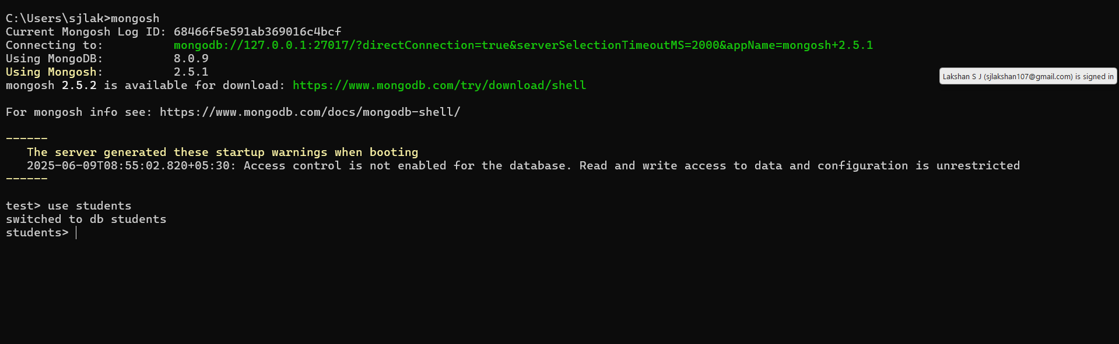

The `students` collection includes:

{

"name": "Amit Kumar",

"age": 17,

"gender": "Male",

"grade": "11th",

"subjects": ["Math", "Physics", "English"],

"marks": { "Math": 82, "Physics": 91, "English": 75 },

"address": {

"city": "Delhi",

"pincode": "110001"

}

}

Q1. Insert 5 student records

db.students.insertMany([

{

name: "Amit Kumar",

age: 17,

gender: "Male",

grade: "11th",

subjects: ["Math", "Physics", "English"],

marks: { Math: 82, Physics: 91, English: 75 },

address: { city: "Delhi", pincode: "110001" }

},

{

name: "Sneha Verma",

age: 16,

gender: "Female",

grade: "10th",

subjects: ["Biology", "Chemistry", "English"],

marks: { Biology: 78, Chemistry: 88, English: 92 },

address: { city: "Mumbai", pincode: "400001" }

},

{

name: "Rahul Singh",

age: 18,

gender: "Male",

grade: "12th",

subjects: ["Math", "Computer", "Physics"],

marks: { Math: 95, Computer: 89, Physics: 93 },

address: { city: "Delhi", pincode: "110002" }

},

{

name: "Anjali Mehra",

age: 17,

gender: "Female",

grade: "11th",

subjects: ["Math", "English", "History"],

marks: { Math: 39, English: 42, History: 78 },

address: { city: "Bangalore", pincode: "560001" }

},

{

name: "Karan Patel",

age: 15,

gender: "Male",

grade: "9th",

subjects: ["Science", "English", "Math"],

marks: { Science: 65, English: 38, Math: 41 },

address: { city: "Ahmedabad", pincode: "380001" }

}

])

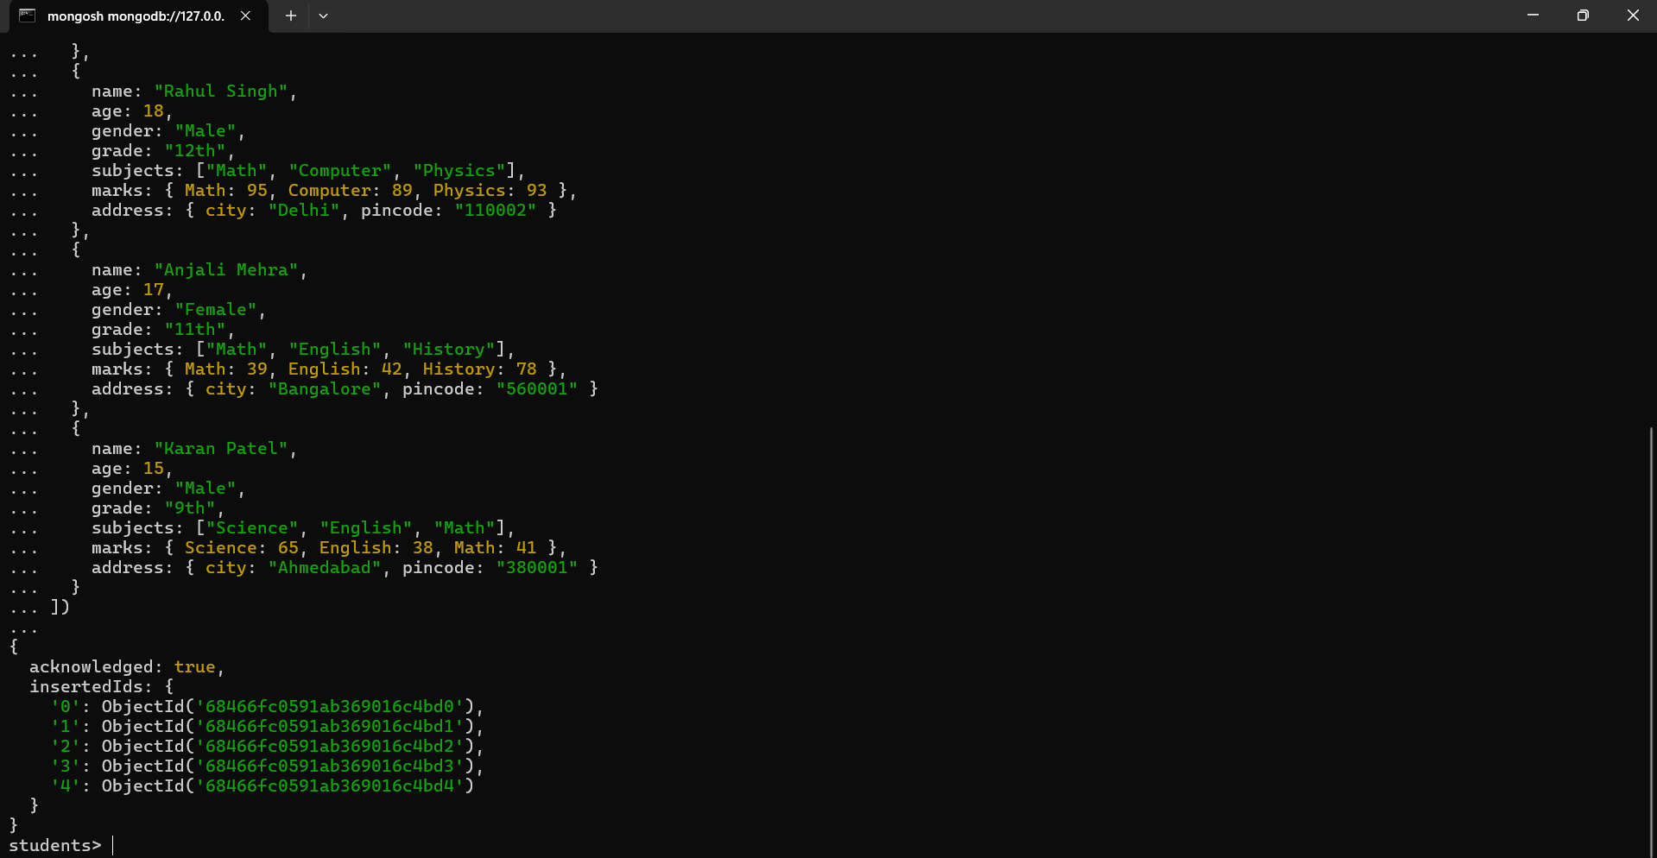

Q2. Find all students who take “Math” as a subject

db.students.find(

{ subjects: "Math" },

{ _id: 0, name: 1, grade: 1, subjects: 1 }

)

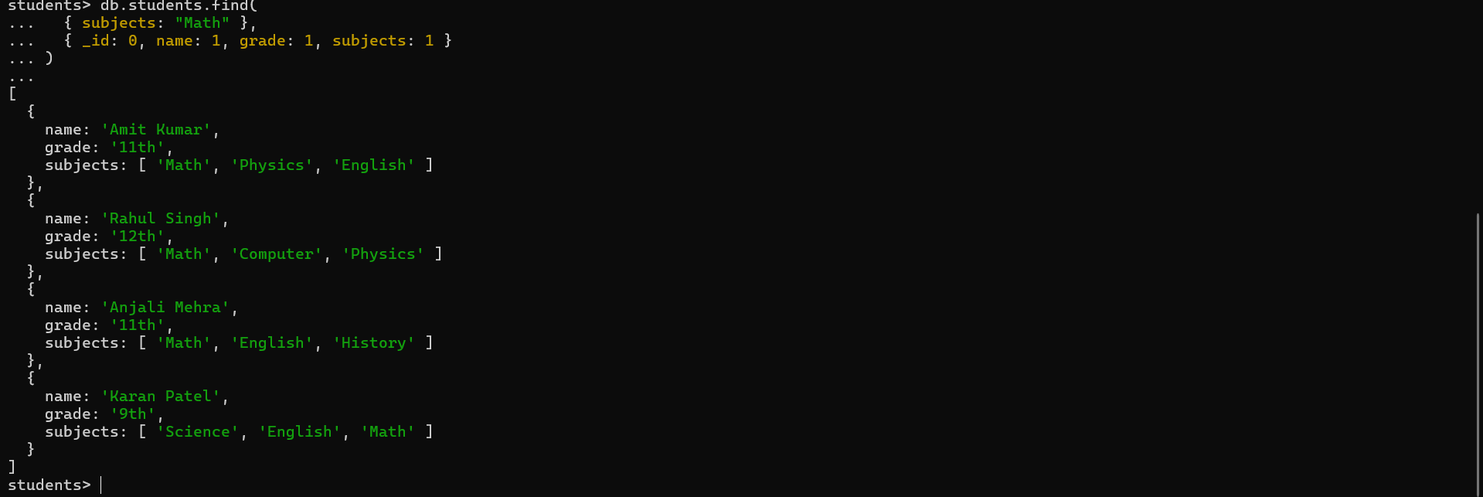

Q3. Find students from city "Delhi" scoring more than 85 in Physics

db.students.find(

{

"address.city": "Delhi",

"marks.Physics": { $gt: 85 }

},

{

_id: 0,

name: 1,

marks: 1,

"address.city": 1

}

)

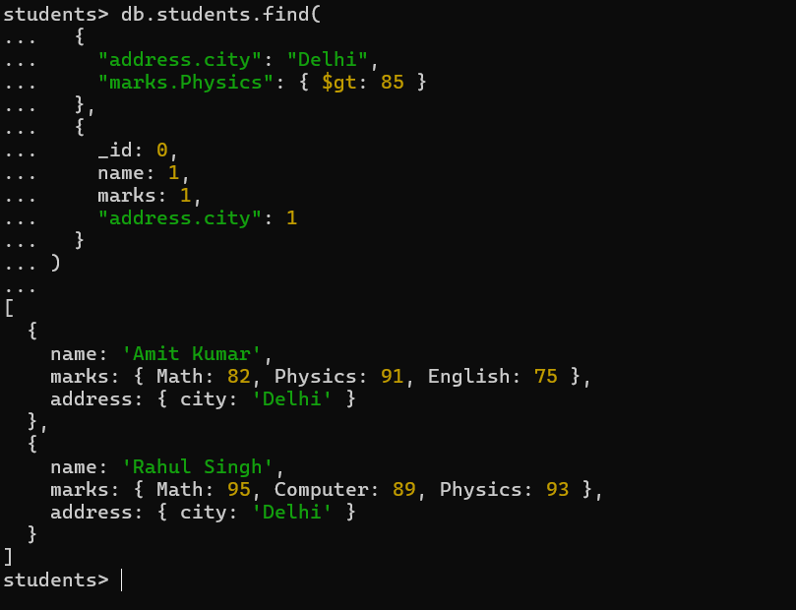

Q4. Sort all students by English marks (descending) and show top 3

db.students.find(

{ "marks.English": { $exists: true } },

{ _id: 0, name: 1, subjects: 1, marks: 1 }

).sort({ "marks.English": -1 }).limit(3)

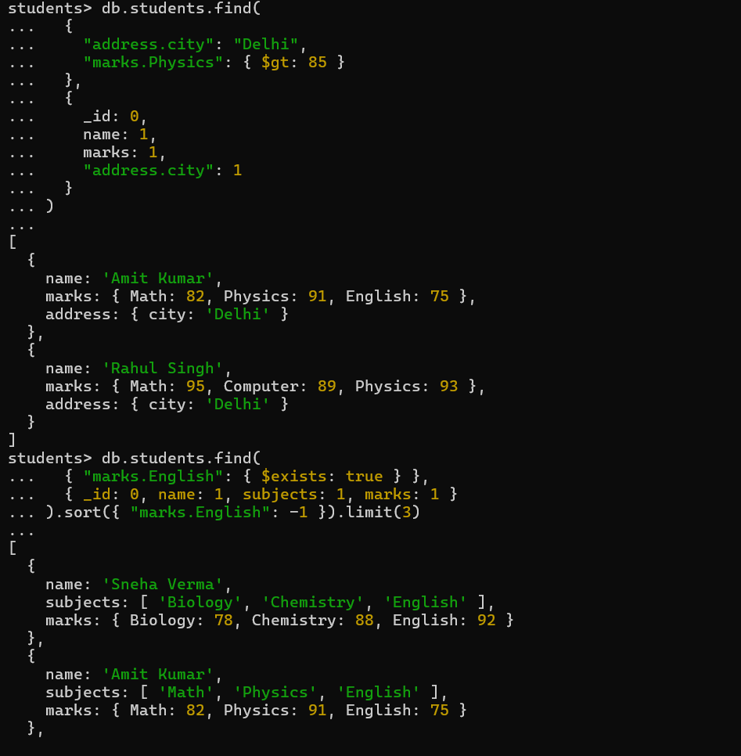

Q5. Group students by city and count how many are from each

db.students.aggregate([

{

$group: {

_id: "$address.city",

total_students: { $sum: 1 }

}

}

])

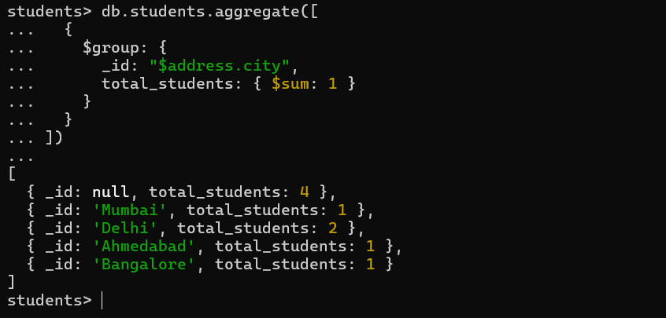

Q6. Update all students who scored less than 40 in any subject

db.students.updateMany(

{

$or: [

{ "marks.Math": { $lt: 40 } },

{ "marks.English": { $lt: 40 } },

{ "marks.Physics": { $lt: 40 } },

{ "marks.Computer": { $lt: 40 } },

{ "marks.Chemistry": { $lt: 40 } },

{ "marks.Biology": { $lt: 40 } },

{ "marks.Science": { $lt: 40 } },

{ "marks.History": { $lt: 40 } }

]

},

{ $set: { status: "Needs Improvement" } }

)

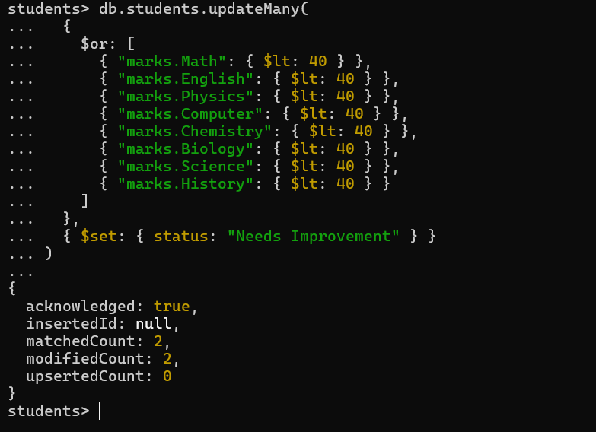

Q7. Calculate average marks of all students in each subject

db.students.aggregate([

{

$group: {

_id: null,

avgMath: { $avg: "$marks.Math" },

avgPhysics: { $avg: "$marks.Physics" },

avgEnglish: { $avg: "$marks.English" },

avgComputer: { $avg: "$marks.Computer" },

avgBiology: { $avg: "$marks.Biology" },

avgChemistry: { $avg: "$marks.Chemistry" },

avgScience: { $avg: "$marks.Science" },

avgHistory: { $avg: "$marks.History" }

}

}

])

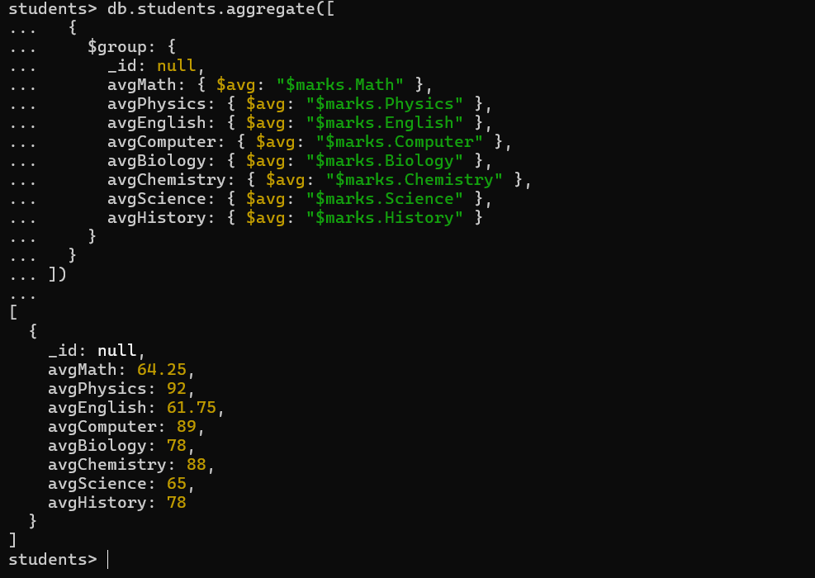

**Project – 2**

**Coding Challenge – 2 (09-06-2025)**

**Online Store Order Management - MongoDB**

Creating new database and named it as OnlineStore,

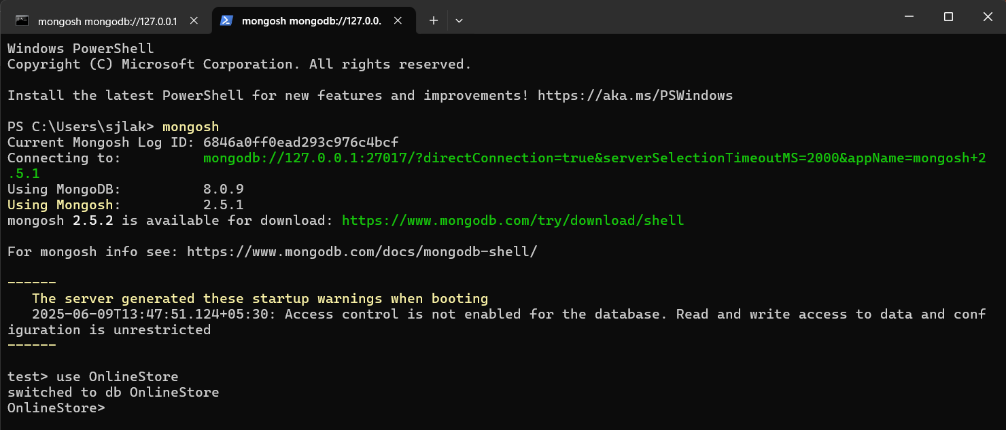

Q1. Insert 5 different orders

db.orders.insertMany([

{

order_id: "ORD1001",

order_date: "2024-06-01",

customer: { name: "Deepa Roy", email: "deepa@example.com", phone: "9876543210" },

shipping_address: { street: "123 Green Park", city: "Mumbai", state: "MH", pincode: "400001" },

items: [

{ product: "Wireless Mouse", price: 599, quantity: 2 },

{ product: "Keyboard", price: 899, quantity: 1 }

],

total_amount: 2097,

payment_status: "Paid",

delivery_status: "Delivered"

},

{

order_id: "ORD1002",

order_date: "2024-06-03",

customer: { name: "Arjun Mehta", email: "arjun@example.com", phone: "9998887777" },

shipping_address: { street: "45 Sector 9", city: "Delhi", state: "DL", pincode: "110001" },

items: [

{ product: "Laptop Bag", price: 1299, quantity: 1 }

],

total_amount: 1299,

payment_status: "Paid",

delivery_status: "Shipped"

},

{

order_id: "ORD1003",

order_date: "2024-06-04",

customer: { name: "Neha Sharma", email: "neha@example.com", phone: "8887776666" },

shipping_address: { street: "78 Hill View", city: "Chennai", state: "TN", pincode: "600001" },

items: [

{ product: "Monitor", price: 10999, quantity: 1 }

],

total_amount: 10999,

payment_status: "Pending",

delivery_status: "Not Shipped"

},

{

order_id: "ORD1004",

order_date: "2024-06-05",

customer: { name: "Suresh Babu", email: "suresh@example.com", phone: "7776665555" },

shipping_address: { street: "Plot 22", city: "Hyderabad", state: "TS", pincode: "500001" },

items: [

{ product: "Pen Drive", price: 399, quantity: 3 },

{ product: "Notebook", price: 99, quantity: 5 }

],

total_amount: 1392,

payment_status: "Paid",

delivery_status: "Processing"

},

{

order_id: "ORD1005",

order_date: "2024-06-06",

customer: { name: "Meena Das", email: "meena@example.com", phone: "6665554444" },

shipping_address: { street: "Lake Road", city: "Delhi", state: "DL", pincode: "110002" },

items: [

{ product: "Desk Lamp", price: 799, quantity: 1 },

{ product: "Chair", price: 2499, quantity: 1 },

{ product: "Table", price: 3499, quantity: 1 }

],

total_amount: 6797,

payment_status: "Paid",

delivery_status: "Delivered"

}

])

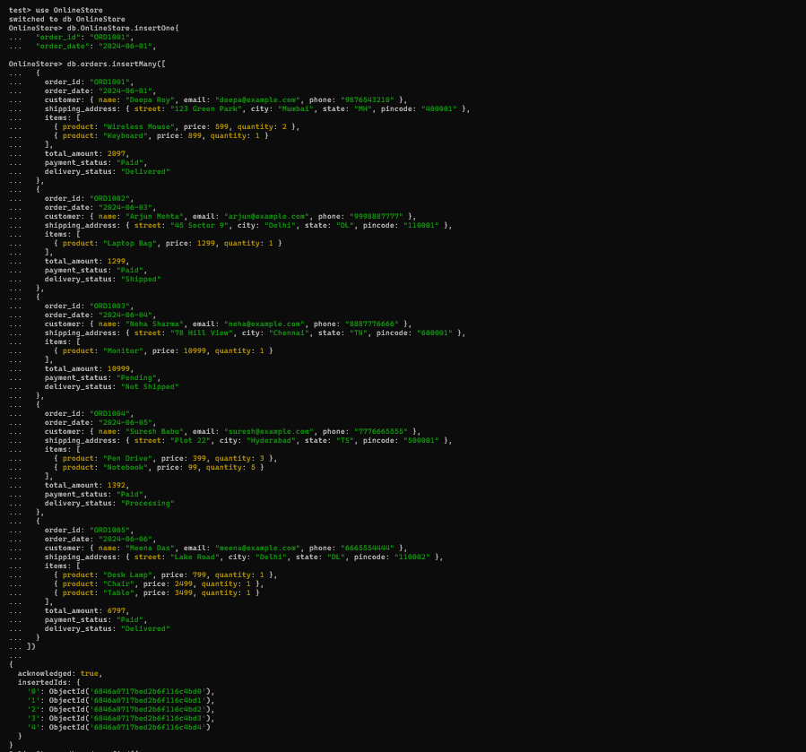

Q2. Find "Paid" but not "Delivered" orders

db.orders.find({

payment_status: "Paid",

delivery_status: { $ne: "Delivered" }

})

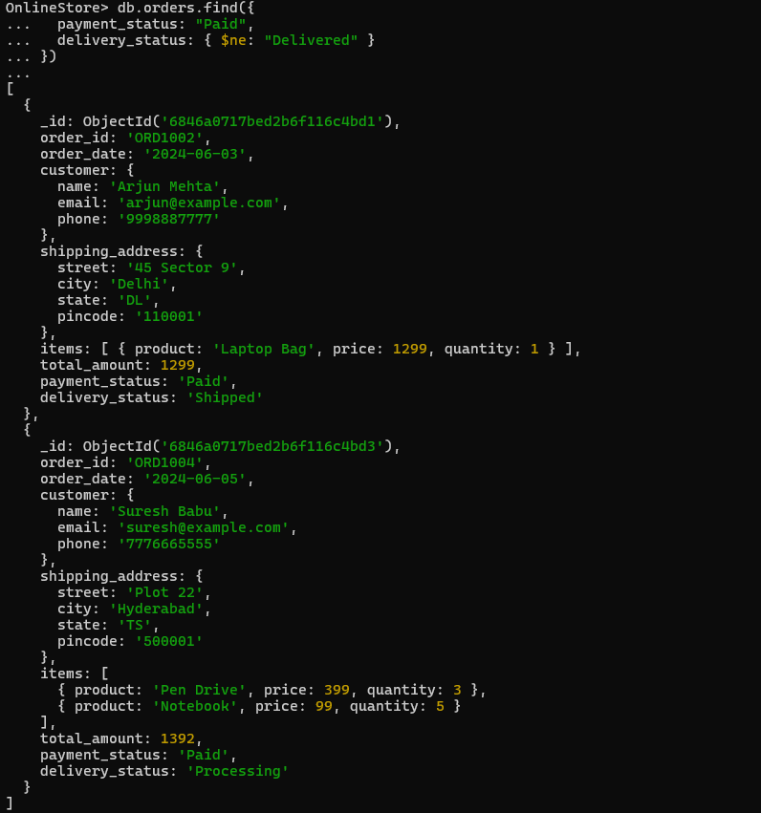

Q3. Orders with at least one product priced > 1000

db.orders.find({

"items.price": { $gt: 1000 }

})

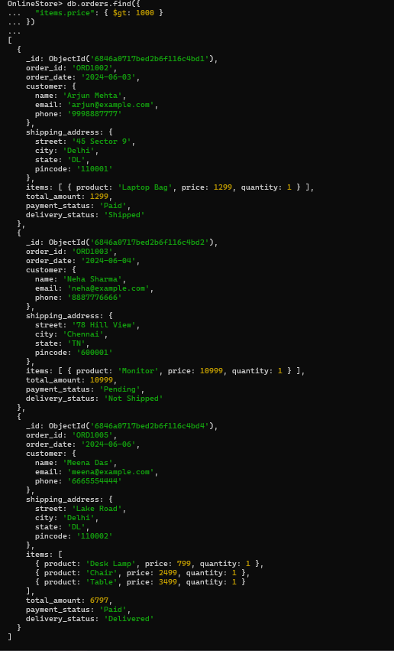

Q4. Orders shipped to Mumbai or Delhi, sorted by date

db.orders.find(

{ "shipping_address.city": { $in: ["Mumbai", "Delhi"] } },

{ _id: 0, order_id: 1, "shipping_address.city": 1, order_date: 1 }

).sort({ order_date: -1 })

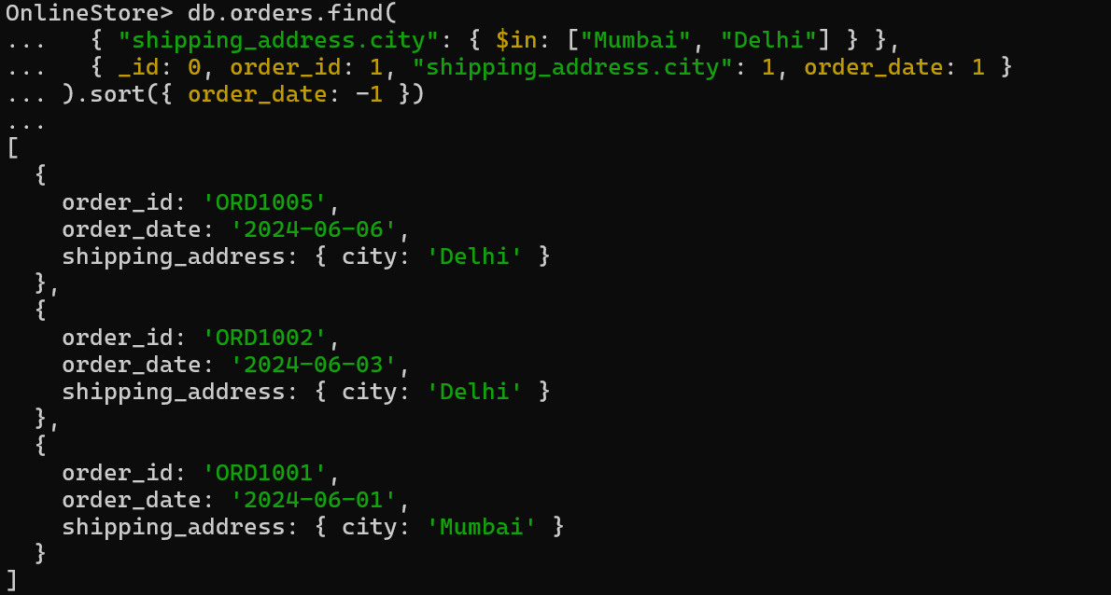

Q5. Group by payment_status

db.orders.aggregate([

{ $group: { _id: "$payment_status", count: { $sum: 1 } } }

])

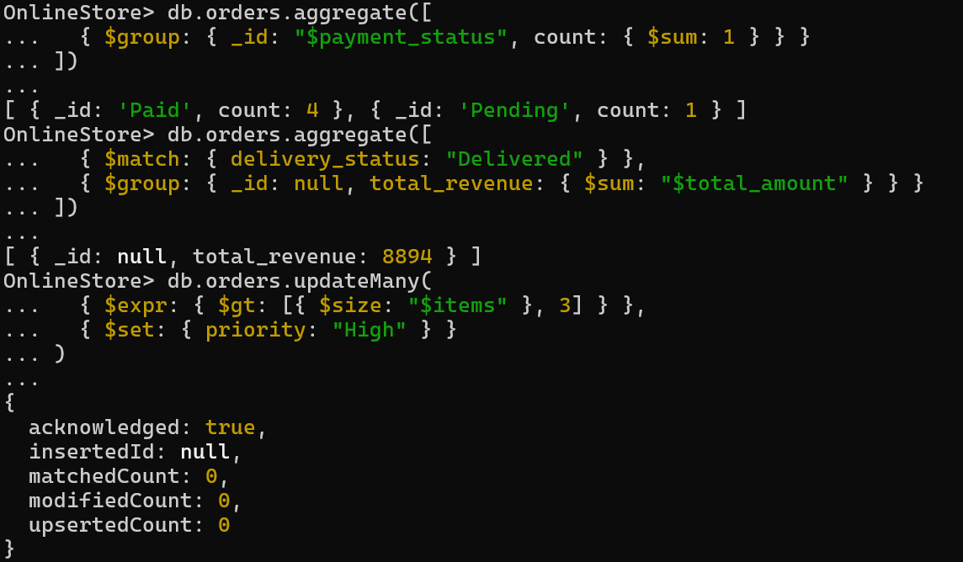

Q6. Total revenue from delivered orders

db.orders.aggregate([

{ $match: { delivery_status: "Delivered" } },

{ $group: { _id: null, total_revenue: { $sum: "$total_amount" } } }

])

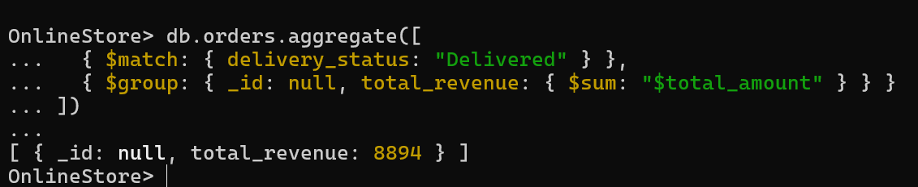

Q7. Add "priority: High" where items > 3

db.orders.updateMany(

{ $expr: { $gt: [{ $size: "$items" }, 3] } },

{ $set: { priority: "High" } }

)

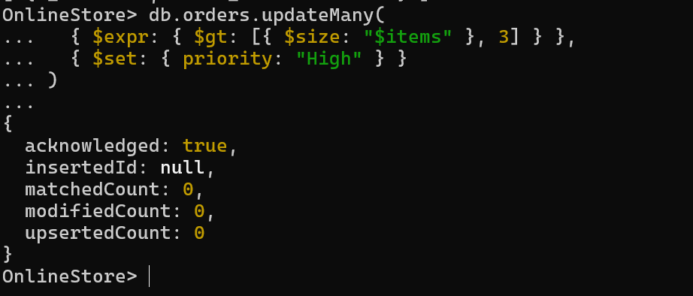

Q8. Count how many times each product was ordered

db.orders.aggregate([

{ $unwind: "$items" },

{ $group: {

_id: "$items.product",

total_quantity: { $sum: "$items.quantity" }

}}

])

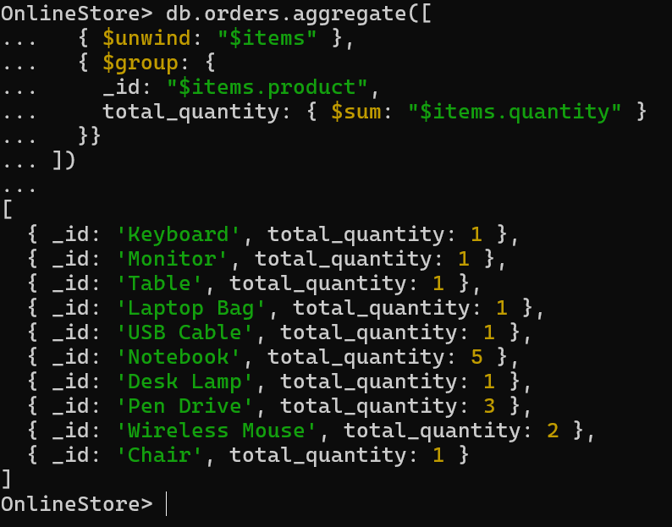

Q9. Add "USB Cable" to order_id "ORD1001"

db.orders.updateOne(

{ order_id: "ORD1001" },

{

$push: {

items: { product: "USB Cable", price: 199, quantity: 1 }

}

}

)

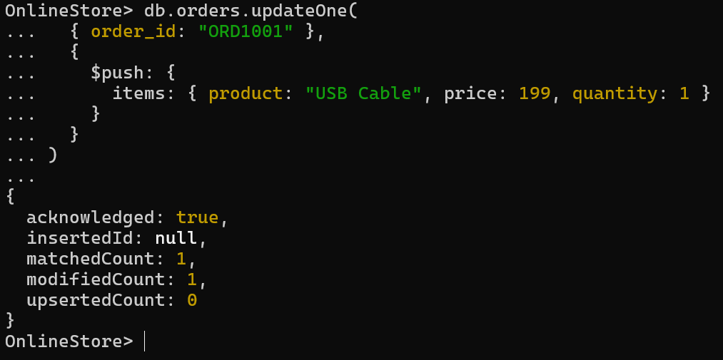

Q10. Rename "phone" to "mobile_number" in customer

db.orders.updateMany(

{},

{ $rename: { "customer.phone": "customer.mobile_number" } }

)

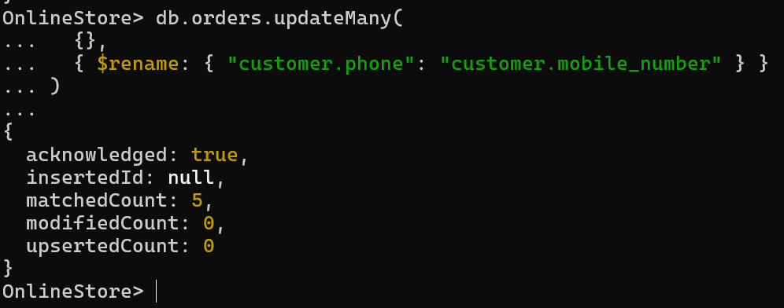

Q11. Create index on customer email

db.orders.createIndex({ "customer.email": 1 })



Q12. Export the data using `mongoexport` for reporting purposes.

mongoexport --db=OnlineStore --collection=orders --out=orders.json

--(for specific path)

mongoexport --db=OnlineStore --collection=orders --out=C:\Users\sjlak\Downloads\orders.json  
  
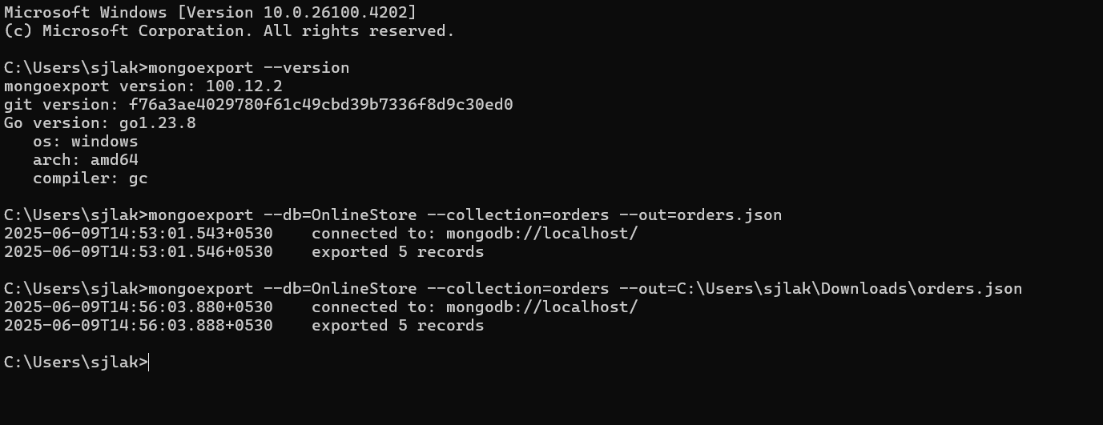

**Day 5 – (10-06-2025)**

**Python Refresher & Advanced Python for Data Engineering**

* **Core Python Refresher**

**Python Basics**

* **Features:** Easy syntax, interpreted, dynamic typing, huge libraries.
* **First Program:**
* print("Hello, Data Engineers!")
* **Variables & Data Types**
* name = "Laks" # String
* age = 21 # Integer
* score = 94.5 # Float
* passed = True # Boolean

**Control Structures**

for i in range(3):

print("Looping", i)

if score > 90:

print("Excellent!")

elif score >= 75:

print("Good job")

else:

print("Keep learning")

**Collections Overview**

| **Type** | **Example** |
| --- | --- |
| List | marks = [85, 78, 92] |
| Dictionary | {"name": "Sakshi", "score": 95} |
| Set | {1, 2, 3} |
| Tuple | ("Alice", [85, 78, 92]) |

**Functions & Lambda**

def greet(name="Friend"):

return f"Hello, {name}!"

add = lambda x, y: x + y

print(add(10, 5)) # Output: 15

**OOP in Python**

class Student:

def __init__(self, name, marks):

self.name = name

self.marks = marks

def average(self):

return sum(self.marks) / len(self.marks)

s = Student("Sakshi", [85, 90, 95])

print(s.average()) # Output: 90.0

**File Handling & Exception**

try:

with open("data.csv", "r") as f:

content = f.read()

except FileNotFoundError:

print("File not found!")

**Modules and Packages**

# mymodule.py

def add(a, b):

return a + b

# main.py

import mymodule

print(mymodule.add(2, 3)) # Output: 5

**Data Engineering Essentials**

**CSV / JSON Handling with Pandas**

import pandas as pd

df = pd.read_csv("students.csv")

print(df.head())

df.to_json("students.json")

**MySQL with Python**

import mysql.connector

conn = mysql.connector.connect(

host="localhost", user="root", password="1234", database="school"

)

cursor = conn.cursor()

cursor.execute("SELECT * FROM students")

for row in cursor.fetchall():

print(row)

**Data Cleaning with NumPy & Pandas**

import numpy as np

import pandas as pd

arr = np.array([[1, np.nan, 3], [4, 5, np.nan]])

df = pd.DataFrame(arr)

df.fillna(0, inplace=True)

**Task 1 – Students Marks Management System**

students = [

("lakshan",[88,89,90]),

("haley",[89,88,90]),

("harish",[90,91,85])

]

print("Average Marks of Each Student: ")

topper_name = ""

highest_avg = 0

for name, marks in students:

avg = sum(marks)/len(marks)

print(f"{name} - Average: {avg:.2f}")

if avg > highest_avg:

highest_avg = avg

topper_name = name

print("\nTopper:",topper_name)

students.append(("Rock", [80,89,95]))

for i in range(len(students)):

if students[i][0] == "Jennifer":

students[i][1][1] = 89

break

print("\n Updated Student's List: ")

for name, marks in students:

print(f"{name}: {marks}")

student_stats = []

for name, marks in students:

total = sum(marks)

avg = total/len(marks)

student_stats.append((name, total, round(avg, 2)))

student_stats.sort(key=lambda x: x[2], reverse=True)

print("\n Students sorted by Average Marks: ")

for name, total, avg in student_stats:

print(f"{name} - Total: {total}, Average: {avg}")

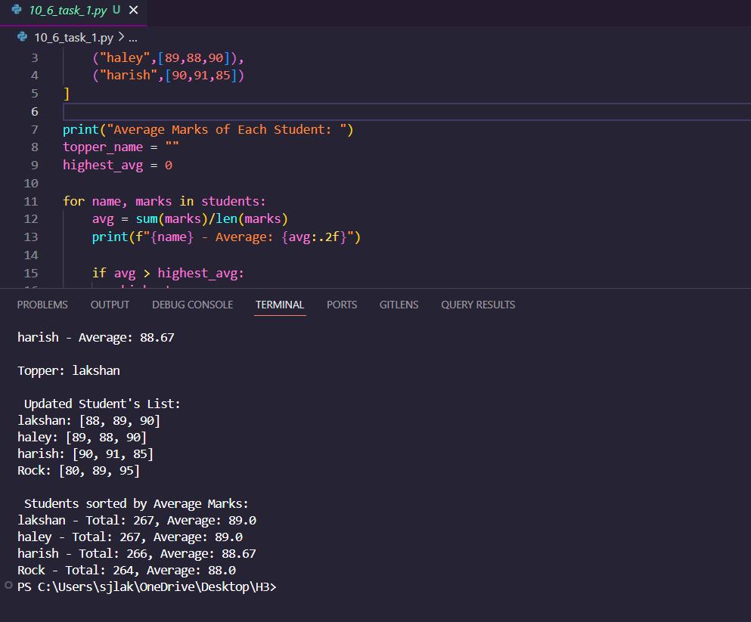

**Task 2 – Smart City Project**

import numpy as np

temps = np.array([

[28, 30, 29, 31, 32, 33, 34],

[35, 34, 36, 37, 38, 36, 35],

[22, 23, 24, 25, 26, 27, 28],

[31, 30, 29, 28, 27, 26, 25],

[39, 38, 40, 41, 42, 40, 39]

])

days = ["Mon", "Tue", "Wed", "Thu", "Fri", "Sat", "Sun"]

#1. Function: Average temperature of a city for the week

def average_temperature(city_index):

return np.mean(temps[city_index])

# 2. Function: Hottest day index for a city

def hottest_day(city_index):

return np.argmax(temps[city_index])

# 3. Loop through all cities and print average temperature and hottest day

print("City-wise Average Temperature and Hottest Day:")

for i in range(5):

avg_temp = average_temperature(i)

hot_day_index = hottest_day(i)

hot_day_name = days[hot_day_index]

print(f"City {i+1}: Avg Temp = {avg_temp:.2f}°C, Hottest Day = {hot_day_name} (Index: {hot_day_index})")

print()

#4. Function: Day-wise average temperature across all cities

def day_wise_avg():

return np.mean(temps, axis=0)

# Print day-wise average

day_avg = day_wise_avg()

print("Day-wise Average Temperatures Across All Cities:")

for i in range(7):

print(f"{days[i]}: {day_avg[i]:.2f}°C")

print()

#5. Loop to find:

# City with highest weekly average

city_avgs = [average_temperature(i) for i in range(5)]

highest_city_index = np.argmax(city_avgs)

# Day with lowest average temperature

lowest_day_index = np.argmin(day_avg)

print(f"City with highest average temperature: City {highest_city_index + 1} ({city_avgs[highest_city_index]:.2f}°C)")

print(f” Day with lowest average temperature: {days[lowest_day_index]} ({day_avg[lowest_day_index]:.2f}°C)")

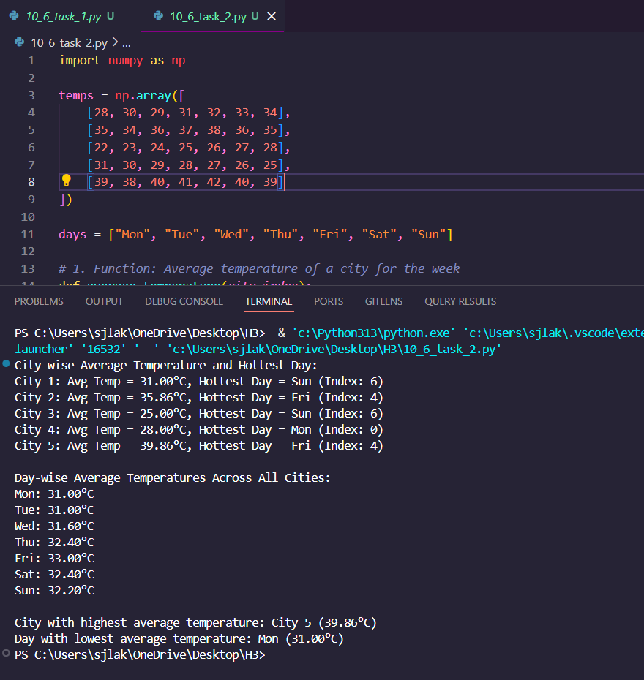

**Python Lists**

In Python, **lists** are one of the most used data structures. A list stores a collection of items in a specific order. You can think of it like a container that holds different types of values.

**📦 What is a List?**

A list is a collection of items separated by commas and enclosed in square brackets [ ].

fruits = ['apple', 'banana', 'cherry']

numbers = [10, 20, 30, 40]

mixed = ['hello', 123, True]

* Lists can store different data types.
* Indexing starts from **0** (just like string indexing).

**🔍 Accessing List Elements**

Use square brackets with the index number to get an item from the list.

colors = ['red', 'green', 'blue', 'yellow']

print(colors[0]) # red

print(colors[2]) # blue

print(colors[-1]) # yellow (last item)

You can also access a **range** of items using **slicing**:

print(colors[1:3]) # ['green', 'blue']

**✏️ Updating List Elements**

You can change any item in the list by assigning a new value at a specific index.

animals = ['cat', 'dog', 'rabbit']

animals[1] = 'parrot'

print(animals) # ['cat', 'parrot', 'rabbit']

**➕ Adding Items to a List**

Use the append() method to add an item to the end:

languages = ['Python', 'Java']

languages.append('C++')

print(languages) # ['Python', 'Java', 'C++']

You can also use insert(index, value) to add an item at a specific position:

languages.insert(1, 'JavaScript')

print(languages) # ['Python', 'JavaScript', 'Java', 'C++']

**❌ Removing Items from a List**

**Using del:**

numbers = [10, 20, 30, 40]

del numbers[2]

print(numbers) # [10, 20, 40]

**Using remove():**

names = ['Alice', 'Bob', 'Charlie']

names.remove('Bob')

print(names) # ['Alice', 'Charlie']

**Using pop():**

scores = [100, 90, 80]

scores.pop() # removes last item

scores.pop(0) # removes item at index 0

print(scores) # [90]

**📏 Useful List Functions**

**1. len(): Count of items**

print(len(['a', 'b', 'c'])) # 3

**2. max() / min(): Highest / Lowest value**

marks = [55, 89, 73]

print(max(marks)) # 89

print(min(marks)) # 55

**3. list(): Convert other types to list**

text = "hello"

print(list(text)) # ['h', 'e', 'l', 'l', 'o']

**🔁 List Operations**

| **Operation** | **Example** | **Result** |
| --- | --- | --- |
| Length | len([1, 2, 3]) | 3 |
| Concatenation | [1, 2] + [3, 4] | [1, 2, 3, 4] |
| Repetition | ['hi'] * 3 | ['hi', 'hi', 'hi'] |
| Membership | 'apple' in ['apple', 'mango'] | True |
| Iteration | for x in [1, 2, 3]: print(x) | prints 1 2 3 |

**🧰 More List Methods**

| **Method** | **Description** | **Example** |
| --- | --- | --- |
| append(x) | Adds x to end | mylist.append(5) |
| extend(seq) | Adds all items from seq | mylist.extend([6, 7]) |
| count(x) | Counts how many times x appears | mylist.count(2) |
| index(x) | Finds the first index of x | mylist.index('apple') |
| reverse() | Reverses the list in place | mylist.reverse() |
| sort() | Sorts the list | mylist.sort() |

**✅ Examples to Try**

shopping = ['milk', 'bread', 'eggs']

shopping.append('butter')

shopping.remove('bread')

shopping.insert(1, 'juice')

print(shopping)

**Output:**

['milk', 'juice', 'eggs', 'butter']

**Day 6 (12-06-25)**

**What is Pandas?**

**Pandas** is a **Python library** used for data analysis and manipulation. It provides **easy-to-use structures** like:

* Series (1D)
* DataFrame (2D – like a table)

It is widely used in **data science**, **machine learning**, **finance**, and many more domains.

**✅ Key Features of Pandas**

* Fast and efficient data manipulation
* Handling of missing data
* Powerful group-by functionality
* Data filtering, sorting, reshaping
* Merging and joining datasets
* Reading/writing CSV, Excel, JSON, etc.

**🧱 Core Structures in Pandas**

**1. Series (1D)**

import pandas as pd

data = [10, 20, 30]

s = pd.Series(data)

print(s)

**2. DataFrame (2D Table)**

import pandas as pd

data = {

'Name': ['Alice', 'Bob', 'Charlie'],

'Marks': [85, 90, 95]

}

df = pd.DataFrame(data)

print(df)

**🔧 Common Pandas Operations**

**🔹 Load CSV**

df = pd.read_csv('filename.csv')

**🔹 View Data**

df.head() # First 5 rows

df.tail() # Last 5 rows

df.shape # Rows x Columns

df.columns # Column names

**🔹 Accessing Data**

df['Name'] # Single column

df[['Name', 'Marks']] # Multiple columns

df.loc[0] # Row by label

df.iloc[0] # Row by index

**🔹 Filtering Rows**

df[df['Marks'] > 90]

**🔹 Sorting**

df.sort_values(by='Marks', ascending=False)

**🔹 Grouping**

df.groupby('Name')['Marks'].mean()

**🔹 Add/Update Column**

df['Grade'] = ['A', 'A+', 'A']

**🔹 Drop Column**

df.drop('Grade', axis=1, inplace=True)

**🔹 Handle Missing Data**

df.dropna() # Remove rows with nulls

df.fillna(0) # Replace nulls with 0

**📘 Use Cases of Pandas**

| **Domain** | **Use Case Example** |
| --- | --- |
| 📊 Data Analysis | Analyzing sales, user data, trends |
| 📉 Finance | Stock prices, risk modeling |
| 🏥 Healthcare | Patient data, statistics |
| 🛒 Retail | Sales forecasting, customer segmentation |
| 🤖 ML/AI | Preprocessing data for training models |

**🔁 File Formats Supported**

| **File Type** | **Function** |
| --- | --- |
| CSV | read_csv() |
| Excel | read_excel() |
| JSON | read_json() |
| SQL | read_sql() |

**Why Use Pandas?**

Pandas makes handling structured data **easy, powerful, and fast**, compared to regular Python lists and dictionaries.

**PROJECT - 3**

**E-commerce Customer & Sales Analysis**

Importing all the required packages

import pandas as pd

import numpy as np

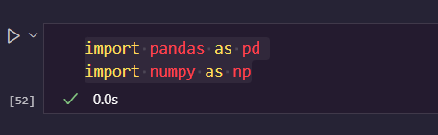

*# 1. Load both CSV files into separate Pandas DataFrames*

customers_df = pd.read_csv("customers.csv")

sales_df = pd.read_csv("sales.csv")

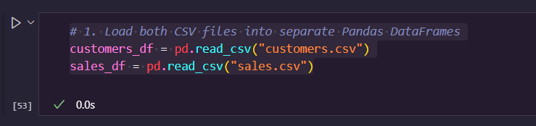

*#2. Display the first 5 and last 5 rows of each DataFrame*

print("Customers - First 5 rows:")

print(customers_df.head())

print("\nCustomers - Last 5 rows:")

print(customers_df.tail())

print("\nSales - First 5 rows:")

print(sales_df.head())

print("\nSales - Last 5 rows:")

print(sales_df.tail())

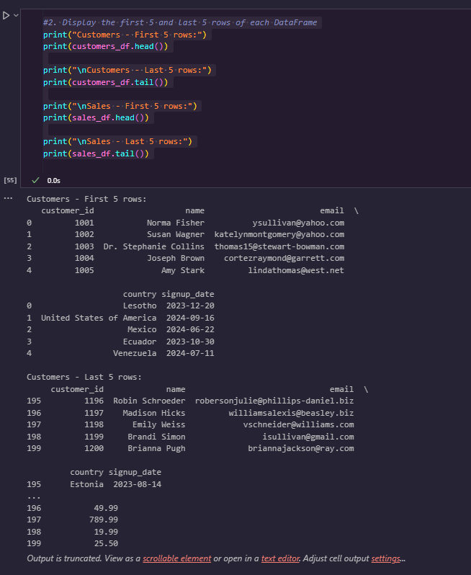

*#3. Show column names, data types, and check for null values*

print("Customers Info:")

print(customers_df.info())

print("\nMissing values:\n", customers_df.isnull().sum())

print("\nSales Info:")

print(sales_df.info())

print("\nMissing values:\n", sales_df.isnull().sum())

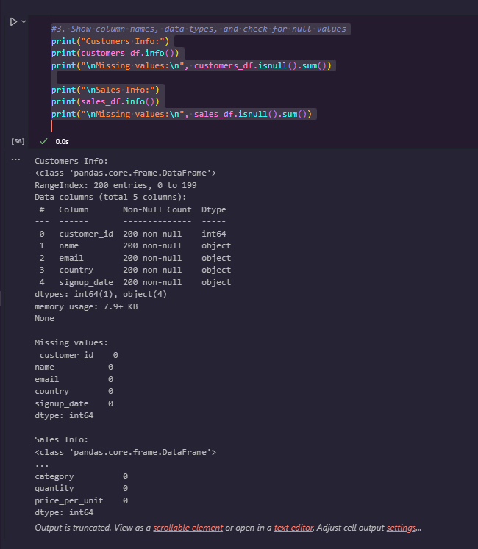

*# 4. Convert the date columns to datetime*

customers_df['signup_date'] = pd.to_datetime(customers_df['signup_date'])

sales_df['order_date'] = pd.to_datetime(sales_df['order_date'])

print("Converted 'signup_date' and 'order_date' to datetime.")

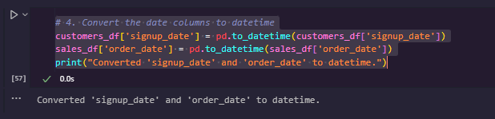

*#5. Calculate total revenue and create 'total_amount'*

sales_df['total_amount'] = sales_df['quantity'] * sales_df['price_per_unit']

print("Sales with total_amount column:")

print(sales_df.head())

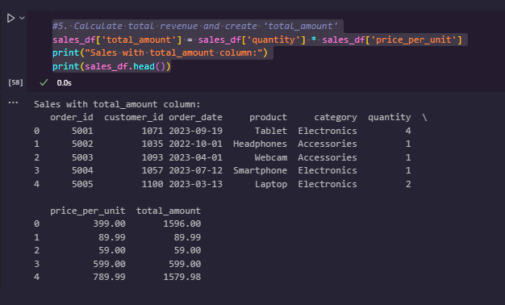

*#6. Merge datasets on customer_id*

merged_df = pd.merge(sales_df, customers_df, *on*='customer_id', *how*='inner')

print("Merged DataFrame:")

print(merged_df.head())

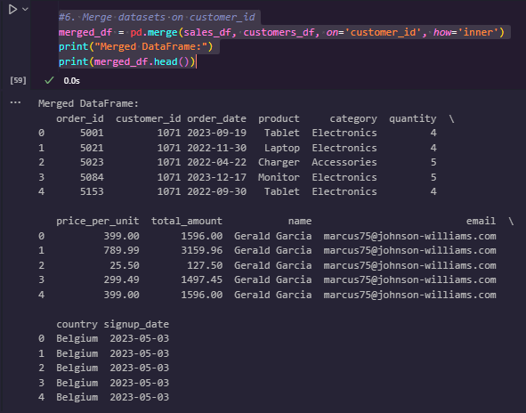

*#7. Top 5 customers by total spending*

top5 = merged_df.groupby(['customer_id', 'name'])['total_amount'].sum().sort_values(*ascending*=False).head(5)

print("Top 5 Customers by Spending:")

print(top5)

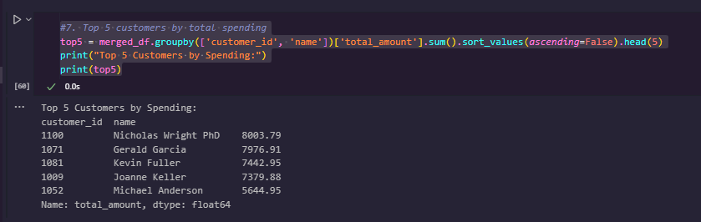

*#8. Count of customers by country*

print("Customer Count by Country:")

customers_df['country'].value_counts()

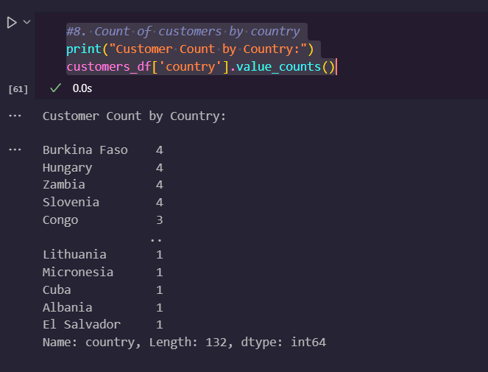

*#9. Average order value per customer*

avg_order_value = merged_df.groupby('customer_id')['total_amount'].mean()

print("Average Order Value per Customer:")

avg_order_value.head()

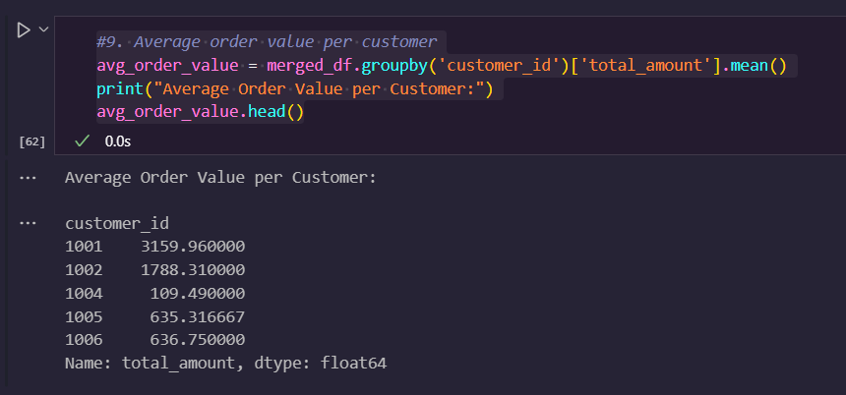

*#10. Remove duplicates from both datasets*

customers_df.drop_duplicates(*inplace*=True)

sales_df.drop_duplicates(*inplace*=True)

print("Removed duplicates. Current shape:")

print("Customers:", customers_df.shape)

print("Sales:", sales_df.shape)

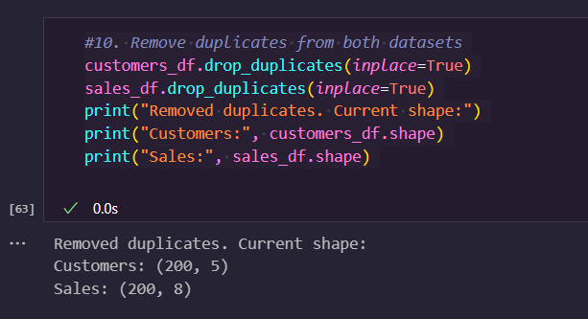

*# 11. Handle missing/invalid data*

sales_df = sales_df[(sales_df['quantity'] > 0) & (sales_df['price_per_unit'] > 0)]

print("Sales after removing invalid rows:")

print(sales_df.head())

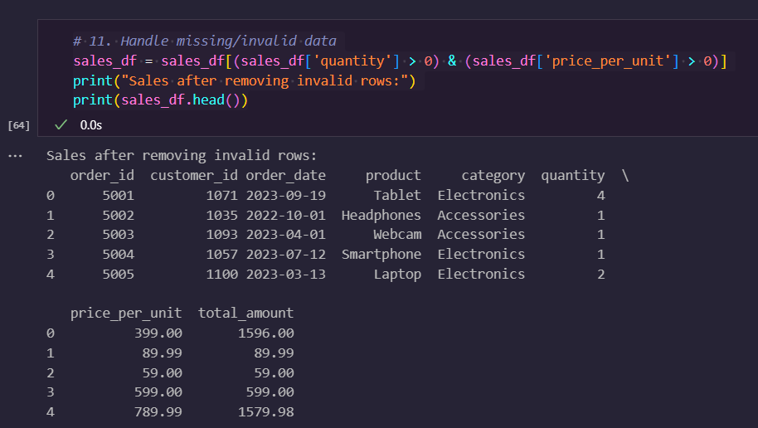

*#12. Group by category: quantity sold and revenue*

category_summary = merged_df.groupby('category').agg(

*total_quantity_sold*=('quantity', 'sum'),

*total_revenue*=('total_amount', 'sum')

)

print("Category Summary:")

print(category_summary)

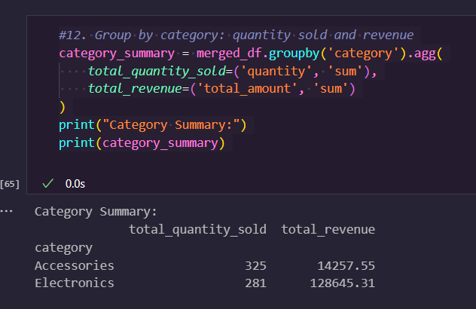

*#13. Extract year and month, analyze monthly sales*

merged_df['order_year_month'] = merged_df['order_date'].dt.to_period('M')

monthly_sales = merged_df.groupby('order_year_month')['total_amount'].sum()

print("Monthly Sales:")

print(monthly_sales)

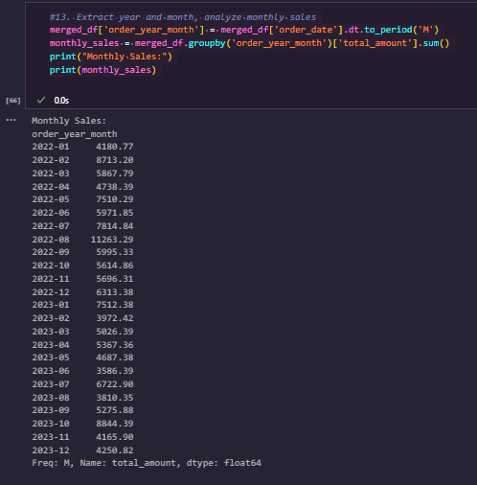

*#14. Customers who signed up in the last 6 months but didn’t buy*

from datetime import datetime

cutoff_date = pd.Timestamp.now() - pd.DateOffset(*months*=6)

recent_signups = customers_df[customers_df['signup_date'] >= cutoff_date]

purchased_customers = merged_df['customer_id'].unique()

inactive_recent = recent_signups[~recent_signups['customer_id'].isin(purchased_customers)]

inactive_recent

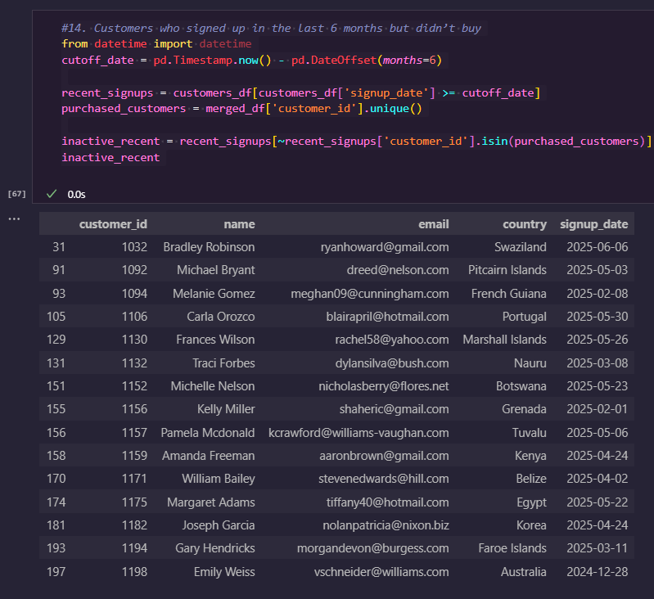

*#15. Products sold less than 10 times (low performers)*

total_sales = merged_df.groupby('product')['quantity'].sum()

low_performers = total_sales[total_sales < 10]

print("Low Performing Products (<10 sales):")

print(low_performers)

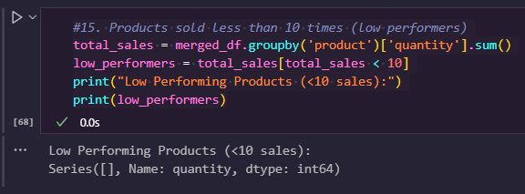

*# 16. Summary report per customer*

summary = merged_df.groupby(['customer_id', 'name']).agg(

*total_orders*=('order_id', 'nunique'),

*total_items*=('quantity', 'sum'),

*total_spent*=('total_amount', 'sum')

)

summary['avg_order_value'] = summary['total_spent'] / summary['total_orders']

summary

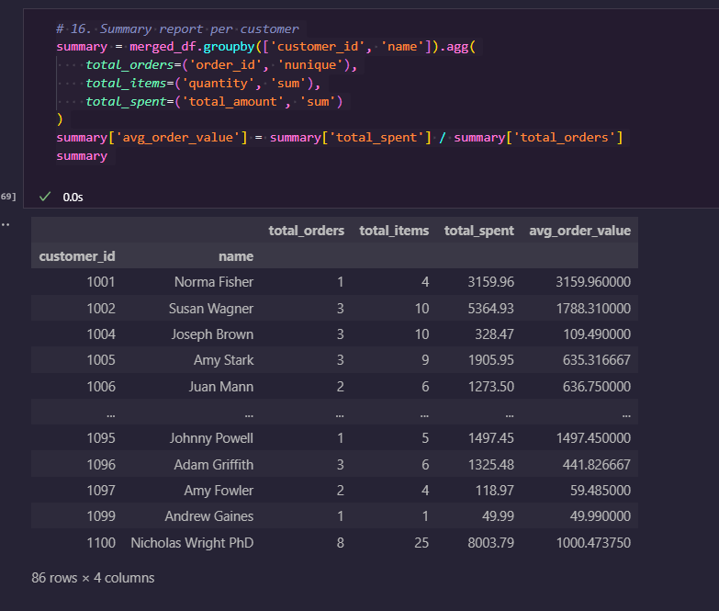

*#17. NumPy discount: Apply 10% discount to Electronics*

merged_df['discounted_amount'] = np.where(

    merged_df['category'] == 'Electronics',

    merged_df['total_amount'] * 0.90,

    merged_df['total_amount']

)

print("\nApplied discount to Electronics category:")

print(merged_df[['product', 'category', 'total_amount', 'discounted_amount']].head())

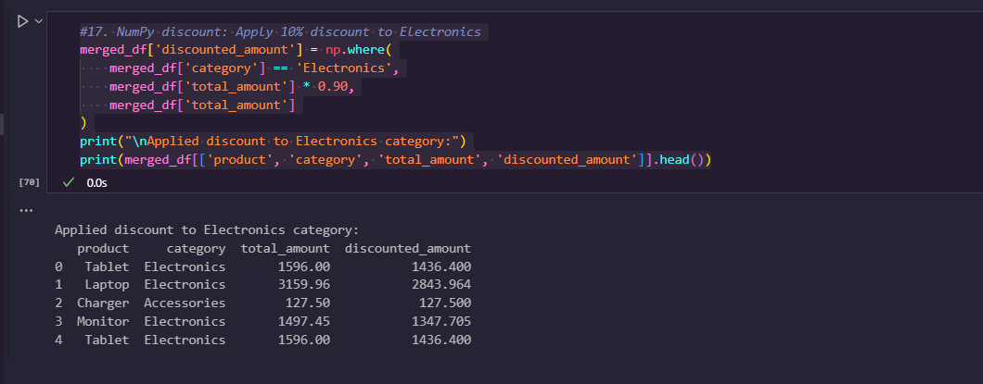

**DAY 7 (13-06-25)**

**BIG DATA**

**What is Big Data?**

**Big Data** refers to extremely large and complex datasets that cannot be managed, processed, or analyzed using traditional data processing tools and techniques.

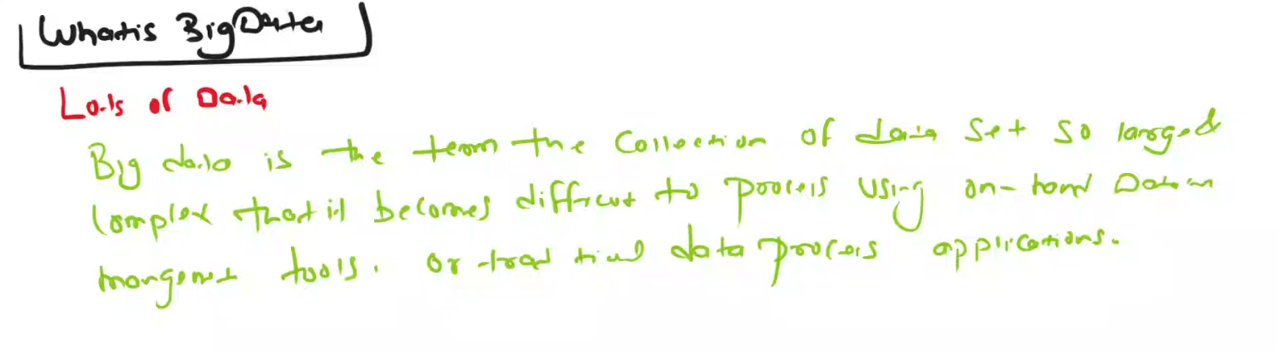

**The Evolution of Big Data: Past, Present, and Future**

Although the concept of big data is relatively new, the need to manage large data sets dates back to the 1960s and ’70s, with the first data centers and the development of the relational database.

**Past.** Around 2005, people began to realize just how much data users generated through Facebook, YouTube, and other online services. Apache Hadoop, an open source framework created specifically to store and analyze big data sets, was developed that same year. NoSQL also began to gain popularity during this time.

**Present.** The development of open source frameworks, such as Apache Hadoop and more recently, Apache Spark, was essential for the growth of big data because they make big data easier to work with and cheaper to store. In the years since then, the volume of big data has skyrocketed. Users are still generating huge amounts of data—but it’s not just humans who are doing it.

With the advent of the Internet of Things (IoT), more objects and devices are connected to the internet, gathering data on customer usage patterns and product performance. The emergence of [machine learning](https://www.oracle.com/in/artificial-intelligence/machine-learning/what-is-machine-learning/) has produced still more data.

**Future.** While big data has come far, its value is only growing as [generative AI](https://www.oracle.com/in/artificial-intelligence/generative-ai/what-is-generative-ai/) and cloud computing use expand in enterprises. The cloud offers truly elastic scalability, where developers can simply spin up ad hoc clusters to test a subset of data. And [graph databases](https://www.oracle.com/in/autonomous-database/what-is-graph-database/) are becoming increasingly important as well, with their ability to display massive amounts of data in a way that makes analytics fast and comprehensive.

Key Characteristics: The **5 V's** of Big Data

| **V** | **Description** |
| --- | --- |
| **Volume** | Huge amount of data (TBs to ZBs) |
| **Velocity** | Data is generated at high speed (e.g., social media, sensors) |
| **Variety** | Different formats – structured (tables), semi-structured (JSON), unstructured (videos, images) |
| **Veracity** | Trustworthiness and quality of data |
| **Value** | Extracting useful insights and business value from data |

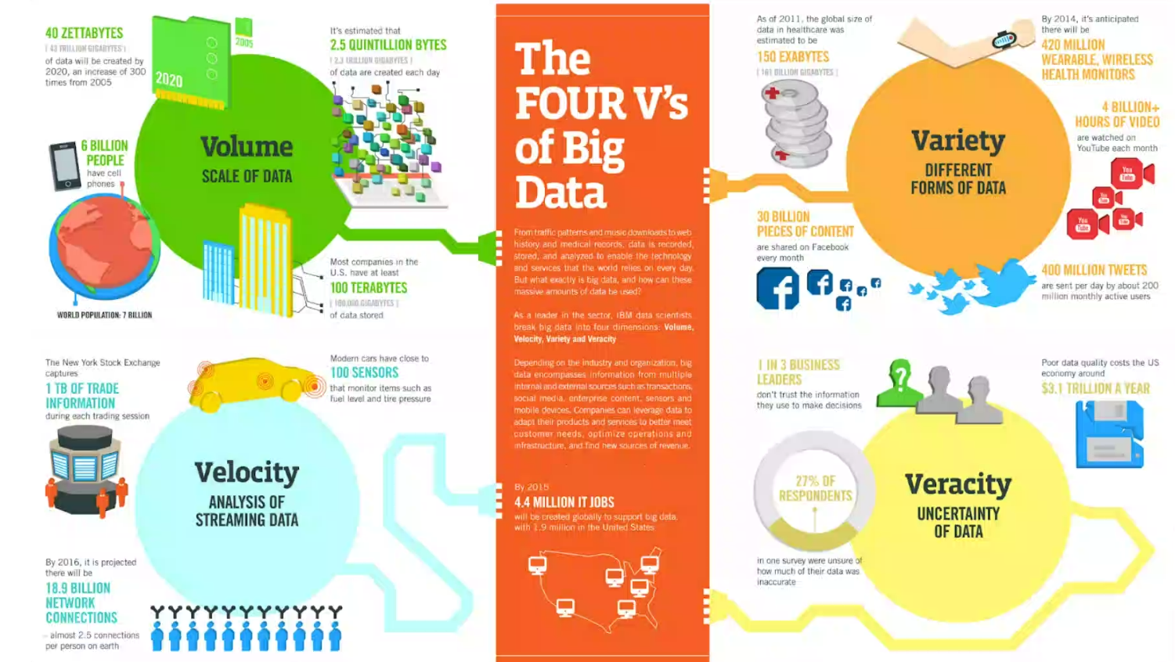

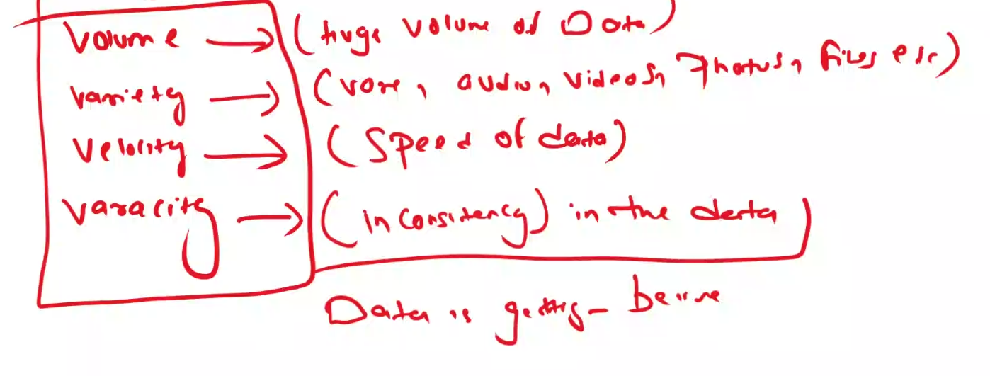

How does big data work?

The central concept of big data is that the more visibility you have into anything, the more effectively you can gain insights to make better decisions, uncover growth opportunities, and improve your business model.

Making big data work requires three main actions:

* **Integration:**Big data collects terabytes, and sometimes even petabytes, of raw data from many sources that must be received, processed, and transformed into the format that business users and analysts need to start analyzing it.
* **Management:**Big data needs big storage, whether in the cloud, on-premises, or both. Data must also be stored in whatever form required. It also needs to be processed and made available in real time. Increasingly, companies are turning to cloud solutions to take advantage of the unlimited compute and scalability.
* **Analysis:**The final step is analyzing and acting on big data—otherwise, the investment won’t be worth it. Beyond exploring the data itself, it’s also critical to communicate and share insights across the business in a way that everyone can understand. This includes using tools to create data visualizations like charts, graphs, and dashboards.

What is **Hadoop**?

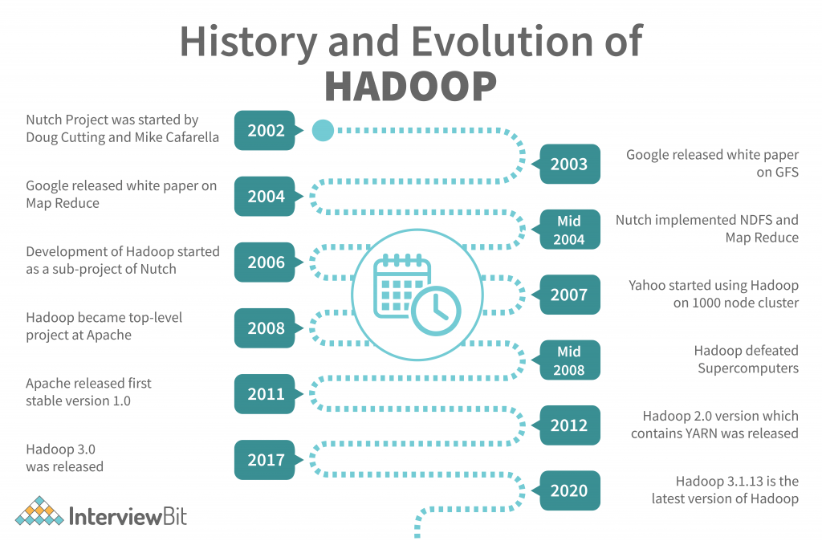

**Hadoop** is an **open-source** framework developed by **Apache** that allows for the **storage** and **processing** of **large datasets** across clusters of computers using simple programming models.

Think of Hadoop as a system that helps you **store and analyze big data** using **multiple machines** working together.

**Core Components of Hadoop:**

**1. HDFS (Hadoop Distributed File System)**

* Stores data by **splitting it into blocks** and **distributing** it across multiple machines.
* Provides **fault-tolerance** and **high throughput**.

**2. MapReduce**

* The **processing engine** of Hadoop.
* Works in two steps:
  + **Map**: Splits task into smaller sub-tasks
  + **Reduce**: Combines sub-task results into final output

**3. YARN (Yet Another Resource Negotiator)**

* Manages **resources** and **scheduling** tasks across the cluster.
* Makes sure all machines are used efficiently.

**4. Common Utilities**

* Provides libraries and Java files needed by the other components.

Key Features of Hadoop:

| **Feature** | **Description** |
| --- | --- |
| **Open Source** | Free to use and modify |
| **Scalable** | Easily add more machines |
| **Fault Tolerant** | Automatically handles failures |
| **Distributed** | Stores and processes data across multiple nodes |
| **High Throughput** | Ideal for processing large volumes of data |

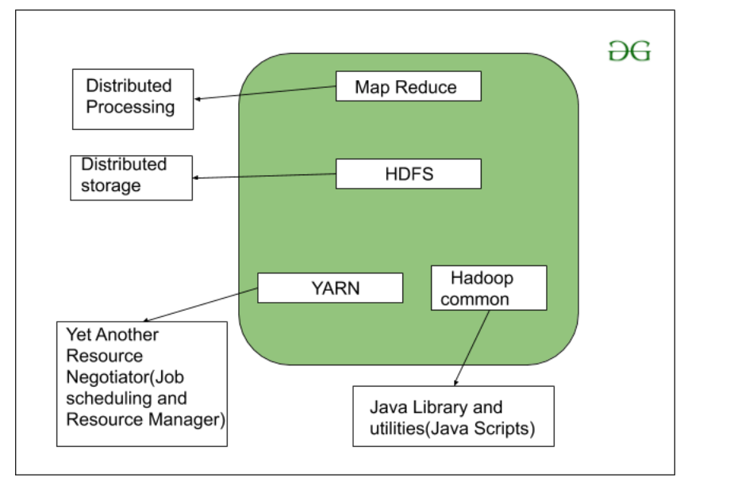

Hadoop Architecture

Components of Hadoop:

**1. HDFS – Hadoop Distributed File System**

**Purpose:** Storage

* Breaks large files into **blocks** (usually 128 MB or 256 MB)
* Stores them across **multiple nodes**
* Ensures **fault tolerance** by making **copies (replicas)** of each block (default = 3)
* Has two parts:
  + **NameNode** – Manages metadata (file names, block locations)
  + **DataNodes** – Store the actual data blocks

**Think of HDFS as a smart, reliable, distributed file storage system**

**2. MapReduce – Data Processing Engine**

**Purpose:** Processing

* A programming model to process data in **two phases**:
  1. **Map**: Splits large data into smaller chunks and processes them
  2. **Reduce**: Aggregates and combines results

Example: Counting word frequency from a book

* **Map** phase: Split book into paragraphs and count words in each
* **Reduce** phase: Add counts from all paragraphs to get the final result

**3. YARN – Yet Another Resource Negotiator**

**Purpose:** Resource Management

* Allocates system resources (CPU, memory, etc.) to various tasks
* Schedules jobs across the cluster
* Helps multiple applications run simultaneously

**YARN is the "manager" or "coordinator" of all tasks running in the Hadoop system**

**4. Hadoop Common – Shared Utilities**

**Purpose:** Support

* Provides **Java libraries**, **APIs**, and other utilities needed by HDFS, MapReduce, and YARN
* Includes basic tools, I/O functions, and configuration files

**It’s like the “toolkit” used by all other components**

**Summary:**

| **Component** | **Role** | **Description** |
| --- | --- | --- |
| **HDFS** | Storage system | Stores data in distributed blocks |
| **MapReduce** | Processing engine | Processes data using map and reduce |
| **YARN** | Resource manager | Allocates and schedules tasks |
| **Common** | Shared tools/libraries | Provides utilities and configs |

Hadoop Distributed File System (HDFS):

**What is HDFS?**

**HDFS** stands for **Hadoop Distributed File System**.  
It is the **storage system** used by **Hadoop** to store large files across multiple machines (called a **cluster**) in a **fault-tolerant** and **scalable** way.

**Why HDFS?**

Imagine you have a 500 GB file. A single machine might be too slow or may not have enough space.  
**HDFS splits the file into smaller blocks and stores them across many machines** so they can be processed faster and stored easily.

**Basic Architecture**

**1. NameNode (Master)**

* Stores **metadata** – file names, locations, permissions.
* Knows **which block is stored on which machine**.

**2. DataNodes (Workers)**

* Actually store the **data blocks**.
* Send heartbeat to NameNode to show they are active.

**3. Blocks**

* Files are split into fixed-size blocks (default is **128 MB**).
* Blocks are **replicated** (usually 3 copies) for **fault tolerance**.

Architecture of HDFS is below,

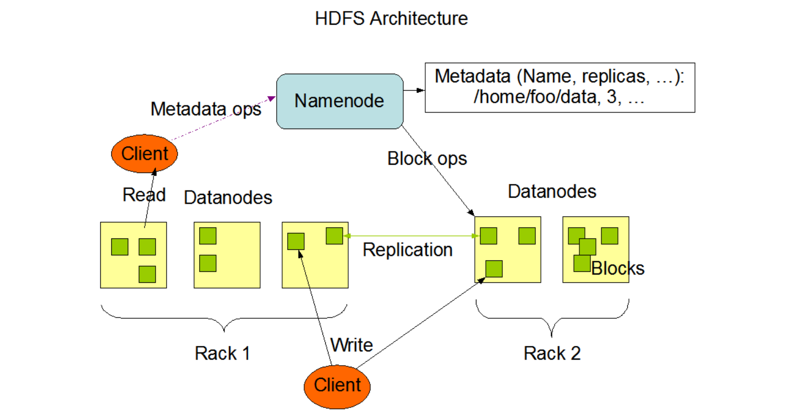

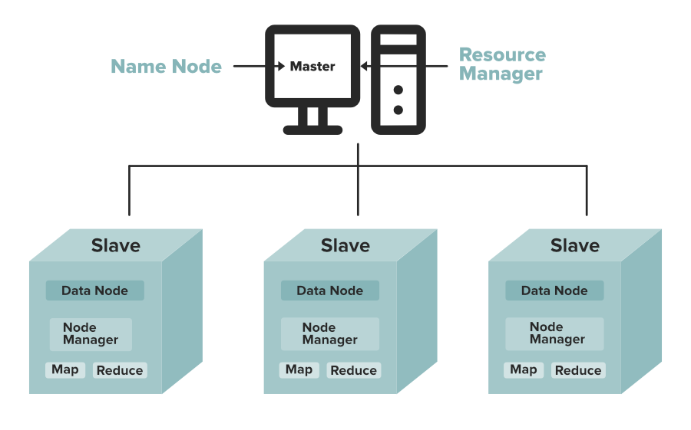

HDFS vs Traditional File System:

| **Feature** | **HDFS** | **Traditional FS** |
| --- | --- | --- |
| Storage | Distributed (across nodes) | Centralized (single disk) |
| Fault Tolerance | Yes (replication) | Limited |
| Suitable For | Big files, batch processing | Small files, random access |

**Data Replication**

HDFS is designed to reliably store very large files across machines in a large cluster. It stores each file as a sequence of blocks; all blocks in a file except the last block are the same size. The blocks of a file are replicated for fault tolerance. The block size and replication factor are configurable per file. An application can specify the number of replicas of a file. The replication factor can be specified at file creation time and can be changed later. Files in HDFS are write-once and have strictly one writer at any time.

The NameNode makes all decisions regarding replication of blocks. It periodically receives a Heartbeat and a Blockreport from each of the DataNodes in the cluster. Receipt of a Heartbeat implies that the DataNode is functioning properly. A Blockreport contains a list of all blocks on a DataNode.

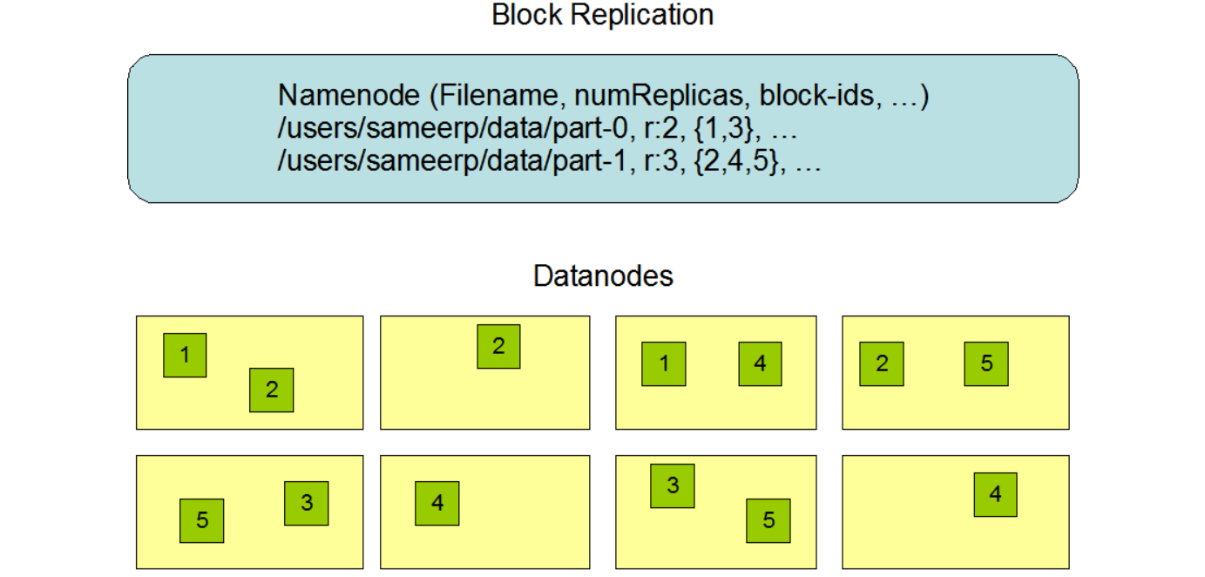

Big Data & Hadoop Ecosystem – Explained Simply and Technically:

| **Term** | **Simple Explanation** | **Technical Definition** |
| --- | --- | --- |
| **Big Data** | Huge amount of data that is hard to manage using normal tools | Large, complex datasets that traditional data processing software cannot handle efficiently; defined by 5 Vs – Volume, Velocity, Variety, Veracity, and Value |
| **Hadoop** | A tool that helps store and process Big Data using many computers | An open-source framework by Apache that allows for distributed storage (via HDFS) and processing (via MapReduce) of large datasets |
| **HDFS** | A system that stores big files by splitting and saving them across multiple computers | Hadoop Distributed File System – a scalable and fault-tolerant file storage system that divides data into blocks and stores them across nodes in a cluster |
| **MapReduce** | A way to process large data in two steps: breaking and combining | A programming model in Hadoop that processes data in two phases: Map (filter/sort) and Reduce (aggregate/summarize) |
| **YARN** | A manager that assigns work to computers in the Hadoop system | Yet Another Resource Negotiator – Hadoop’s resource management layer that handles scheduling and cluster resource allocation |
| **Hadoop Common** | Basic tools used by all parts of Hadoop | A collection of shared utilities, libraries, and APIs needed by other Hadoop modules to function |

Simple Summary Table:

| **Term** | **Simple Meaning** |
| --- | --- |
| **Big Data** | Huge and complex data |
| **Hadoop** | Tool to store and process Big Data |
| **HDFS** | Hadoop’s way to store data across machines |
| **MapReduce** | Method to process data in steps |
| **YARN** | Manages resources and tasks |
| **Common** | Tools that support everything in Hadoop |

Map Reduce:

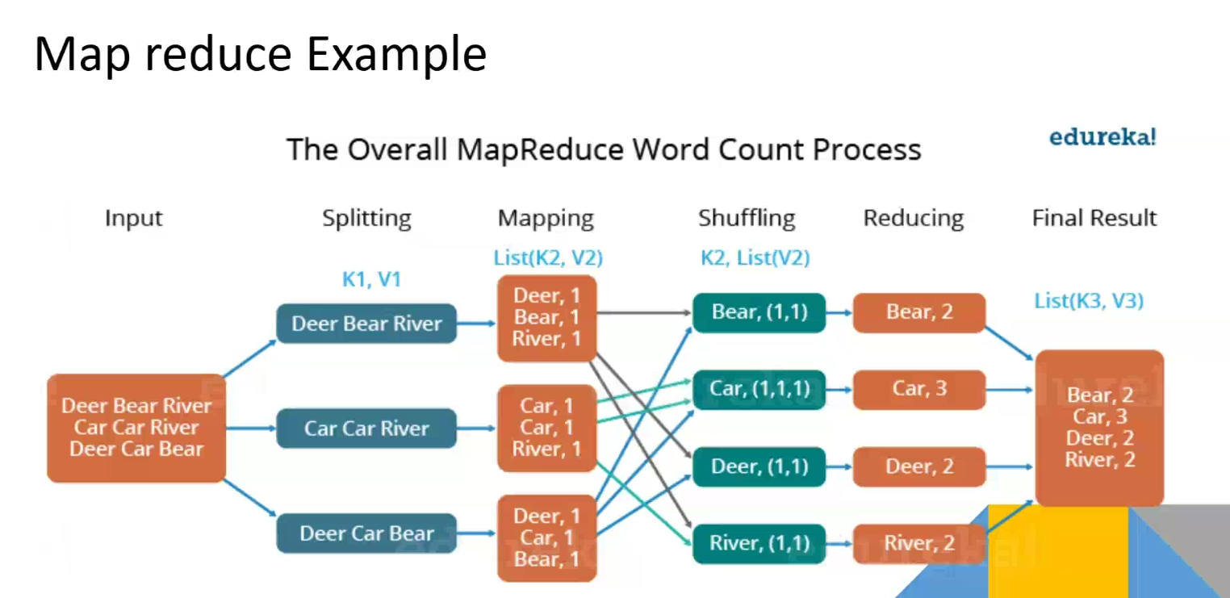

**MapReduce** is a **programming model** and **processing technique** introduced by **Google** and later implemented in **Apache Hadoop**.  
It is designed to **process large volumes of data in parallel** by dividing the work across a cluster of computers.

MapReduce works in two main steps:

* **Map Phase** → Break the data into small key-value pairs and perform filtering or transformation.
* **Reduce Phase** → Aggregate or summarize those results based on keys.

It is ideal for batch processing of massive data (like log files, social media data, sensor data, etc.).

**How It Works – Step-by-Step**

Let’s walk through the full MapReduce workflow:

**1. Splitting**

Hadoop divides the input data into **splits** (usually based on block size – e.g., 128 MB). Each split is sent to a different **Mapper**.

**2. Mapping (Map Phase)**

Each **Mapper** processes its split.  
It takes a line or record and transforms it into **key-value pairs**.

* Example:  
  Input: "Big data is big"
* Output:
  + (Big, 1)
  + (data, 1)
  + (is, 1)
  + (big, 1)

Note: The words are case-insensitive, so "Big" and "big" might be normalized before processing.

**3. Shuffling and Sorting**

After mapping, Hadoop groups and sorts the intermediate data **by key** (e.g., all "big" values together).  
It then sends the grouped key and list of values to **Reducers**.

Example:

* (big, [1, 1])
* (data, [1])
* (is, [1])

**4. Reducing (Reduce Phase)**

The **Reducer** takes each key and applies an **aggregation function** (like sum, max, min, etc.).

* Output:
  + (big, 2)
  + (data, 1)
  + (is, 1)

**5. Output**

The result is written to HDFS in output files (e.g., part-0000).

**Advantages of MapReduce**

* **Scalable**: Works well on huge datasets across hundreds or thousands of machines.
* **Fault-tolerant**: Failed tasks are automatically retried.
* **Cost-effective**: Uses commodity hardware.
* **Parallelism**: Breaks work into independent tasks.

What is YARN?

* **YARN (Yet Another Resource Negotiator)** is the **resource management and job scheduling layer** of Hadoop.  
  It allows **multiple applications** (like MapReduce, Spark, Hive, etc.) to run on a Hadoop cluster by **managing resources** (CPU, memory) and **allocating tasks** dynamically.
* YARN separates **job processing** and **resource management**, which makes Hadoop more **scalable** and **efficient**.
* **YARN** is like the **manager or boss** in the Hadoop system.
* It decides **which computer** will run **which task** and **when**.

**Why YARN?**

Before YARN (in Hadoop v1), MapReduce was responsible for both:

* Processing jobs
* Managing cluster resources

This was limiting, because only MapReduce jobs could run.

With YARN (Hadoop v2+):

* **Resource Management** is done by YARN
* **Job Processing** can be done by **any engine** (MapReduce, Spark, etc.)

**YARN Architecture Components**

| **Component** | **Description** |
| --- | --- |
| **ResourceManager (RM)** | The **main master**. It manages resources across the whole cluster. |
| **NodeManager (NM)** | A **worker** on each machine. Reports to the RM and manages containers on that machine. |
| **ApplicationMaster (AM)** | Controls **one running job**. It talks to RM to get resources and to NM to run tasks. |
| **Containers** | Units where actual tasks (like Map or Reduce) run. Each has its own memory and CPU. |

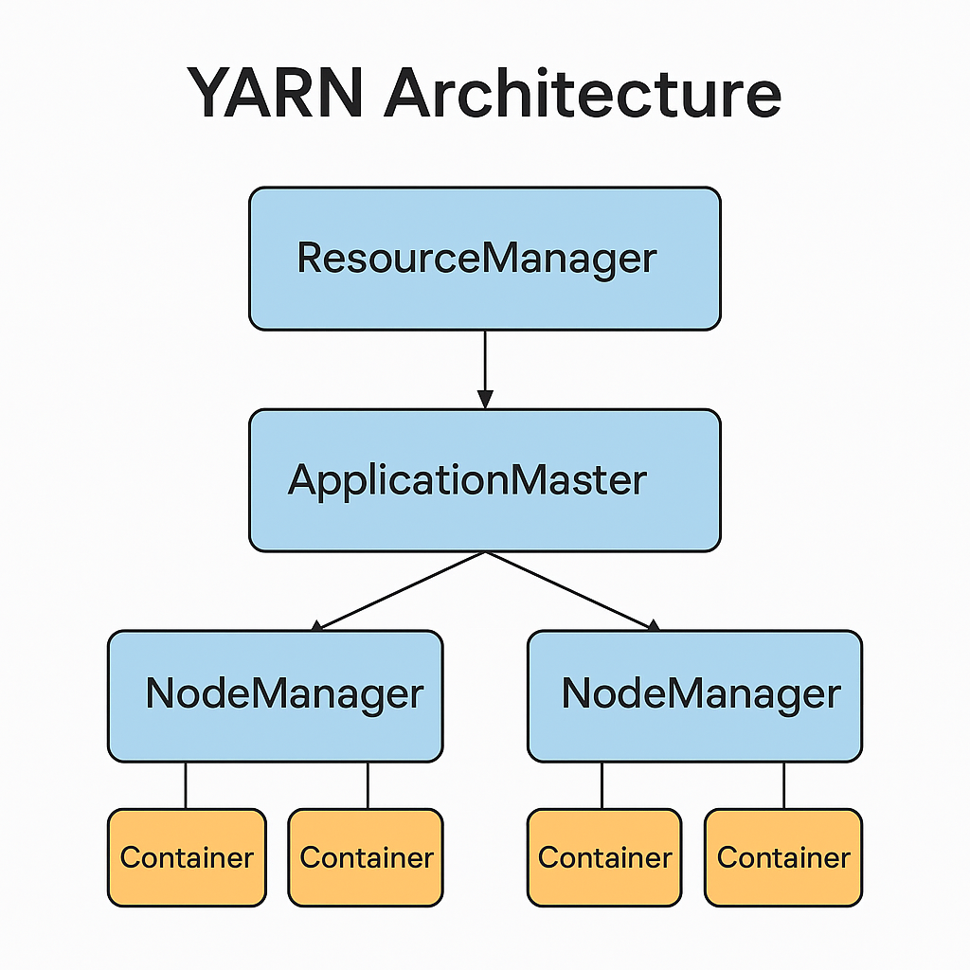

**How YARN Works:**

1. **User submits a job** (e.g., a MapReduce task)
2. **ResourceManager** creates a **Container** to start an **ApplicationMaster**
3. **ApplicationMaster** requests more **Containers** to run Map or Reduce tasks
4. **NodeManagers** launch those tasks in their local **Containers**
5. Once done, the **ApplicationMaster shuts down**

**Key Features of YARN:**

| **Feature** | **Explanation** |
| --- | --- |
| **Multi-engine support** | Runs MapReduce, Spark, Tez, etc. |
| **Efficient resource use** | Avoids idle nodes, improves cluster usage |
| **Fault-tolerant** | Restarts failed components |
| **Scalable** | Supports thousands of nodes |
| **Flexible** | Works for batch, real-time, streaming apps |

**YARN Summary:**

| **Term** | **Simple Meaning** | **Technical Definition** |
| --- | --- | --- |
| **YARN** | Boss of the Hadoop system | A resource manager and job scheduler in Hadoop |
| **ResourceManager** | Master that tracks all work | Allocates resources and monitors node status |
| **NodeManager** | Worker that does the job | Manages tasks on a single machine |
| **ApplicationMaster** | Controls one running job | Manages execution of a single application |
| **Container** | Space where tasks run | A resource slot (CPU + memory) to run a task |

YARN Application Types:

YARN supports many kinds of applications, not just MapReduce:

| **Engine** | **Purpose** |
| --- | --- |
| **MapReduce** | Batch processing |
| **Apache Spark** | In-memory fast computation |
| **Apache Tez** | DAG-based jobs (used in Hive) |
| **Apache Flink / Storm** | Real-time streaming |

**YARN Resource Scheduling Policies:**

| **Policy** | **Description** | **Use Case** |
| --- | --- | --- |
| **FIFO** | First-In-First-Out | Simple, but not resource-balanced |
| **Capacity** | Resources divided among queues (departments, teams) | Large orgs needing quotas |
| **Fair** | Distributes resources so all jobs get fair share | Multi-user clusters |

**Day 8 – (16-06-25)**

**Hadoop ECOSYSTEM**

What is the **Hadoop Ecosystem**?

* The **Hadoop Ecosystem** is a **collection of tools and frameworks** that work together to **store, process, manage, and analyze big data** in a distributed computing environment.
* Think of it like an **operating system for big data**. Just like your computer OS has different programs for file storage, editing, networking, etc., Hadoop has different tools for different big data tasks.

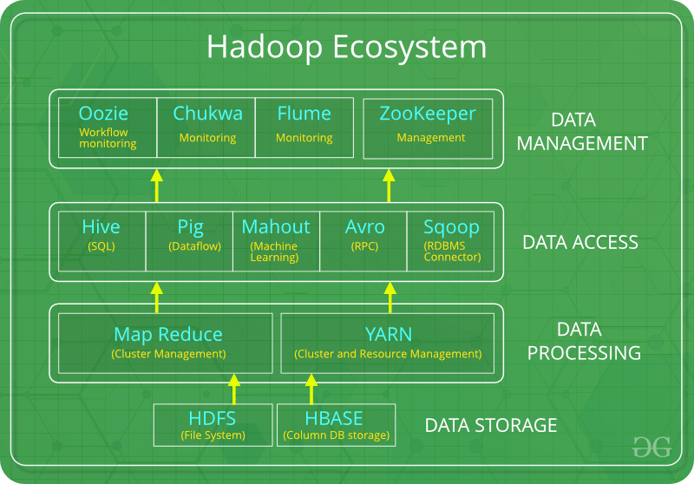

Core Components of Hadoop Ecosystem (With Examples):

**1. Storage Layer**

This is where data is stored.

**HDFS (Hadoop Distributed File System)**

* **Definition**: A **distributed file system** that stores huge files by splitting them into blocks and saving them across multiple machines.
* **Example**: If you upload a 100GB file, HDFS splits it into blocks (say, 128MB each) and stores them on different machines.
* **Purpose**: Handles **large-scale storage** reliably.

**2. Resource Management Layer**

**YARN (Yet Another Resource Negotiator)**

* **Definition**: A **resource management** and **job scheduling** system in Hadoop.
* **Example**: If multiple users submit data jobs, YARN decides **which job runs where and when**.
* **Purpose**: It allocates resources to different tasks in the cluster.

**3. Processing Layer**

Used to **analyze or process data** stored in HDFS.

**a. MapReduce**

* **Definition**: A programming model to **process large data sets** with parallel computation.
* **Example**: Count how many times each word appears in a huge text file.
* **Purpose**: Traditional and reliable batch processing.

**b. Apache Spark**

* **Definition**: A **faster processing engine** compared to MapReduce; supports in-memory computing.
* **Example**: Real-time log analysis.
* **Purpose**: For high-speed batch or streaming data processing.

**4. Data Access & Query Tools**

To make it easier to **read/write/query** big data without writing complex code.

**a. Hive**

* **Definition**: A **SQL-like tool** to run queries on Hadoop data.
* **Example**: SELECT * FROM big_sales_data WHERE region = 'South';
* **Purpose**: Query big data using simple **SQL-style commands**.

**b. Pig**

* **Definition**: A scripting language for data analysis.
* **Example**: Count total sales grouped by product.
* **Purpose**: Easier than Java (used in MapReduce), used for transformation pipelines.

**c. HBase**

* **Definition**: A **NoSQL database** that works on top of HDFS.
* **Example**: Store sensor data with fast read/write access.
* **Purpose**: Real-time read/write access to large data sets.

**d. Sqoop**

* **Definition**: A tool to **transfer data between Hadoop and RDBMS** like MySQL.
* **Example**: Import customer data from MySQL to Hadoop.
* **Purpose**: Bridges traditional databases and Hadoop.

**e. Flume**

* **Definition**: Used to **collect and transfer streaming data** to HDFS.
* **Example**: Ingest logs from servers in real-time.
* **Purpose**: Handle real-time data ingestion.

**Other Useful Tools:**

| **Tool** | **Purpose** | **Example Use** |
| --- | --- | --- |
| **Zookeeper** | Coordination & configuration | Keeps track of nodes in the Hadoop cluster |
| **Oozie** | Workflow Scheduler | Run a MapReduce job every night at 1 AM |
| **Mahout** | Machine Learning | Build recommendation systems |
| **Ambari** | Hadoop Cluster Management (UI) | Monitor and manage all Hadoop services easily |

**Final Summary Table:**

| **Layer** | **Component** | **Description** |
| --- | --- | --- |
| **Storage** | HDFS | Stores large data across machines |
| **Resource Manager** | YARN | Manages jobs and resources |
| **Processing** | MapReduce | Traditional batch data processing |
|  | Spark | Fast in-memory processing |
| **Query/Access** | Hive, Pig | SQL or scripts for data analysis |
|  | HBase | NoSQL database on Hadoop |
|  | Sqoop, Flume | Import/export and data collection tools |
| **Support Tools** | Zookeeper, Oozie, Ambari | Monitoring, coordination, scheduling |

What is **Apache Spark**?

* Apache Spark is a **unified analytics engine** for **large-scale data processing**, with built-in modules for **batch processing, real-time streaming, machine learning, and graph processing**. It runs **100x faster** than Hadoop MapReduce in memory.
* **Apache Spark** is a **powerful open-source big data processing engine** used to **analyze huge amounts of data quickly**.

Hadoop vs Spark: Side-by-Side Table:

| **Feature** | **Hadoop (MapReduce)** | **Spark** |
| --- | --- | --- |
| **Basic Idea** | Processes data in **batches**, one step at a time | Processes data **in memory**, much faster |
| **Speed** | **Slower**, due to disk read/write between tasks | **Faster**, as it keeps data in **memory (RAM)** |
| **Ease of Use** | **Complex**, mostly written in Java | Easier with APIs in **Python, Scala, Java, R** |
| **Processing Type** | **Batch processing only** | Supports **batch**, **stream**, **ML**, **graph** |
| **Fault Tolerance** | High – uses **HDFS replication** | High – uses **RDD lineage** |
| **Use Case Example** | Monthly report generation | Real-time Twitter sentiment analysis |
| **Component** | Based on **MapReduce** programming model | Based on **RDD** (Resilient Distributed Datasets) |
| **Speed** | Data is read from disk every time | Data is cached in memory (RAM) for fast access |
| **Resource Management** | YARN (Yet Another Resource Negotiator) | Can use YARN, Mesos, or its own cluster manager |
| **Cost Efficiency** | Cheaper for huge batch jobs on low RAM systems | Needs more RAM → can be **costlier** |

**When to Use What?**

| **Situation** | **Choose** |
| --- | --- |
| Very large batch jobs, limited RAM | **Hadoop** |
| Real-time analytics or fast processing | **Spark** |
| Machine Learning or Stream processing | **Spark** |
| Lower cost, disk-based | **Hadoop** |

**Why Use Spark Instead of MapReduce?**

| **Feature** | **Apache Spark** | **Hadoop MapReduce** |
| --- | --- | --- |
| **Speed** | **Very fast (in-memory processing)** | **Slower (disk-based)** |
| **Ease of Use** | **Easy APIs in Python, Java, Scala** | **More complex (Java code needed)** |
| **Real-time Support** | **Yes (via Spark Streaming)** | **No** |
| **Use Cases** | **Batch + Streaming + ML + Graph** | **Mostly batch** |

**Overview of Apache Spark’s Ecosystem and Core Libraries:**

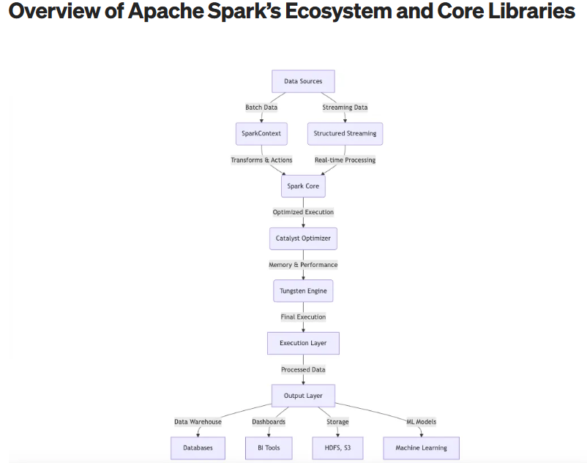

**Components of Apache Spark:**

| **Component** | **Purpose** | **Example Use Case** |
| --- | --- | --- |
| **Spark Core** | Base engine for Spark functionality | Reads and processes data |
| **Spark SQL** | Use SQL queries on big data | SELECT * FROM sales WHERE region='East' |
| **Spark Streaming** | Real-time data processing | Analyze live website logs |
| **MLlib** | Machine learning library | Build recommendation engines |
| **GraphX** | Graph processing | Analyze social networks |

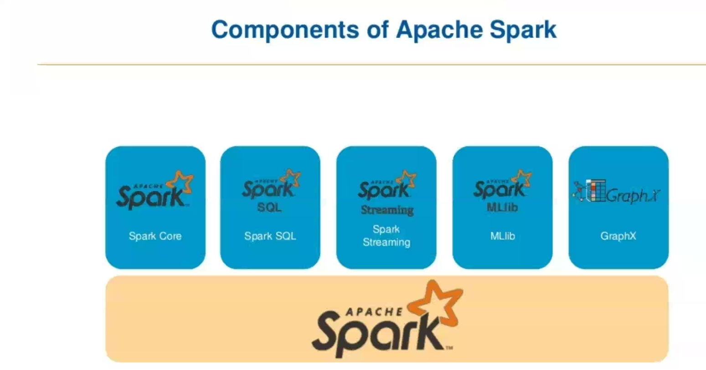

Apache Spark Features:

| **Feature** | **Simple Explanation** | **Technical Explanation** |
| --- | --- | --- |
| **In-Memory Computing** | Keeps data in **RAM** to avoid slow hard disk read/write | Uses **RDDs** to cache intermediate results, reducing I/O and speeding up computations |
| **High Speed** | 10–100x faster than Hadoop for many tasks | Optimized DAG execution engine + in-memory processing |
| **Real-Time Processing** | Can handle **live data streams** like Twitter or sensors | Supports **Spark Streaming** for real-time data with micro-batches |
| **Fault Tolerance** | Automatically recovers from crashes or errors | RDDs track lineage to **recompute lost data** instead of re-running whole job |
| **Machine Learning** | Built-in support for ML tasks like classification, clustering | Includes **MLlib** – scalable machine learning library |
| **Multi-language Support** | Can write code in **Python, Java, Scala, R** | APIs available for all major programming languages |
| **Easy Integration** | Works well with other tools like Hadoop, Hive, Kafka, Cassandra | Supports Hadoop HDFS, YARN, Hive, JDBC, Kafka, and more |
| **Graph Processing** | Analyze data with connections (e.g., social networks) | Built-in **GraphX** engine for graph-parallel computations |
| **DataFrame & SQL** | Query big data using **SQL-like syntax** | Supports **Spark SQL** and DataFrames (structured data processing) |
| **Flexible Deployment** | Can run on **laptop**, **cluster**, or in **cloud** | Works with YARN, Mesos, Kubernetes, or Spark Standalone Cluster |
| **Modular Architecture** | Choose what you need: streaming, SQL, ML, etc. | Components: Spark Core, Spark SQL, Spark Streaming, MLlib, GraphX |

**Spark Core:**

* **Spark Core** is the **base engine** of Apache Spark.
* It handles basic tasks like **memory management**, **task scheduling**, **fault recovery**, and **interacting with storage**.

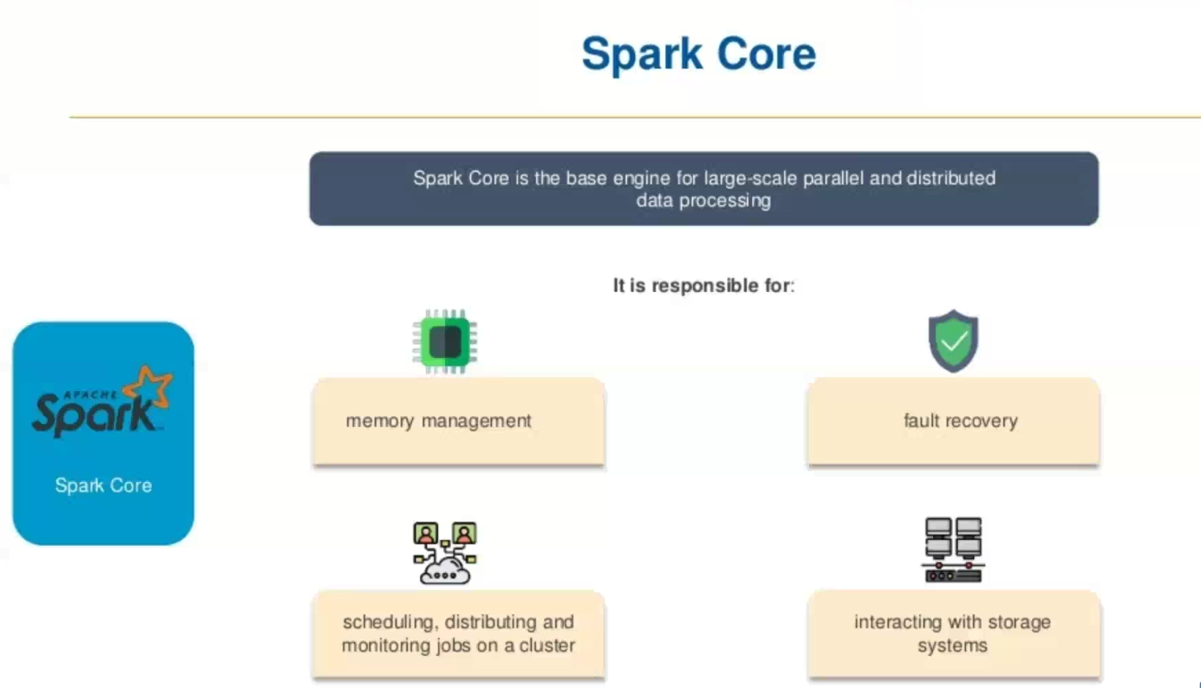

**Main Responsibilities of Spark Core,**

| **Feature** | **Explanation** |
| --- | --- |
| **Task Scheduling** | Decides how to run your jobs on clusters or nodes |
| **Memory Management** | Efficiently uses **RAM** to cache data and avoid disk usage |
| **Fault Tolerance** | If a worker fails, Spark Core can **recalculate lost data** from the lineage |
| **Distributed Computing** | Splits your job across many machines and coordinates the results |
| **Storage Interaction** | Connects with **HDFS, S3, local file systems, HBase, Cassandra**, etc. |
| **Support for RDD** | Provides API to create and process **RDDs (Resilient Distributed Datasets)** |

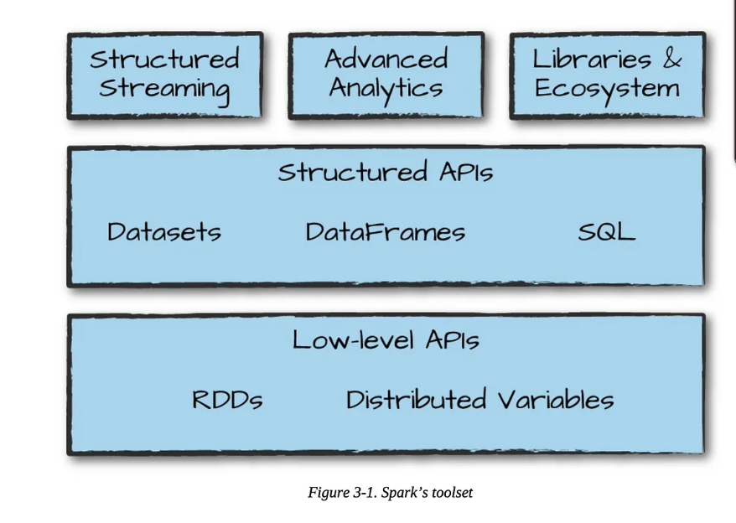

| **Feature** | **Description** |
| --- | --- |
| Core engine | Manages memory, scheduling, execution, and fault tolerance |
| RDD support | Immutable distributed collections with transformations/actions |
| Storage integration | Works with HDFS, S3, Cassandra, HBase, local files |
| Execution environment | Cluster management and task scheduling |
| Basis for other modules | Required for Spark SQL, MLlib, GraphX, Streaming |

RDD (**Resilient Distributed Dataset**):

* RDD is an **immutable**, **distributed collection** of objects that can be processed in **parallel**.  
  It offers **fault tolerance** using **lineage** (i.e., how it was created).
* RDD is like a **big list of data** that is **split across multiple machines**, and **Spark can work on it in parallel**.

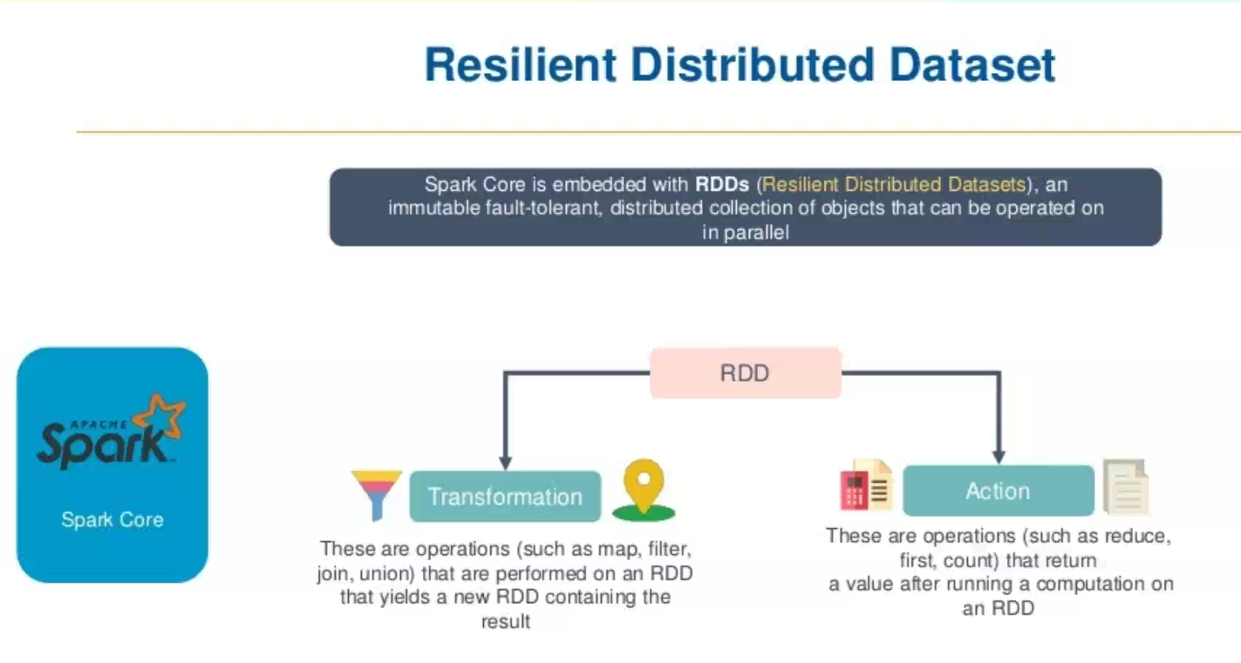

**Key Features of RDD,**

| **Feature** | **Explanation** |
| --- | --- |
| **Resilient** | Recovers automatically from failures using lineage info |
| **Distributed** | Spread across many machines or nodes |
| **Immutable** | Once created, it **cannot be changed**; but you can create **new RDDs** |
| **In-Memory** | Can **store data in RAM** for faster access |
| **Lazy Evaluation** | Nothing runs until you call an action (like .collect()) |
| **Parallel Processing** | Spark splits work across cores and nodes |

**Types of Operations on RDD**

| **Type** | **Example** | **Purpose** |
| --- | --- | --- |
| **Transformations** | map(), filter(), flatMap() | Creates a **new RDD** |
| **Actions** | collect(), count(), reduce() | Triggers **actual computation** |

**When to Use RDD?**

* You need **fine-grained control** over your data and operations.
* You want to handle **unstructured data** (like logs, text).
* You’re okay with **writing more code** for **more control**.

How RDD works,

Resilient Distributed Datasets are resilient and distributed. That means:

Resilient:

RDDs are called "resilient" because they track [data lineage](https://www.ibm.com/think/topics/data-lineage) information so that lost data can be rebuilt if there is a failure, making RDDs highly fault-tolerant.

As an example of this [data resilience](https://www.ibm.com/think/topics/data-resiliency), consider an executor core that is lost during the processing of an RDD partition. The driver would detect that failure, and that partition would be reassigned to a different executor core.

Distributed:

RDDs are called "distributed" because they are split into smaller groups of data that can be distributed to different compute nodes and processed simultaneously.

In addition to these 2 core characteristics, RDD has other features that contribute to its importance and operations in Spark.

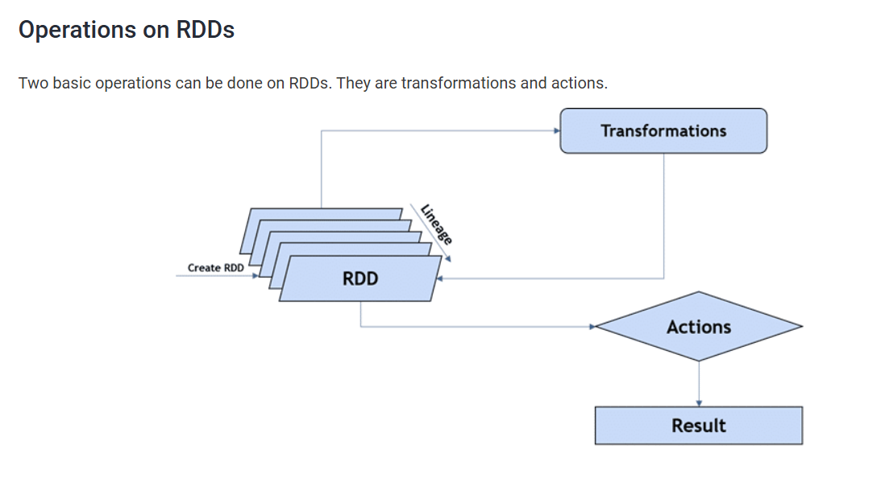

**Basic Spark Architecture:**

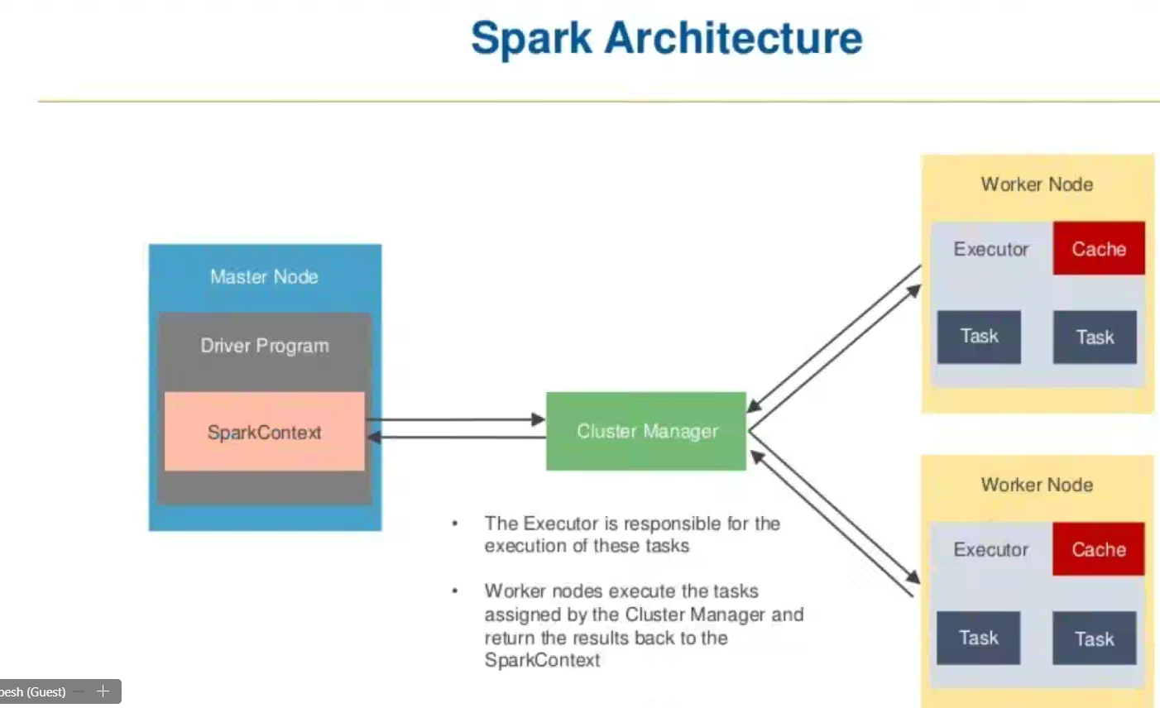

Apache Spark follows a **master-slave architecture** where the **Driver Program** (on the Master node) coordinates with **Executors** (on Worker nodes) to execute tasks in a distributed fashion. The **Cluster Manager** acts as a resource allocator.

**Main Components**

**1. Master Node**

* **Driver Program**:
  + This is the main application process.
  + It creates the **SparkContext** and handles job scheduling.
  + Divides the job into **tasks** and sends them to executors on worker nodes.
* **SparkContext**:
  + Acts as the entry point to any Spark application.
  + Connects to the **Cluster Manager** to request resources.
  + Communicates with all executors.

**2. Cluster Manager**

* Manages resources across all applications.
* Types of Cluster Managers supported by Spark:
  + **Standalone** (Spark’s own)
  + **YARN** (from Hadoop)
  + **Apache Mesos**
  + **Kubernetes**
* Responsibilities:
  + Allocates resources to SparkContext.
  + Launches **executors** on worker nodes.

**3. Worker Nodes**

Each worker node runs one or more **executors**.

* **Executor**:
  + A process launched for a Spark application.
  + Executes **tasks** assigned by the driver.
  + Stores data in memory (caching).
  + Sends results back to the driver.
* **Cache**:
  + Spark executors can **cache data in memory**.
  + This enables faster repeated computations.
* **Tasks**:
  + Smallest unit of work.
  + Spark breaks jobs into stages, and stages into tasks.
  + Tasks run in parallel across the executors.

**How Spark Works (Step-by-Step)**

1. **SparkContext** is created in the driver program.
2. It connects to the **Cluster Manager**.
3. The Cluster Manager allocates resources on **Worker Nodes**.
4. **Executors** are launched on the worker nodes.
5. SparkContext sends **tasks** to executors.
6. Executors run the tasks and return results to the driver.
7. If caching is used, executors store intermediate results in memory for reuse.

**Advantages of This Architecture**

* **Distributed processing** allows Spark to handle large-scale data efficiently.
* **In-memory computation** via executors provides high performance.
* **Fault tolerance** through task re-execution using lineage info.
* **Scalability** by adding more worker nodes to the cluster.

**Example Scenario**

Imagine you're analyzing a large CSV file with Spark:

* The file is loaded by the driver using SparkContext.
* Spark splits the data into partitions.
* Each partition is assigned as a **task** to worker nodes.
* Executors process the tasks in parallel.
* Results are sent back to the driver or cached for reuse.

Spark Context:

* SparkContext is the **entry point** and **main control gateway** for any Spark application.
* It **connects your application to the Spark cluster** and allows you to create RDDs, accumulate variables, and interact with all Spark functionalities.

**Parameters in SparkContext:**

| **Parameter** | **Description** |
| --- | --- |
| master | The cluster URL (e.g., "local", "yarn", "spark://") |
| appName | Name of your Spark application |
| config | Optional SparkConf object for custom settings |

**What is the Task Scheduler?**

The **Task Scheduler** in Apache Spark is a key internal component responsible for:

* **Distributing tasks** (the smallest units of execution) across executors on worker nodes.
* **Managing task execution** based on data locality and resource availability.
* **Monitoring** the status of each task and **handling failures**.

**Responsibilities of Task Scheduler,**

| **Responsibility** | **Description** |
| --- | --- |
| **Task Allocation** | Assigns tasks to executors based on available resources and data location |
| **Data Locality Optimization** | Tries to run tasks on nodes where the required data is already present |
| **Monitoring Task Execution** | Tracks task progress, retries failed tasks |
| **Failure Recovery** | If a task fails, it re-executes it on another executor |
| **Communication** | Sends updates (success/failure) back to the **DAGScheduler** and driver |

**Summary Execution Flow (Simple View),**

1. Spark application is submitted → SparkContext is created.
2. RDD/DataFrame operations → DAG of stages.
3. DAG Scheduler creates task sets per stage.
4. **Task Scheduler**:
   * Picks executors
   * Assigns tasks
   * Monitors task progress
5. Executors complete tasks → send results back to driver.

Simple Diagram:

Driver

|

DAG Scheduler

|

Task Scheduler  
|

Executors

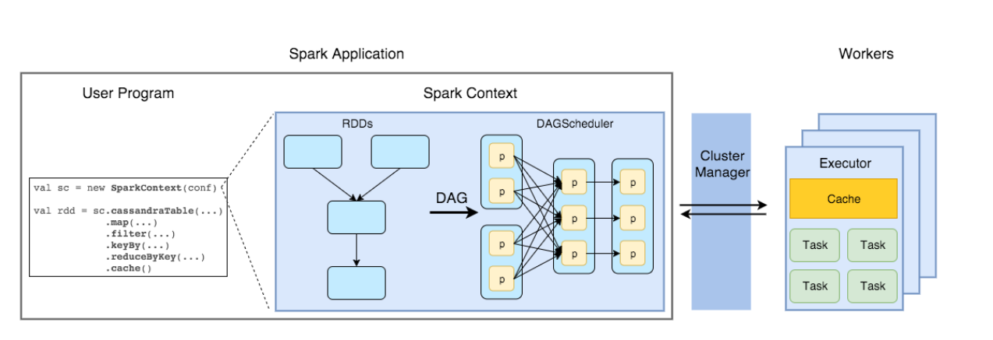

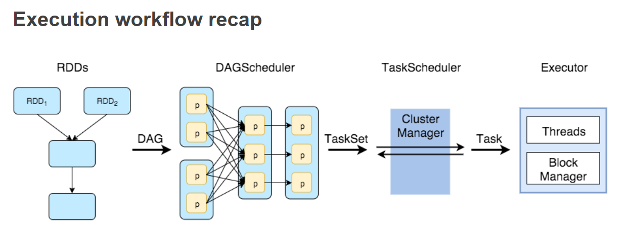

**What is a DAG?**

A **DAG (Directed Acyclic Graph)** in Spark is a graph structure that represents the **logical execution plan** of a Spark job.  
It consists of **vertices (nodes)** and **edges (connections)**:

* **Vertices**: RDDs or stages.
* **Edges**: Operations or dependencies between them.

“Directed” means operations flow in one direction, and “Acyclic” means there are **no loops**.

**Why DAG in Spark?**

In older systems like Hadoop MapReduce:

* Every job was broken into map and reduce phases.
* It used **intermediate disk I/O** and had limited optimization.

**Spark DAG eliminates these limitations** by:

* Combining operations into a **chain of transformations**.
* **Optimizing execution** before it runs.
* Reducing unnecessary shuffling or disk access.

**DAG Execution Flow in Spark,**

1. **User Code**: You write transformations (e.g., map, filter, join, etc.).
2. **Lazy Evaluation**: Spark doesn't execute immediately. It builds a DAG.
3. **DAG Scheduler**:
   * Breaks the DAG into **stages** (based on shuffle boundaries).
   * Each stage is divided into **tasks** (based on data partitions).
4. **Tasks** are scheduled and sent to **executors** for parallel execution.

**Benefits of DAG in Spark**

* **Optimized execution plan** before running jobs
* **Better fault tolerance** (via lineage)
* **Efficient task scheduling**
* **Minimized disk I/O** and **reduced data shuffling**

Simple Visual Summary,

[Stage 1]

RDD1 --map--> RDD2 --flatMap--> RDD3

↓

shuffle (wide)

↓

[Stage 2]

RDD4 --reduceByKey--> FinalRDD

Summary of - [**Apache Spark: core concepts, architecture and internals**](https://datastrophic.io/core-concepts-architecture-and-internals-of-apache-spark/)

**1. Introduction to Apache Spark,**

Apache Spark is a distributed data processing engine designed for speed and general-purpose analytics. It supports in-memory computation and is compatible with cluster managers like YARN, Mesos, and its own Standalone manager. It works with various storage systems such as HDFS, Cassandra, and Amazon S3, and supports APIs in Scala, Python, Java, and R.

**Spark Architecture:**

**[ Driver Program ]**

**|**

**[ SparkContext ]**

**|**

**[ DAG Scheduler ]**

**|**

**[ Task Scheduler ]**

**|**

**[ Scheduler Backend ] <----> [ Cluster Manager ]**

**|**

**[ Executors (on Worker Nodes) ]**





**2. Resilient Distributed Datasets (RDDs)**

**What is an RDD?**

* An RDD (Resilient Distributed Dataset) is an immutable, distributed collection of objects partitioned across nodes in a cluster.
* It supports lazy evaluation and tracks lineage to recover lost data in case of failure.

**Key Methods in RDD:**

1. getPartitions
2. getDependencies
3. compute
4. getPreferredLocations
5. partitioner (optional)

**RDD Operations:**

* Transformations: Lazy operations that create new RDDs (e.g., map, filter, reduceByKey)
* Actions: Trigger execution (e.g., collect, count)
* Persistence: Allows caching of RDDs in memory/disk (cache(), persist())

**RDD Lineage Example:**

RDD1 = sc.textFile("file.txt")

RDD2 = RDD1.map(...)

RDD3 = RDD2.filter(...)

RDD4 = RDD3.reduceByKey(...)

RDD4 maintains the lineage from RDD3 → RDD2 → RDD1.

**3. Directed Acyclic Graph (DAG) and Execution,**

**DAG Basics:**

* A DAG represents the sequence of computations as nodes (RDDs) and edges (transformations).
* Spark constructs a DAG when you define transformations, which is only executed upon an action.

**Dependency Types:**

* **Narrow Dependency**: Child RDD depends on one parent partition (e.g., map, filter)
* **Wide Dependency**: Child RDD depends on multiple parent partitions and requires a **shuffle** (e.g., groupByKey)

**Stage Formation:**

* DAG is split into **stages** at shuffle boundaries.
  + **ShuffleMapStage**: Involves shuffle write operations.
  + **ResultStage**: Returns data to the driver.

**Task Types:**

* **ShuffleMapTask**: Writes intermediate shuffle data to disk.
* **ResultTask**: Computes and returns final result to driver.

**DAG and Stages:**

Job

├── Stage 1 (map, narrow)

│ ├── Task 1

│ ├── Task 2

└── Stage 2 (reduce, shuffle)

├── Task 1

├── Task 2

**4. Shuffle Process,**

**Shuffle Write:**

* Map tasks write data for each reduce partition.
* Involves writing M × R output files (M = map tasks, R = reduce tasks).
* Hash-based or sort-based shuffle is used. Sort-based shuffle is the default since Spark 1.2.

**Shuffle Read:**

* Reduce tasks fetch, optionally sort, and aggregate data from all mappers.

**5. Spark Architecture**

**Key Components:**

**1. Driver Program:**

* Hosts the SparkContext.
* Coordinates the overall execution.
* Breaks jobs into tasks and stages.

**2. SparkContext:**

* Entry point for Spark application.
* Manages configuration, job submission, and connection to cluster manager.

**3. Cluster Manager:**

* Allocates resources on the cluster (YARN, Mesos, or Standalone).

**4. Executors:**

* JVM processes launched on worker nodes.
* Run tasks and store data for in-memory processing.

**6. Spark Internal Execution Flow**

1. **User Code**: Written using Spark APIs to create a DAG of RDDs.
2. **SparkContext**: Initializes Spark and communicates with the cluster manager.
3. **DAGScheduler**:
   * Divides the job into stages based on shuffle boundaries.
   * Maintains stage dependencies.
4. **TaskScheduler**:
   * Schedules individual tasks to be run on executors.
   * Handles retry logic and locality-aware scheduling.
5. **SchedulerBackend**:
   * Integrates with the underlying cluster manager to launch executors and tasks.
6. **Executors**:
   * Execute tasks.
   * Cache RDDs.
   * Handle data shuffle and I/O.

**7. Memory Management in Spark (Spark 1.6+)**

Spark divides the JVM heap into the following regions:

1. **Execution Memory**: Used for runtime operations like shuffles, joins, and aggregations.
2. **Storage Memory**: Used for caching RDDs and broadcast variables. It can borrow from execution memory if needed.
3. **User Memory**: Used by Spark internal metadata and user-defined objects.
4. **Reserved Memory**: A fixed amount (300 MB by default) reserved to prevent JVM crashes

**8. Summary Table,**

| **Component** | **Description** |
| --- | --- |
| **RDD** | Immutable dataset, supports lazy transformations and lineage tracking. |
| **DAG Scheduler** | Splits a job into stages and identifies shuffle boundaries. |
| **Task Scheduler** | Schedules and executes tasks on executors. |
| **Executors** | Run tasks and store data on worker nodes. |
| **Driver Program** | Orchestrates the application and manages SparkContext. |
| **Cluster Manager** | Allocates resources to executors across nodes. |
| **Shuffle** | Redistributes data across partitions; requires disk and network I/O. |
| **Memory Manager** | Manages Spark memory into execution, storage, and user memory regions. |

**Kubernetes: (Own interest research not covered )**

**1. What is Kubernetes?**

* Kubernetes (often abbreviated as **K8s**) is an **open-source container orchestration platform**. It automates the **deployment**, **scaling**, **management**, and **operation** of containerized applications (like Docker containers) across a cluster of machines.
* Kubernetes was originally developed by **Google** and is now maintained by the **Cloud Native Computing Foundation (CNCF)**.
* **Kubernetes** is the industry standard for managing containers at scale.
* It automates infrastructure operations like deployment, scaling, and recovery.
* The architecture is based on **Control Plane** and **Worker Nodes**.
* It supports a wide range of production-grade features like auto-scaling, load balancing, and service discovery.

**2. Why Use Kubernetes?**

Without Kubernetes:

* You have to **manually deploy** containers on each server.
* Scaling, load balancing, and failure recovery are **manual and error-prone**.

With Kubernetes:

* **Auto-scaling** of applications.
* **Self-healing** (restarts failed containers).
* **Service discovery and load balancing**.
* **Declarative configuration** using YAML/JSON files.
* **Rolling updates and rollbacks**.

**3. Where is Kubernetes Used?**

Kubernetes is widely used in:

* **Cloud-native applications**
* **Microservices architecture**
* **DevOps pipelines**
* **Big Data platforms** (like Spark on Kubernetes)
* **Machine Learning pipelines**
* **Hybrid cloud/multi-cloud deployments**

Major companies using Kubernetes: Google, Netflix, Amazon, Spotify, Reddit, Pinterest, and thousands of others.

**4. Kubernetes Architecture**

Kubernetes uses a **master-worker** architecture:

**Cluster = Control Plane (Master) + Worker Nodes**

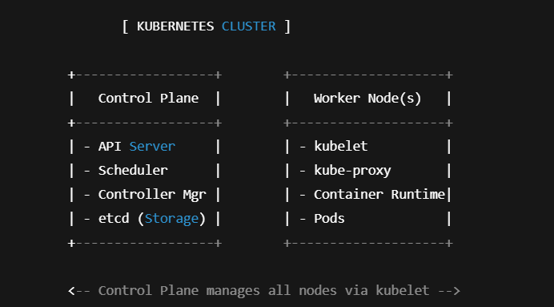

**Control Plane (Master Components)**

1. **API Server (kube-apiserver)**
   * Entry point for all REST commands.
   * Clients, kubectl, and other components communicate through this.
2. **etcd**
   * Distributed key-value store.
   * Stores the entire state of the cluster (like a database).
3. **Controller Manager**
   * Watches the cluster state and makes changes to reach the desired state.
   * Example: Node Controller, Replication Controller.
4. **Scheduler**
   * Assigns Pods to Nodes based on resource needs and policies.

**Worker Node Components**

1. **kubelet**
   * Agent that runs on every worker node.
   * Communicates with the control plane to manage containers in pods.
2. **kube-proxy**
   * Handles networking and load-balancing.
   * Forwards traffic to the correct pod in a node.
3. **Container Runtime**
   * Runs containers (e.g., Docker, containerd, CRI-O).
4. **Pods**
   * Smallest unit in Kubernetes.
   * A pod can contain one or more tightly coupled containers.

**Kubernetes Workflow:**

1. **Developer** writes a YAML configuration file describing the app.
2. File is submitted to **API Server**.
3. API Server stores desired state in **etcd**.
4. **Scheduler** picks the best node to run the pod.
5. **kubelet** on that node pulls the container image and runs it.
6. **kube-proxy** ensures the pod is network-accessible.
7. If the pod crashes, **Controller Manager** ensures it is restarted.

**Core Kubernetes Concepts,**

| **Concept** | **Description** |
| --- | --- |
| **Pod** | Smallest unit in Kubernetes; wraps one or more containers |
| **Service** | Defines a network policy and load-balancer for pods |
| **Deployment** | Manages rolling updates, replica scaling, self-healing |
| **Namespace** | Isolated environments within a single cluster |
| **Node** | Physical or virtual machine where pods run |
| **Cluster** | Group of nodes managed by Kubernetes |

**Kubernetes in Big Data and Spark,**

Kubernetes can run **Apache Spark** jobs using the native Kubernetes scheduler.

Benefits include:

* Dynamically launch Spark executors as pods
* Better resource isolation
* Native integration with cloud providers (AWS, GCP, Azure)
* Easier DevOps integration with CI/CD pipelines

**DAY 9 (17-06-2025)**

**PySpark - Big Data Processing with Python and Apache Spark**

**Introduction to Apache Spark**

**Apache Spark** is an open-source, distributed computing engine designed for fast and general-purpose big data processing. It can handle massive amounts of data across a cluster of machines.

* **Speed**: In-memory computation makes Spark faster than traditional systems like Hadoop MapReduce.
* **Scalability**: Designed to process data across hundreds of machines in parallel.
* **Language Support**: Originally written in Scala, Spark supports Scala, Java, Python (via PySpark), and R.

**What is PySpark?**

**PySpark** is the Python API for Apache Spark. It allows developers to harness the full power of Spark from Python code.

* Enables Python developers to interact with Spark’s core capabilities.
* Internally uses **Py4J**, which bridges Python and the JVM (Java Virtual Machine).

**PySpark Architecture**

**Working Mechanism:**

1. Python code is written in PySpark.
2. **Py4J** translates the Python commands and sends them to the JVM.
3. Spark (written in Scala) executes the logic on the cluster.

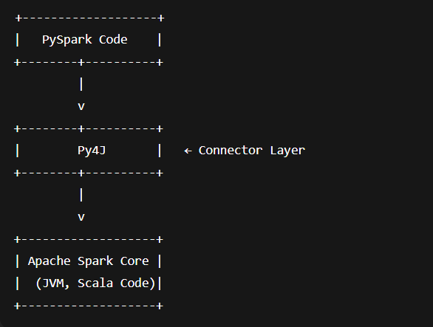

**Key Characteristics of RDDs:**

| **Feature** | **Description** |
| --- | --- |
| Immutability | Once created, RDDs cannot be modified. Transformations create new RDDs. |
| In-Memory Storage | Intermediate data is cached in memory for faster computation. |
| Lazy Evaluation | Transformations are not executed until an action is triggered. |
| Fault Tolerance | Lost partitions are recomputed using the transformation lineage. |
| Partitioning | RDDs are divided into partitions and distributed across nodes. |
| Persistence | Frequently accessed RDDs can be cached using persist() or cache(). |
| Granular Control | Supports both coarse-grained (entire dataset) and fine-grained (individual elements) transformations. |

**RDD Operations in Spark:**

**Transformations:**

* Return a **new RDD** and are **lazy** (executed only when an action is called).
* Do not modify the original RDD.

Examples:

* map()
* filter()
* flatMap()
* groupByKey()
* sortByKey()

**Types of Transformations:**

| **Type** | **Description** | **Examples** |
| --- | --- | --- |
| Narrow | Data needed to compute one partition lives in a single parent partition. | map(), filter() |
| Wide | Data required to compute one partition lives in multiple parent partitions. Involves shuffling. | groupByKey(), reduceByKey() |

**Actions**

* **Trigger the execution of transformations.**
* **Return results to the driver program or store them in a file.**

**Examples:**

* **collect()**
* **count()**
* **first()**
* **take()**
* **reduce()**
* **saveAsTextFile()**

**Working with Data in PySpark (Using DataFrames in Databricks Serverless)**

**Why Not RDDs?**

In Databricks **serverless compute**, you **cannot use**:

sc.parallelize()

spark.sparkContext.parallelize()

This is because **direct access to the JVM (Java Virtual Machine)** is restricted in serverless environments for security and scalability reasons. These methods rely on low-level APIs (SparkContext) which are disabled.

**Solution**: we can use DataFrames, which are high-level, optimized APIs supported on all Databricks cluster types.

**What is a DataFrame?**

A **DataFrame** in PySpark is a **distributed collection of data** organized into **named columns**, similar to a table in a relational database or a pandas DataFrame in Python.

* **Structured**: DataFrames have schema (column names and types).
* **Optimized**: Spark automatically optimizes execution using its Catalyst engine.
* **Powerful**: Supports SQL queries, complex transformations, and data integration.

Step 1:

Creating a DataFrame from a List:

# Define some sample numbers as a list of tuples

data = [(10,), (20,), (30,), (40,), (50,)]

# Convert the list into a DataFrame with a column named "number"

df = spark.createDataFrame(data, ["number"])

# Display the DataFrame in tabular format

df.show()

Output:

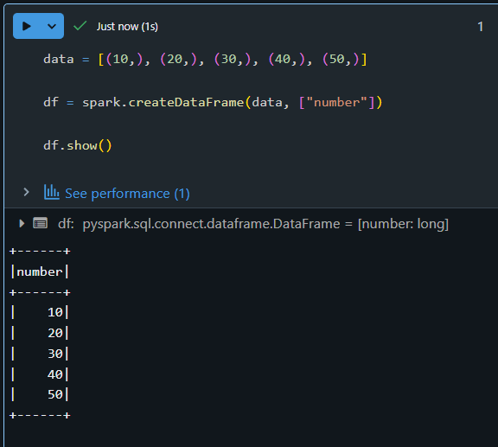

**Explanation:**

* data = [(10,), (20,), ...]: This is a list of tuples, where each tuple represents a row.
* spark.createDataFrame(data, ["number"]): Converts the list into a distributed DataFrame with a column name.
* .show(): Displays the content in a table-like structure.

Step 2:

Filtering the Data (Like RDD’s filter):

# Keep only numbers greater than 25

filtered_df = df.filter(df.number > 25)

# Display filtered results

filtered_df.show()

OUTPUT:  
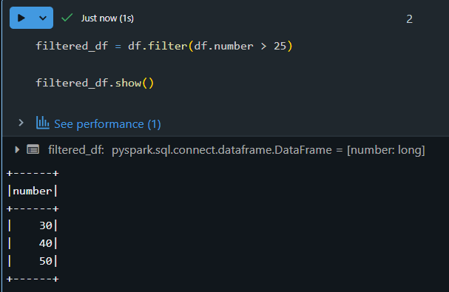

Step 3:

Transforming Data (Like RDD’s map):

# Create a new column "squared" by squaring the existing values

transformed_df = filtered_df.withColumn("squared", filtered_df.number * filtered_df.number)

# Show final result

transformed_df.show()

OUTPUT:  
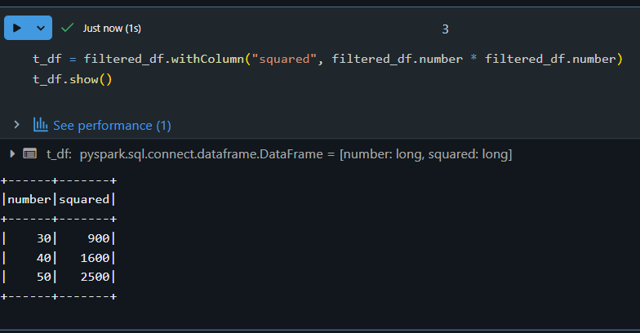

**Explanation:**

* withColumn("squared", ...): Adds a new column named "squared" which contains the square of each number.
* This simulates rdd.map(lambda x: x * x) in RDD.

Step 4:

Collecting Results to Driver:

# Collect results to driver node as Python objects

results = transformed_df.collect()

# Display each row

for row in results:

print(row)

OUTPUT:  
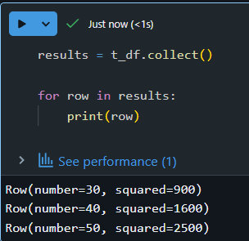

**Explanation:**

* .collect(): Brings all rows to the driver (like rdd.collect()).
* Looping through the collected rows lets you see each record in Python format.

**Step 5:**

**Saving Data to File System:**

# Save transformed data to a CSV in Databricks FileStore

transformed_df.write.mode("overwrite").csv("/FileStore/output/transformed_data")

**Explanation:**

* .write.csv(...): Writes the DataFrame as CSV files.
* mode("overwrite"): Replaces folder if it already exists.
* This replaces rdd.saveAsTextFile() in RDD.

we can view this data in the Databricks UI under **Data → DBFS → FileStore → output → transformed_data**.

Summary Table: RDD vs DataFrame Equivalents

| **Action** | **RDD Syntax**  **(Not supported on serverless)** | **DataFrame Syntax**  **(Supported)** |
| --- | --- | --- |
| Create in memory | sc.parallelize([1,2]) | spark.createDataFrame([(1,), (2,)], ["col"]) |
| Filter data | rdd.filter(lambda x: x > 5) | df.filter(df.col > 5) |
| Map/transformation | rdd.map(lambda x: x * x) | df.withColumn("squared", df.col * df.col) |
| Show output | rdd.collect() | df.collect() / df.show() |
| Save to file | rdd.saveAsTextFile("path") | df.write.csv("path") |

1. **DataFrames** are the recommended approach in modern PySpark.
2. They are **faster**, **easier**, and **compatible** with Databricks serverless and cloud environments.
3. You can chain multiple operations just like with RDDs, but with better performance and readability.

RDD creation in in spark:

In Spark, RDDs (Resilient Distributed Datasets) can be created in a few ways: by parallelizing an existing collection, loading data from external storage, or transforming existing RDDs. Here's a breakdown:

1. Parallelizing an Existing Collection:

* This method involves taking a collection (like a list or array) in your driver program and distributing it across the cluster using SparkContext.parallelize().
* Example (Python):

Python

data = [1, 2, 3, 4, 5]

rdd = sc.parallelize(data)

* This is useful for quick prototyping and testing, but not ideal for large datasets where the entire dataset needs to reside on one machine initially.

2. Loading from External Storage:

Spark can read data from various sources like text files, CSV files, JSON files, and more, creating an RDD for each.

Examples:

* + Text file: rdd = sc.textFile("path/to/file.txt")
  + CSV file: (using a library like spark-csv or a custom function)
  + HDFS, HBase, or any Hadoop InputFormat supported data source

This is the most common way to work with large datasets in Spark.

3. Transforming Existing RDDs:

* RDDs can be created by applying transformations (like map, filter, flatMap) to existing RDDs.
* Example:

Python

numbers = sc.parallelize([1, 2, 3, 4, 5])

squared_numbers = numbers.map(lambda x: x * x)

* This allows for building complex data pipelines by chaining operations on RDDs.

**Converting Spark RDD to DataFrame and Dataset**

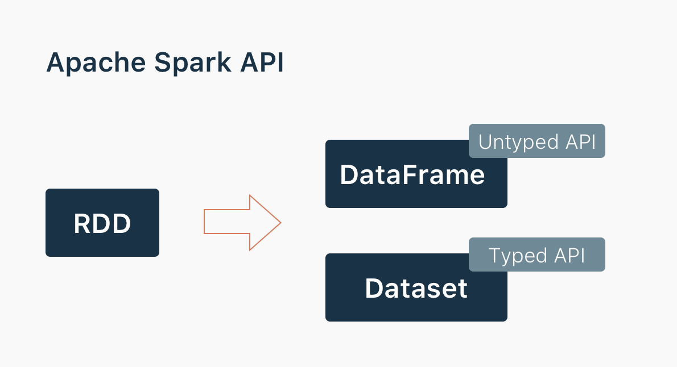

Spark provides 3 main abstractions to work with it. First, we will provide you with a holistic view of all of them in one place. Second, we will explore each option with examples.

[RDD](https://spark.apache.org/docs/latest/rdd-programming-guide.html) (Resilient Distributed Dataset). The main approach to work with unstructured data. Pretty similar to a distributed collection that is not always typed.

[Datasets](https://spark.apache.org/docs/latest/sql-programming-guide.html#datasets-and-dataframes). The main approach to work with semi-structured and structured data. Typed distributed collection, type-safety at a compile time, strong typing, lambda functions.

[DataFrames](https://spark.apache.org/docs/latest/sql-programming-guide.html#datasets-and-dataframes). It is the Dataset organized into named columns. It is conceptually equivalent to a table in a relational database or a data frame in R/Python, but with richer optimizations under the hood. Think about it as a table in a relational database.

**Creating a SparkSession in PySpark:**

The following code initializes a **SparkSession**, which is the entry point for working with DataFrames and the Spark SQL API in PySpark:

from pyspark.sql import SparkSession

spark = SparkSession.builder.appName("Spark DataFrames").getOrCreate()

**Line-by-line Breakdown:**

1. **from pyspark.sql import SparkSession**
   * This imports the SparkSession class from PySpark’s SQL module. SparkSession is the main entry point to interact with Spark’s DataFrame and SQL functionality.
2. **SparkSession.builder**
   * This is a builder pattern to configure and create a SparkSession object.
3. **.appName("Spark DataFrames")**
   * Sets the name of the Spark application. This name appears in the Spark UI and logs, useful for monitoring and debugging.
4. **.getOrCreate()**
   * This either retrieves an existing SparkSession or creates a new one if none exists. It ensures only one SparkSession is active per application.

**Creating and Displaying a DataFrame in PySpark**

The following code creates a DataFrame using PySpark and displays its content:

df = spark.createDataFrame(

[(1, 2, 3, 'a b c'),

(4, 5, 6, 'd e f'),

(7, 8, 9, 'g h i')],

['id', 'name', 'salary', 'department']

)

df.show()

**Line-by-line Breakdown:**

1. **spark.createDataFrame(...)**
   * This method creates a DataFrame from a list of tuples.
   * Each tuple represents a row of data.
2. **[(1,2,3,'a b c'), (4,5,6,'d e f'), (7,8,9,'g h i')]**
   * A list of rows. Each row contains 4 elements: integers and a string.
3. **['id', 'name', 'salary', 'department']**
   * Specifies the column names for the DataFrame.
4. **df.show()**
   * Displays the contents of the DataFrame in a tabular format.

**Output:**

+---+----+------+----------+

| id|name|salary|department|

+---+----+------+----------+

| 1| 2| 3| a b c|

| 4| 5| 6| d e f|

| 7| 8| 9| g h i|

+---+----+------+----------+

**Importing the Data**

data = spark.read.csv('/Volumes/dataset1/default/people/sales_200_rows.csv', header=True)

data.show()

data.printSchema()

Changing the Datatype

from pyspark.sql.types import StructField, StringType,IntegerType, StructType

data_schema = [StructField('order_id', IntegerType(), True),

StructField('customer_id', IntegerType(), True),

StructField('order_date', StringType(), True),

StructField('product', StringType(),True),

StructField('category', StringType(),True),

StructField('quantity', StringType(),True),

StructField('price_per_unit', IntegerType(),True)]

defines a custom schema using StructField and data types from PySpark to precisely control how each column in a CSV file is interpreted.

Each StructField specifies the column name, data type, and whether null values are allowed.

Changing into SQL:

data.createOrReplaceTempView('people')

%sql

select * from people